Chapter 1 5
Name 5
Calibration 5
Harness Application and Usage 9
Home Use 9
PULSAR demographics part 1 12
Starting the Program 12
Connecting the Device to your Computer 14
Demographics 15
SOC questionnaire 18
Birth Information 20
Chapter 2 21
Testing 21
Subfiles 23
Menu bar 24
Auto Focus Zap 25
Blue info grid 26
Chain Reaction Function 30
Columns in the main matrix 32
Main Matrix 34
Manfly 35
VARHOPE Score Interpretation 37
Alarm reaction 40
Chapter 3 40
Risks Profile – Mineral Panel 40
Risks Profile – Virtual Doctor Test 44
Risks Profile 45
Short Sarcode Feedback Rx 46
Chapter 4 62
Bodyviewer Training Program Activation 62
Iridology 67
Chapter 5 69
Disease Probability and Dictionary 69
Chapter 6 72
Close Out of Programs 72
Shut Down Your Device 73
Check Current Rectifications 73
Close Out of ED.X and NUCLEUS SOFTWARE 74
Closing a session with your client 74
Chapter 7 78
Modifying the SOC Index of a Previous Client 78
Loading a Previous Client 80
Modifying Birth Date 81
Chapter 8 81
Auto Frequency Therapy / Auto VARHOPE 81
Auto Meridian / Hyper-Reactants 83
Auto Scalar 85
Auto Trivector 86
Spiritual Resonance 87
Trivector and Hololinguistic Therapy 88
Two Suggested Training Programs 88
Auto Colour Therapy 89
Chapter 9 90
Superlearning 90
Timed Therapies 92
Chapter 10 93
ECG Fast Fourier Transform 93
Superconscious Reduction Panel 93
Autonomic Nerval System 94
Chapter 11 96
Bones, Nerves, Circulation, Lymph, Digestion 96
Spinal Muscular Re-Education, Sarcode Feedback 98
Timed Biofeedback Therapies 100
Chapter 12 100
Hormonal Training Program 100
Internal Enzymes 101
Nutrition and Homeopathy Feedback 102
Stress and Cortisol 103
Chapter 13 103
Stimulate Emotional Growth Stress Reduction 103
Chapter 14 104
Other Biofeedback Choices 104
Reduce Stress in Nerves 105
Chapter 15 106
Body Scan and Face Therapy 106
Appendix A 107
EDUCATIONAL LANGUAGE 107
TERMINOLOGY for PRACTITIONERS 110
Appendix B 110
Electrode Data Check Box Does Not Appear 110
BASIC TROUBLESHOOTING 111
Problems With Graphics or Multimedia 112
Biofeedback Systemic Relaxation 112
Disease Probability And Dictionary 113
Hints And Warnings 113
Setting The Com Port 114
Special ED.X and NUCLEUS Programs Or AFE 114
Training Programs Prone To Lock Up 115
Tricks To Prevent And Deal With Freeze-Up 116
Using Ctrl+Alt+Delete Tricks 116
What to do when computer screen is frozen 116
Updates and chnages 117
Brain wave pattern therapy 117
Changes made with Update no.43 & 44 119
Changes made with Update no.45 & 46 124
Changes made with Update no. 46 130

User manual for Nucleus and ED.X
devices

Version 1.0



Chapter 1

Name
Step 1: NAME
Type in the name of the Client.

If doing a Practice Session:
for Client Name, type the words Test Client 1.
(for later sessions, you may type in Test Client 2, etc.)

If doing a Client Session:
for Client Name, type the full name (first, last and middle name if desired)

Click Male or Female or Both

Calibration
Now that we have our client set up in demographics, we are here in the main panel where the calibration option is now bold.
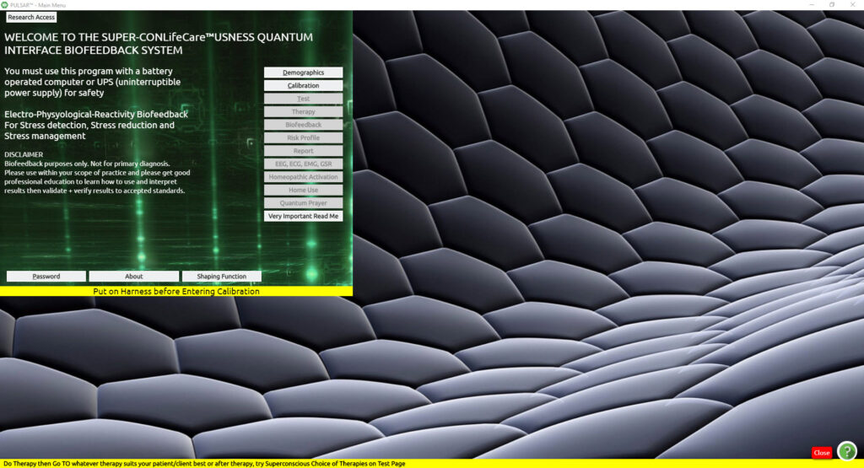
The Calibration process is our first hand-shake or connection with the device. This is the process whereby VARHOPE numbers are calculated.
Click Calibration (from the Main Menu)
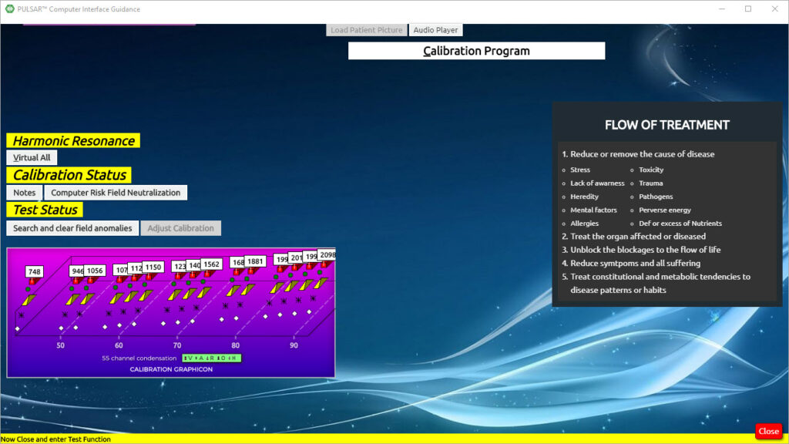
On this panel, you also have the option to choose VIRTUAL ALL. This disables the harness from the patient, especially in the case you work on a person with a pacemaker.
In the option Computer Risk Field Neutralization, you can check your room for geopathic stress, and clear it if you wish. This is a good idea especially when you start or finish your day at your office, or even between clients
Other options when you can click Computer Risk Field Neutralization:
- Neutralize and diminish computer stress
- Check and clear area/room for Geopathic Stress – it is suggested to start your day or end your day with this, or at least to do it every week, or when working in a new area
- The Schuman Field and Subspace protection field can be activated and deactivated here
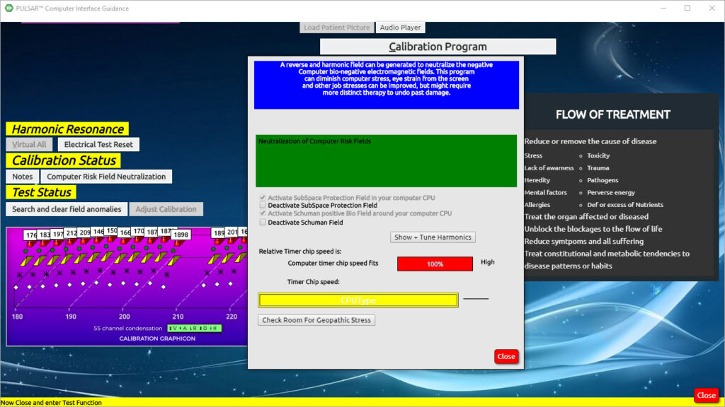
Click close on the Computer Risk Field Neutralization
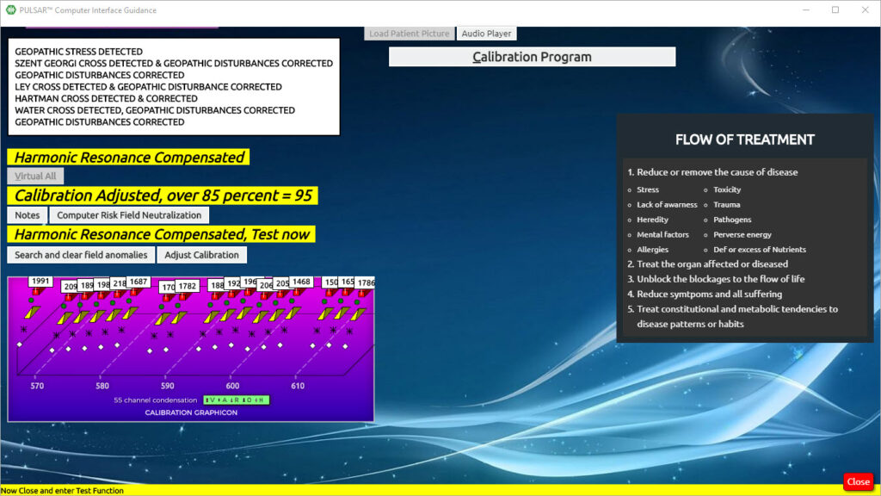

Now you may either proceed with the Calibration Program directly, or you may Load the Client’s Picture first if you did not do it in Demographics.
We also have the option of loading in a picture (Load Patient Picture)
The PULSAR software loads the picture of the client much easier than previous devices, and there is no need to alter the picture in any way. All you need is a saved .jpeg photo.
Click on Load Patient Picture
This will automatically load the patient’s picture in the background of the calibration interface
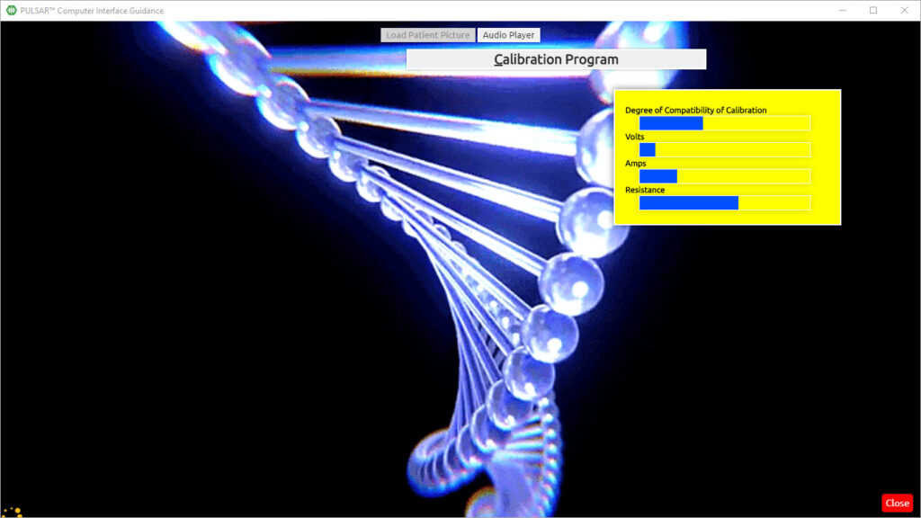
Click (Calibration Program)
Calibration begins
If a message comes up you just read it and convey it to your client and
Click OK
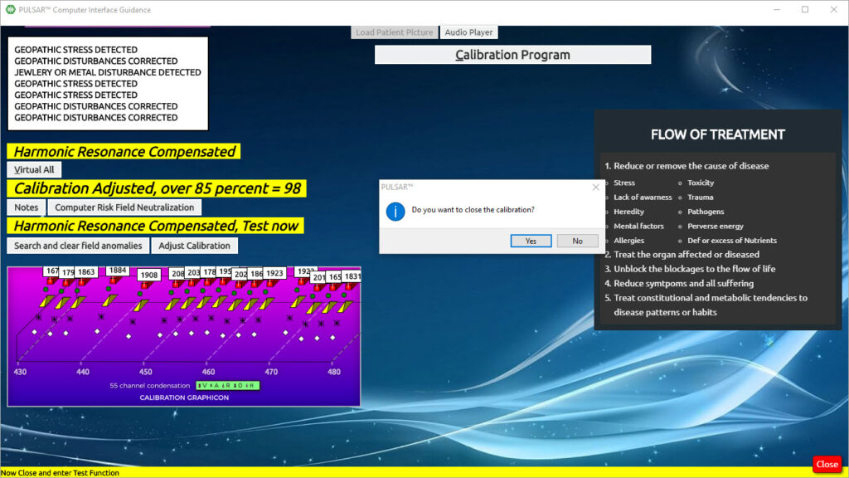
Click Yes (Do you want to close the calibration?)
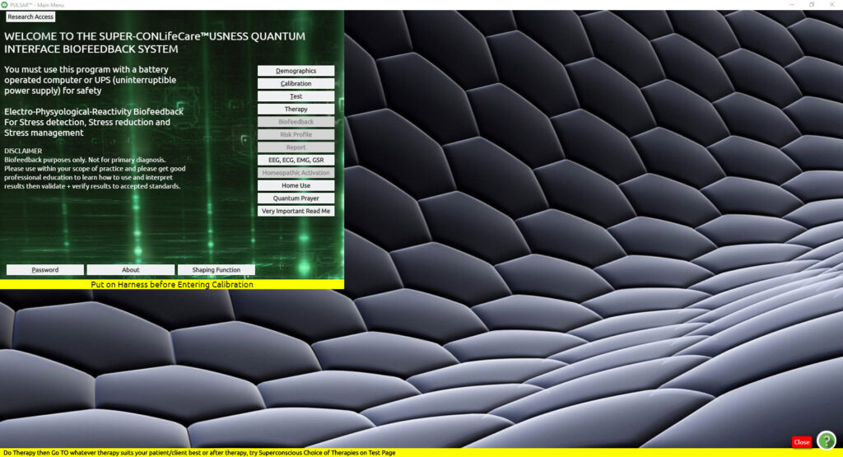
And you are returned to the Main Panel where you can continue.

Harness Application and Usage
Have the client remove all jewelry not worn at night, loose change, keys, and cell phone.
Attach the tray, head harness, and limb straps to the device accordingly in the back of the device matching the colors of each cable.
Headband – Wrap the head harness around the client’s head, with the White cord to the Right side of the head and the eight electrodes on the forehead. If you wish, you may use a wet single-ply tissue between the forehead and the headband. It needs to be comfortable but not too tight.
Limb Straps – Attach limb straps around wrists and ankles, in a comfortably snug fit. The wires should be connected in the following manner:
Wrists – RED on Right – YELLOW on Left
Ankles – BLUE on Right – BLACK on Left
- Do not apply over broken skin
- Do not use on clients with pacemakers
- Do not use on clients with extreme electrical allergy
- Be cautious with clients who have had electric shock therapy
- Wipe and clean the harness after each use (consider a microfiber cloth as it is naturally disinfecting without chemicals). You can also use diluted Everclear or diluted Vodka as they leave no chemical residue. Do not use Isopropyl Alcohol as it dries out the harness and leaves a chemical residue.
- Surrogate testing can be done on infants with the harness connected to the mother and the child in the mother’s arms
- If you suspect some difficulties with the client, do not connect the harness to the client, but have them place their hand on the tray or work in virtual.
- For clients who :
  - Are Pregnant
  - Have a history of epilepsy
  - Who has pacemaker
Please do not do therapy on them until you have acquired enough experience and have become a Biofeedback Specialist, in order to have a complete understanding of the type of protocols that can be followed.
- Note:
Attempting to open the box will interfere with the operation and void any warranty on your device.

Home Use
All buttons on the Main Menu panel are now bold and ready to open. At this point, you have the option to open any of the buttons, but more commonly, you would go to either Home Use or Test.
The Home Use is a program that is automatic and can use unconscious choices based on the calibration.
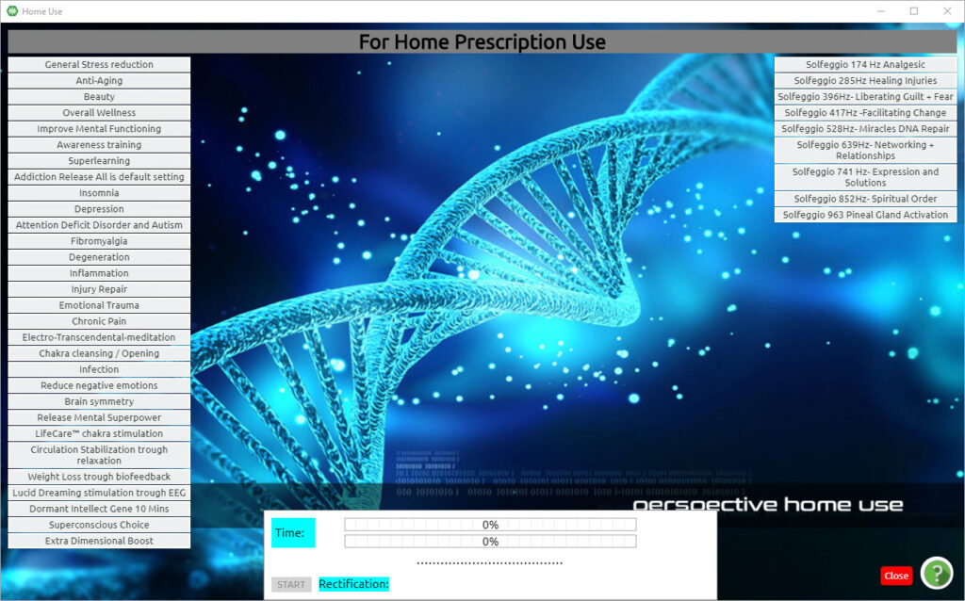
Click HOME USE ONCE
In order to select the program, you can:
click on SuperConscious Choice a few times (on the bottom of the list of programs), so that the PULSAR shows you the unconscious needs of the client.

Or you can select an individual therapy of your choice based on your professional experience.
The Home Use is a program that is automatic and can use unconscious choices based on the calibration.
By default the timer for each therapy is set at 1 minute, however, you may change the time according to what you think is best. The maximum time per individual therapy is 20 minutes.
The total time of the programmed therapies is shown in blue at the bottom part of the panel. The maximum of programmed therapies allowed is one and a half hours.
When you are ready with your selections and times, Click on Start on the white bottom part of the Home Use panel.
While the program is working, in the bottom white part of the panel you will be able to see which therapy is being done, how much percent and time are left to finish the therapy and the average percent of rectification of all programs.
Upon completion of each therapy, a percentage is shown on the side of the timer.
The Home Use is a program that is automatic and can use unconscious choices based on the calibration.

Upon completion of the selected therapies, you will see rectification results beside each selection and an average rectification result at the bottom.
If you wish to continue with more therapies you can click on other individual programs once to make them bold.
To de-select a therapy, all you need to do is click on the selection once and the items will be de-selected.
Click Close
Here you can either click OK to proceed to the EEG/ECG panel or Cancel to proceed to TEST.

PULSAR demographics part 1
From the MAIN MENU, press on DEMOGRAPHICS. (This will access the demographics panel).
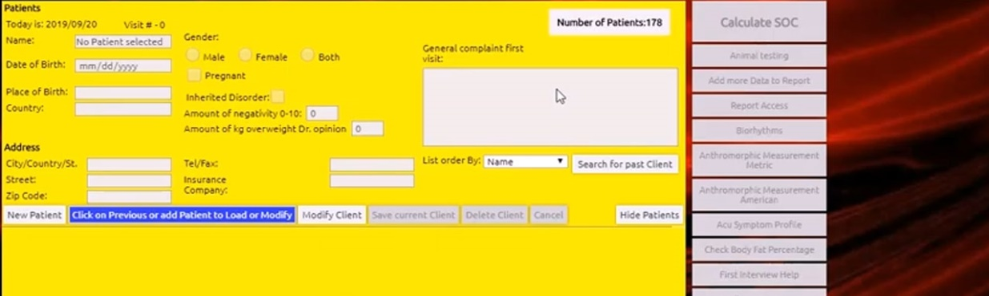
Start by clicking once on the option NEW PATIENT. (That enables us to enter new details for a new patient).
Important: The client can be a person, an animal an inanimate object, a group of people, land, etc, depending on your scope of practice.
At the NAME, introduce the name of the PATIENT. For the gender, you shall select according to what you were working on, male or female, or if it is an inanimate object, a group of people with both male and female, or depending on physical or personal identity, or expression, you may choose BOTH.
Fill the rest of the fields with specific information: Date of birth, Place of Birth, and Country. The remaining fields are optional.
From the menu bar (on the top of the window) select: BIRTH TIME AND PLACE, then EDIT BIRTH DATA. (IF you are unsure of birth time, you can calculate. It’s usually quite precise)
From the GEOGRAPHY tab, select EUROPE, and double-click on the country of birth (on the showing map). A window will pop up to tell you DATA RECEIVED, then press OK. This will send you back to the main demographics panel. From here, press SAVE CURRENT CLIENT. A window will pop up then press OK.

Starting the Program

Note: freeze ups may occur if clicks are too rapid, if you double click when only one click is needed, or if you click when and where no clicks are needed, with experience and practice you will avoid this from happening. If this happens wait and see if it clears, or you may have to restart. Please keep in mind that the software needs its time from program to program, do not rush.

DBL Click the PULSAR Icon on your desktop.
It displays as ED.X and NUCLEUS on your Task Bar.
This brings up the Welcome Screen.
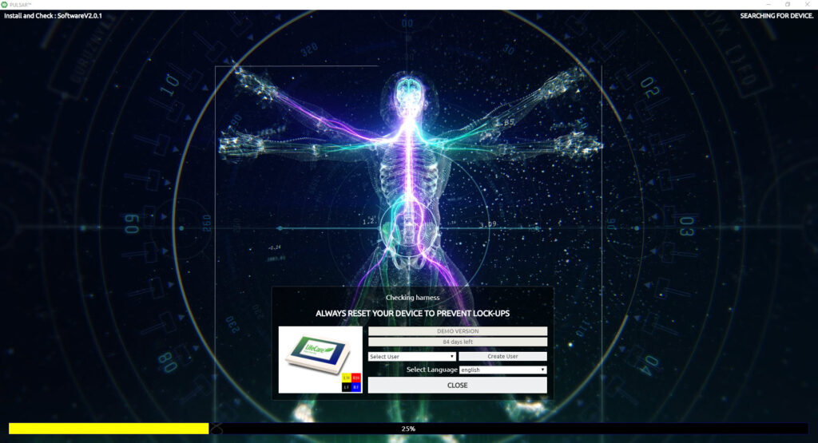
At this point, you can also choose your language preference at the bottom center of the Welcome Screen with a drop-down button.
At 25% of loading, you will see the Electro Data check appear on the screen.
If this panel does not appear then it indicates that the ED.X or NUCLEUS device is still searching.
If it continues searching, please make sure that the ED.X or NUCLEUS device is on, and that the USB cable is connected, otherwise please check Appendix B Troubleshooting for help.
Click Close on the Electro Data check panel and the program will continue to load.

The Main Menu screen now appears:
Click Password
Type 0210 into the password box
Click OK
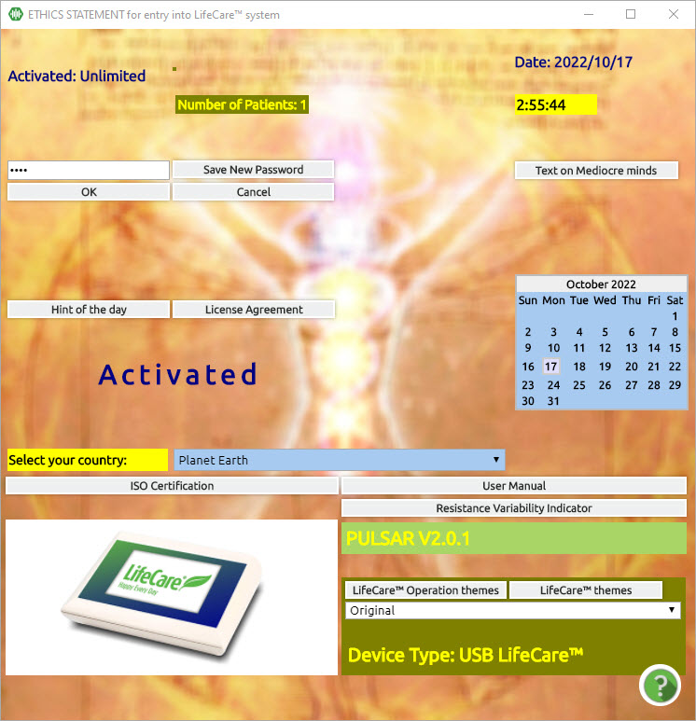

Click OK
Note: from here on in the software, you will find various text buttons that you can read for educational purposes. On this panel, you will see (as in the above picture) Text on the License Agreement, Text on Mediocre minds, the user manual, and the troubleshooting manual.

Connecting the Device to your Computer
- You have received a USB3 type A male to type B male cable in your Starter Pack.
- Insert one end of the cable into the back of the device.
- Insert the other end into the designated USB3 port on your computer.
- Note: It is a good idea that the laptop you will use for your new device is specifically for this usage so that you have better results and output. Your computer must be configured to communicate with the device.
- Download the PULSAR from https://quantum-medical.eu/index.php/downloads/ after you have connected your device to the computer, turn the device on. After that, you can run the downloaded installer. For more detailed instructions click here: https://quantum-medical.eu/wp-content/uploads/2022/04/PULSAR-Installation-and-activation-instructions-1.pdf
- If you have issues with installation or activation, please contact the technical department of Quantum Medical SRL for the configuration of your laptop and activation of your software.
- Turn your laptop on.
- When the start-up of Windows on your laptop has been completed, push the POWER button on the back of your ED.X and NUCLEUS device to ON.
- You will see graphics appear on the top panel of the device where it will also appear ED.X or NUCLEUS is on.

Demographics
Click Demographics (from the Main Menu)
While learning to navigate, it is important to practice on Test Clients (fictitious) in order to navigate freely. This enables us to explore the program without the need to complete each Training Protocol properly and without concern for imbalances.
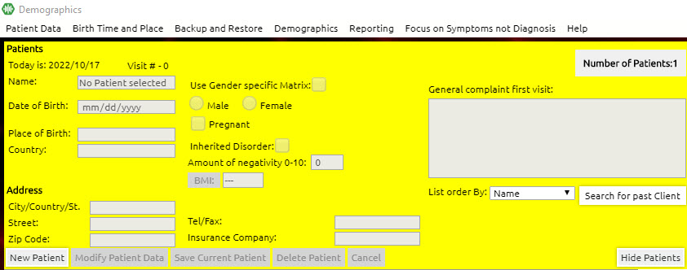
Click New Patient
Curser will go directly to the patient data so you can enter details.
Note:
For previous already entered patient
Click the name of the patient in the list (or you can search for a past client by pressing the button on the left to search for your client, whereby you can then click the name of the patient )
And the relative client shall be loaded
Click the small close button (shown above)
(please refer to Chapter 7 in this manual to load/modify previously existing clients)

Step 1: NAME

Type in the name of the Client.
If doing a Practice Session:
for Client Name, type the words Test Client 1.
(for later sessions, you may type in Test Client 2, etc.)
If doing a Client Session:
for Client Name, type the full name (first, last and middle name if desired)
Click Male or Female or Both

Step 2: Birth Information

Fill in the Birth information:
For a Practice Session (Test Client):
Date of Birth: you can put today’s date
Place of Birth: Type in any City, Province, or State
Country: Type in any country (wherever you are is fine)
There is no need to fill in the Address
For a Client Session: Enter your own (if working with yourself) or your client’s date of birth
Make sure to enter the date in the same format in which your computer is set:
Month/day/year 03/19/2008

Or-
Day/month/year 19/03/2008
Place of Birth: Type in the City, Province or State or other necessary identifiers
Country: Enter country of birth
Note:
In order to achieve the correct calibration of the individual, it is important to enter the client’s date of birth and place of birth with accuracy.
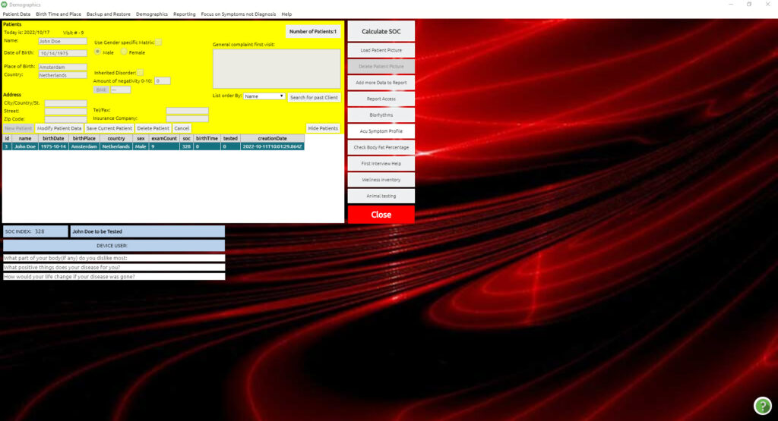
- Select Birth Time and Place in the top menu bar, and select Edit Birth Data
If the time of birth is known, please enter it in the space provided where it says Enter Birth Time in Nautical Time
Otherwise, if it is unknown, Select If unsure of Birth Time, calculate, and enter the time which will appear in the designated box under the latitude marker in the space provided for entering Birth Time in Nautical Time
- Select the drop-down button for Geography, and select the continent in which the client was born
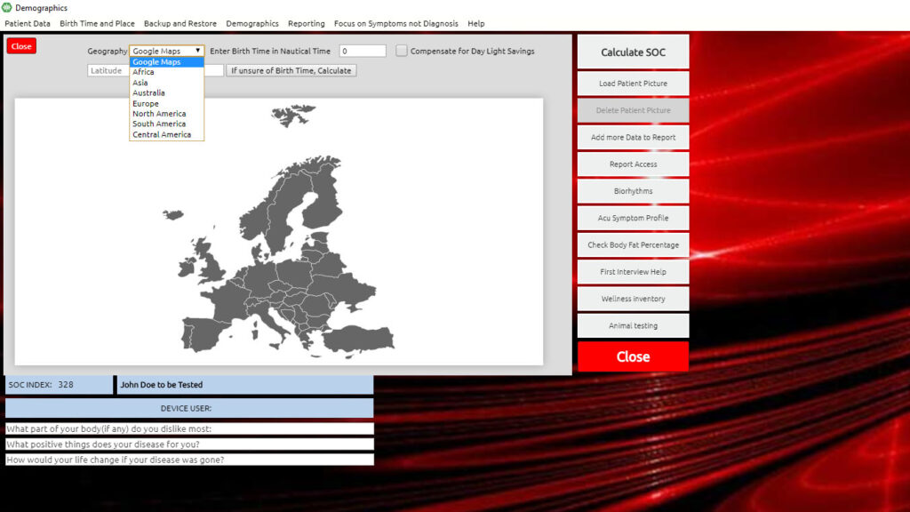

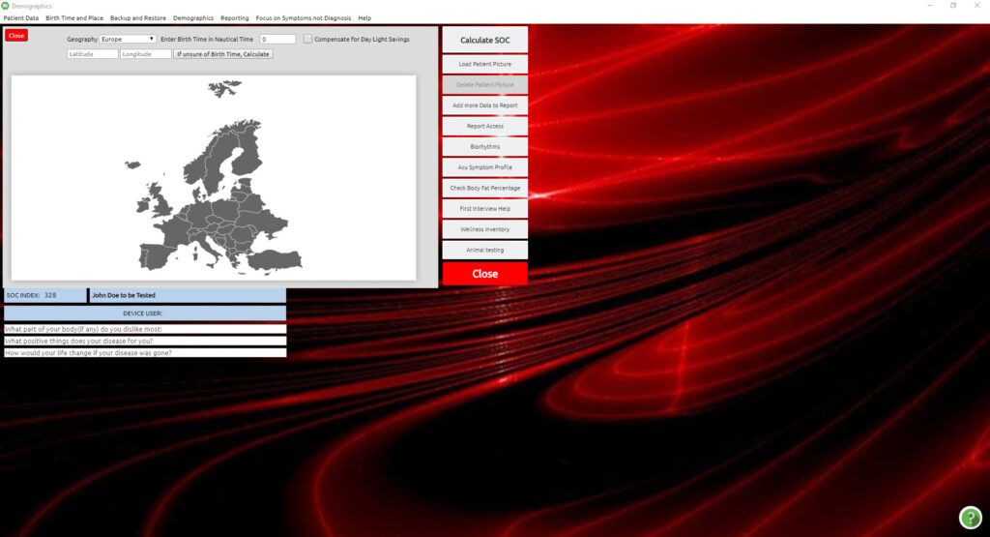
DBL Click on the area of the country in which the client was born
Click OK
The panel with the Demographics of the client details will appear. Click the small Close

Step 3: SOC INDEX QUESTIONNAIRE
The SOC questionnaire is done for educational and not medical purposes. It is used to raise client awareness and acquire an understanding of any areas of stress. When the SOC information is entered, the PULSAR program can now individuate to the specifics of the client. This ensures that the program will be more specific to the client as opposed to running generically. Certain answers may prompt other buttons to appear. Filling in the SOC will also provide an important opportunity to dialogue, educate and develop a rapport with the client. Here we are building a relationship with the client.
In further training, you will learn more about the details of filling in SOC details.
For our purposes, fill in the SOC details as the client answers you accordingly.
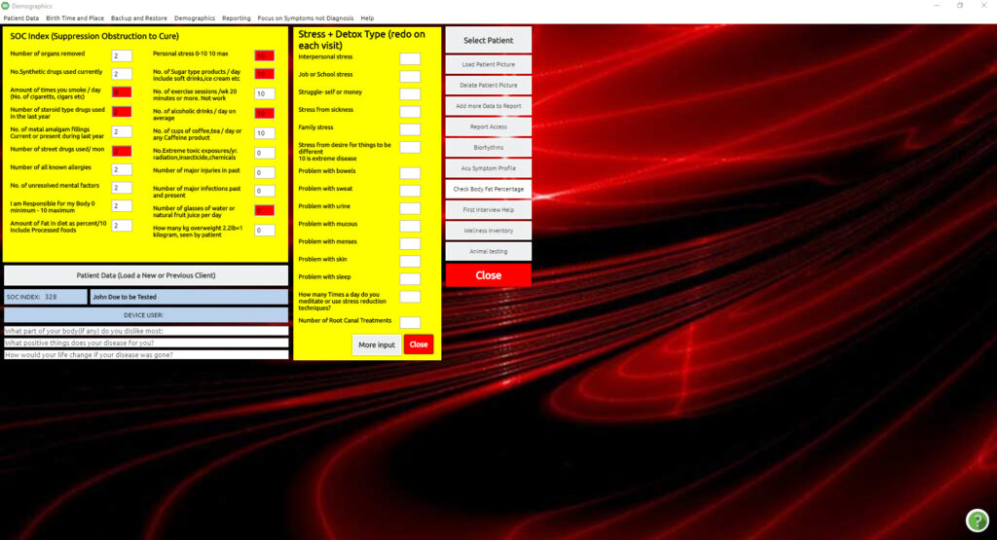
Click the big Close button
If a pop-up box displays a Biorhythm Concern for Today
Click No

Note:
See Chapter 7 to learn how to return to a client you have previously entered in your Data List or how to modify a client’s demographic information
Patient data is automatically saved when closing.

SOC questionnaire

The SOC questionnaire is done for educational and not medical purposes. It is used to raise client awareness and acquire an understanding of any areas of stress. When the SOC information is entered, the PULSAR program can now individuate to the specifics of the client. This ensures that the program will be more specific to the client as opposed to running generically. Certain answers may prompt other buttons to appear. Filling in the SOC will also provide an important opportunity to dialogue, educate and develop a rapport with the client. Here we are building a relationship with the client.
In further training, you will learn more about the details of filling in SOC details.

For our purposes, fill in the SOC details as the client answers you accordingly.
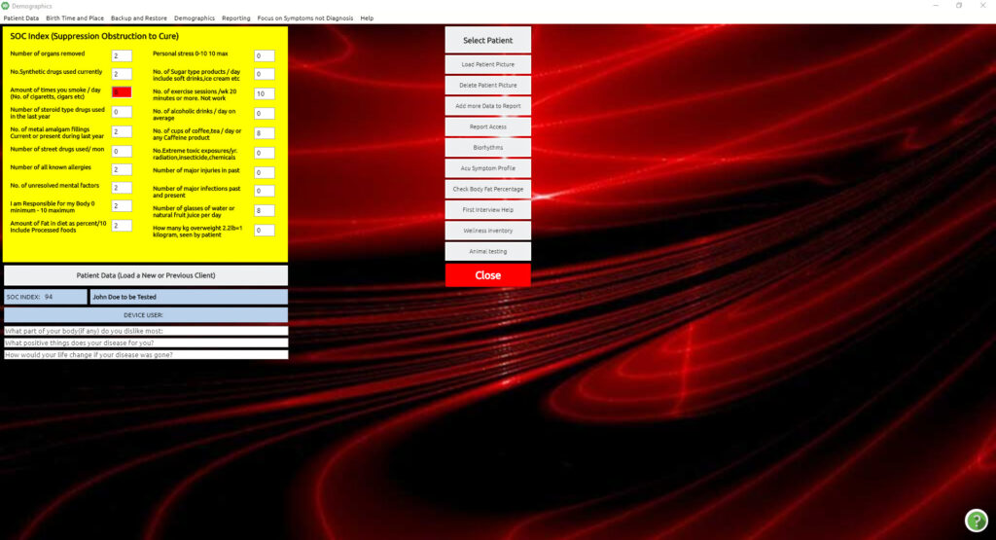
Click the big Close button
If a pop-up box displays a Biorhythm Concern for Today
Click No
Note:
See Chapter 7 to learn how to return to a client you have previously entered in your Data List or how to modify a client’s demographic information

Patient data is automatically saved when closing.
NOTE:
The importance of filling in the data entry of the SOC, is for the device to operate at its full capacity.
Entering SOC data is required by the system, as the entered values of each factor listed can affect results. High or low entries depending on the factor, which turns red, alert the system’s power settings and safety features. The fields pictured in white do not affect the system.
The system calculates and takes note of the numeric entries entered to alert the system accordingly or to compensate for the factors. For example, the number of injuries a client or patient lists may require an adjustment to the level of resistance energy the system uses in order to ensure both safety and efficiency. Another example such as the number of glasses of water, if left blank, the system will artificially lower the general resonant frequency setting for the client for reasons of safety and optimal results will be reduced.
This panel is also an opportunity for the client or patient to be educated about lifestyle factors that are the client’s responsibility to remain aware of and maintain for optimal results.
Hovering over the data entry fields reveals hints:

Number of organs removed | Don’t forget tonsils, adenoids, appendix, uterus or ovaries, and one kidney. Only the majority of teeth removed would count as an organ removed.
Number of synthetic drugs | Count all taken, even OTC which stands for “over the counter” medications. Some medications can suppress symptoms and might reduce biofeedback reactivity strength to significant items, such as pain signatures. Users who are unlicensed in medicine seeking certification with a scope of stress management, however, are prohibited from advising on medications.
Amount of times you smoke | Use daily average over the last two months
Number of steroid-type drugs | Count again if in the second category
Number of amalgam fillings | Any metal fillings in teeth
Number of street drugs | Total number of different types use double # if excessive
Number of all known allergies | List of all major confirmed allergies
Number of unresolved mental factors | Anger, greed, desire, sadness, resentment, and fear are examples
Amount of fat in the diet yields | Most diets are 40%, and 20% is ideal. Note: this is one field that uses a scale of 1-10 to represent 10%-100%. Therefore if the client in diet intake is 30%, you enter 3.
Personal Stress 0-10 | Max is the number of most tolerated, higher is possible
Number of Sugar Products per day | Men should not have over 3, women over 2
Number of cups of coffee per day | Caffeine is in chocolate and other foods too
Number of extreme toxic exposures in the past year | Count each chemotherapy and radiation treatment as well as any accidental exposures
Number of major injuries in the past year | Count all emotional, physical, or other trauma
Number of major infections | Count all major health-threatening infections
Number of glasses of water per day | Does not reveal a hint
Number of kilos overweight | Window to Patients self-view is designed for patients to answer

For more specific concerns you may click on More Input or Add More Data. Please note that the input in these panels is not saved from session to session.

Birth Information
Fill in the Birth information:

- For a Practice Session (Test Client):
- Date of Birth: you can put today’s date
- Place of Birth: Type in any City, Province, or State
- Country: Type in any country (wherever you are is fine)
- There is no need to fill in the Address
- For a Client Session: Enter your own (if working with yourself) or your client’s date of birth
- Place of Birth: Type in the City, Province or State or other necessary identifiers
- Country: Enter country of birth
Note:
In order to achieve the correct calibration of the individual, it is important to enter the client’s date of birth and place of birth with accuracy.

- Select Birth Time and Place in the top menu bar, and select Edit Birth Data
- If the time of birth is known, please enter it in the space provided where it says Enter Birth Time in Nautical Time
- Otherwise, if it is unknown, Select If unsure of Birth Time, calculate, and enter the time which will appear in the designated box under the latitude marker in the space provided for entering Birth Time in Nautical Time
- Select the drop-down button for Geography, and select the continent in which the client was born
- DBL Click on the area of the country in which the client was born
- Click OK
- The panel with the Demographics of the client details will appear. Click the small Close

Chapter 2

Testing
This process will reveal the body’s response to over 10,000 frequencies, showing potential weaknesses and strengths.
After the Calibration process mentioned above, we are ready to proceed with Testing.
Click Test (from the Main Menu)

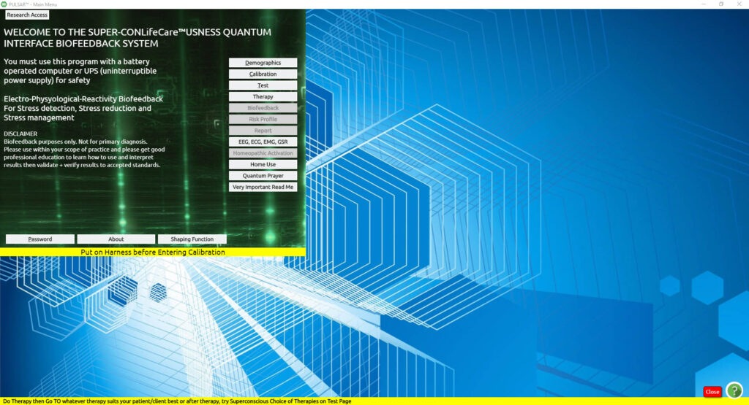
After clicking TEST, you enter the panel where you can prepare for Testing. In this panel, you will notice the VARHOPE panel in red, which are the first reactions that come up after Calibration. Please refer to the VARHOPE INTERPRETATION section for more information.
Click Prepare [top right and center of the screen (by the arrows)]
As soon as Prepare is pressed, a small electrical pulse is sent to the client to prepare them for testing. Once preparation is done, this button now gives you the prompt for TEST.
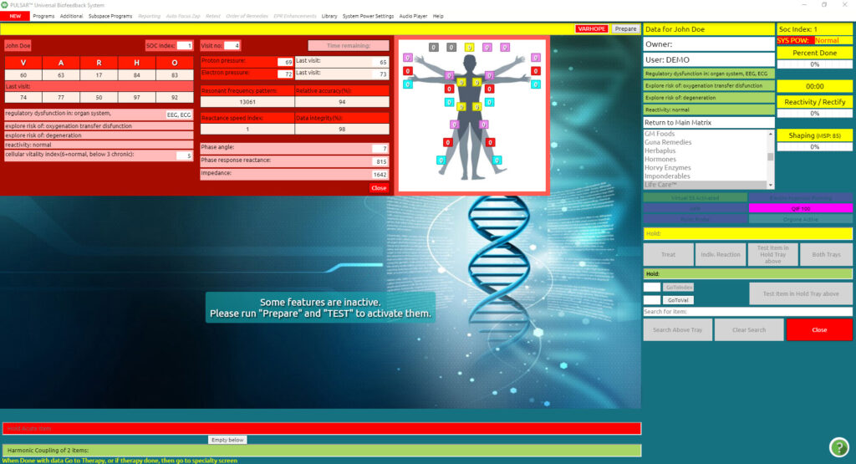
Note:
During the testing process, the client should remain relaxed, and still and refrain from speaking. It is also important to refrain from crossing arms, legs, or interlacing fingers during the entire session; this helps to keep the meridian flow open.
The word TEST now appears in red.
Click TEST
WAIT for the test to complete, it takes approximately 3 minutes. There is a yellow box in the upper right corner of the VARHOPE panel that tells you the amount of time left for the testing process.
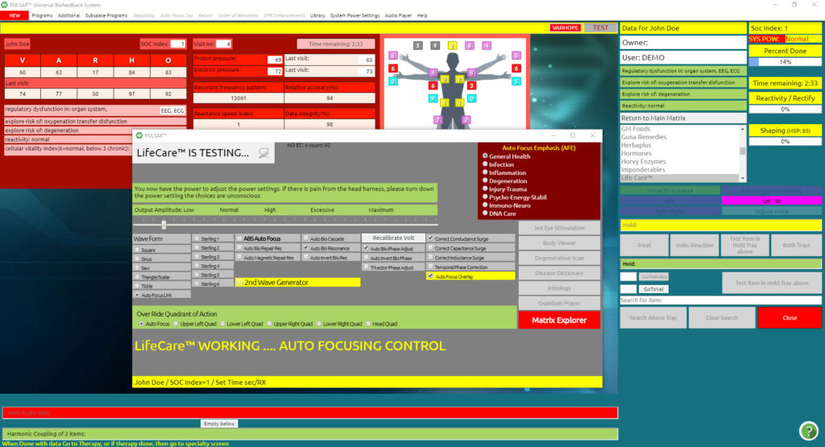
When Testing is over the screen is automatically transferred to the main matrix that shows all the results from the test, and the blue info grid (“Info Report”) and the VARHOPE panel are also automatically opened. You can close or reopen them at any time with the buttons above the Matrix called “Info Report” and “VARHOPE”.

You can place the “Info Report” with your mouse, anywhere you want on the screen. It is “draggable”. The VARHOPE Panel is not draggable, it will stay at the top of the screen.
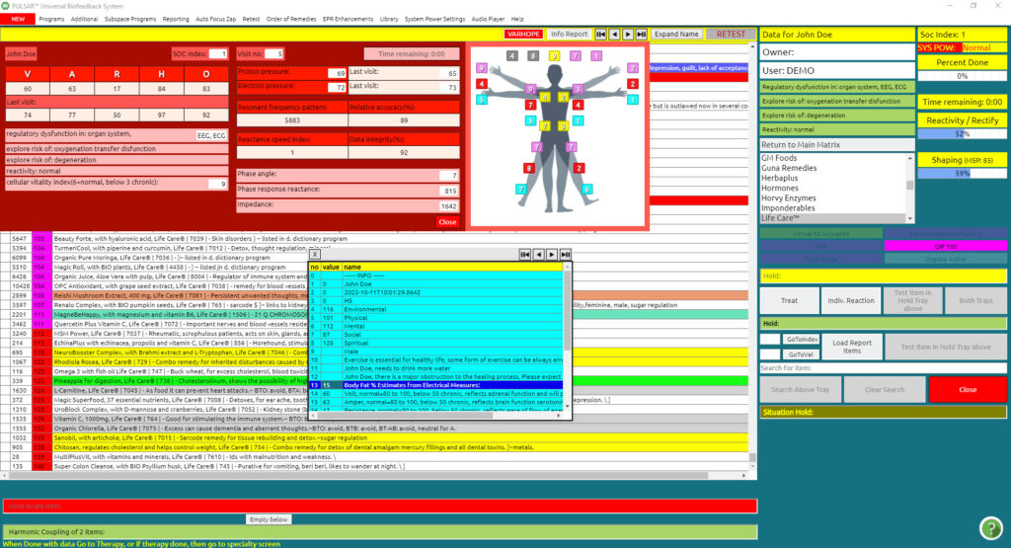

Subfiles
The subfiles are specifically filtered items from the Main Matrix. They are grouped into different categories in which all items are ranked by the degree of reactivity.
Subfiles are located on the right side of the main Matrix page.
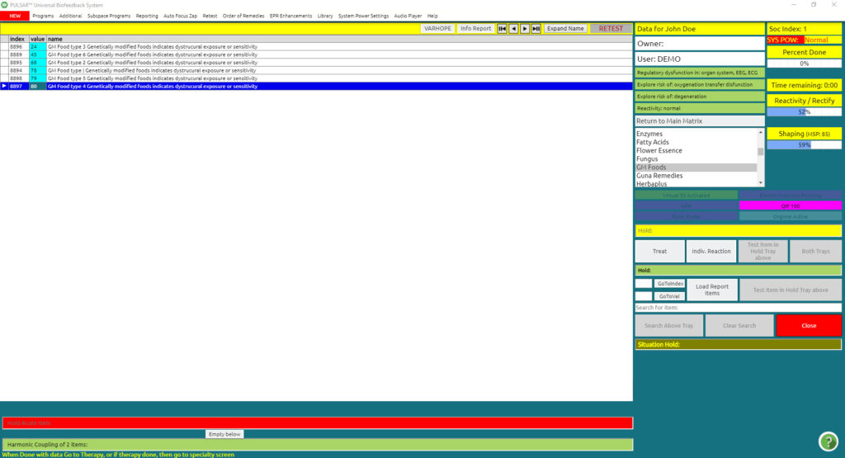
Click on any subfile to bring up all related items in that category. Check the ones that are of special interest to you, making note of the ones with the highest reactivity values, while also looking for any patterns that may be repeating.
To exit the filtered list, click Return to Main (first file under the subfiles) and you will return to the original Main Matrix results.
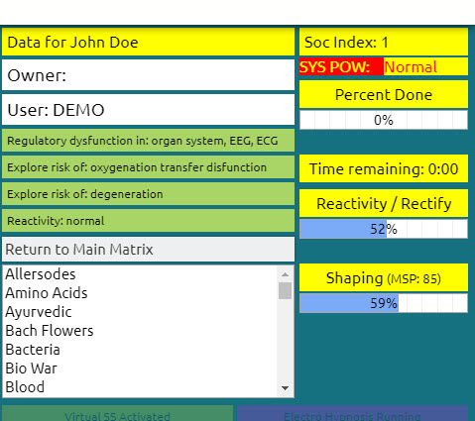

Menu bar

The Main Matrix menu bar contains various options for programs that have drop-down menus offering many choices thereafter. The main options are:
- NEW
- Program
- Additional
- Subspace Programs
- Reporting
- Auto Focus Zap
- Retest
- Order of remedies
- EPR Enhancements
- Library
- System Power Settings
- Audio Player
- Help

Auto Focus Zap
From the Main Matrix screen:
Click Auto Focus Zap (top menu bar)
Click on any function from the list
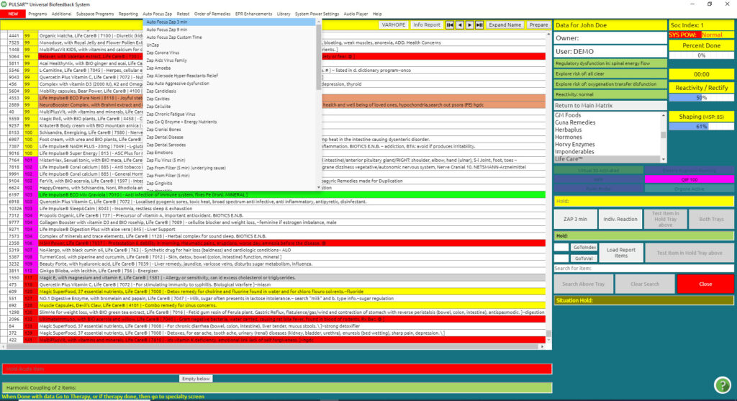
This will begin a Training Protocol for items having the top reactivity values for each particular category. Most of these functions last about 5 minutes, with the exception of Zap top Pathogens, which will engage a 12-minute training protocol.
Note:
Remember to click Return to Main (first item under the Subfiles) before initiating any Auto Focus Zap Training: to return to the original full Main Matrix results.
Tip:
After you have entered the Risk Profile (Chapter 3) and closed with the bottom close button Zap Close, and thereafter go to this drop-down menu, you will see an “x” mark in the most needed autofocus bio resonance zap training. These “X” marks give you a hint in general of also what is most needed for the client.
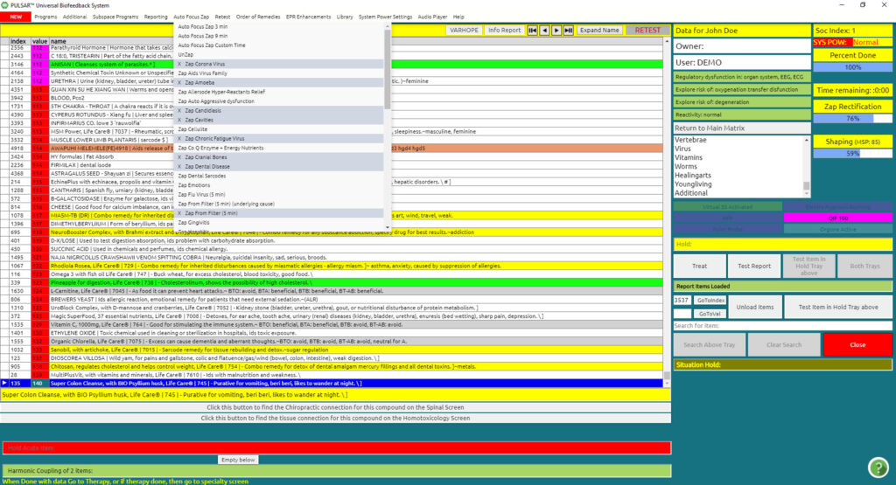

Blue info grid
Once the TEST is complete, the main matrix appears with a blue info grid box showing Environmental, Physical, Mental, Social, and Spiritual reactions.
The highest numbers indicate the general area of reactivity for that day.
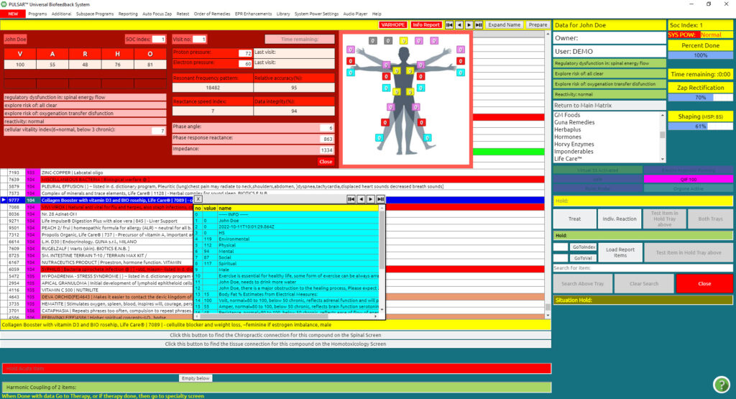
The blue info grid, lists all the details from the VARHOPE panel, as a reminder. It also lists reactions to stress in categories of Environmental, physical, mental, social, and spiritual.
The highest numbers indicate the general area of reactivity for today.
You can also retrieve this panel by simply clicking on the “Info Report” button above the Matrix, or:
Click Reporting (from the main matrix drop-down menu)
Click Show INFO
The blue info box can also be utilized as a “system tray function” for multiple Zapping, or a “Piggyback field” for entraining multiple items together.
Click Reporting (from the top bar in the Main Matrix) drop-down menu.
Click Empty INFO to start a new one.
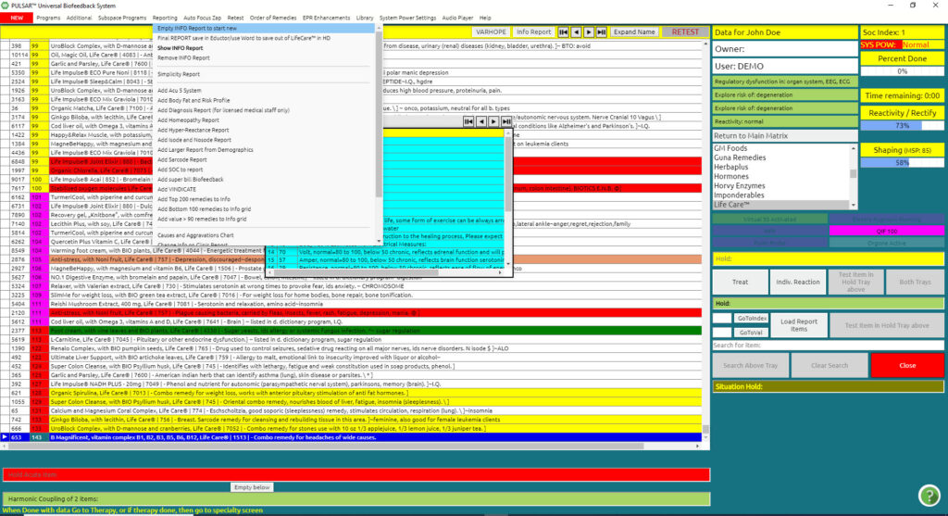

A prompt will come up:
“Are You Sure? Empty INFO Table?”
Click OK
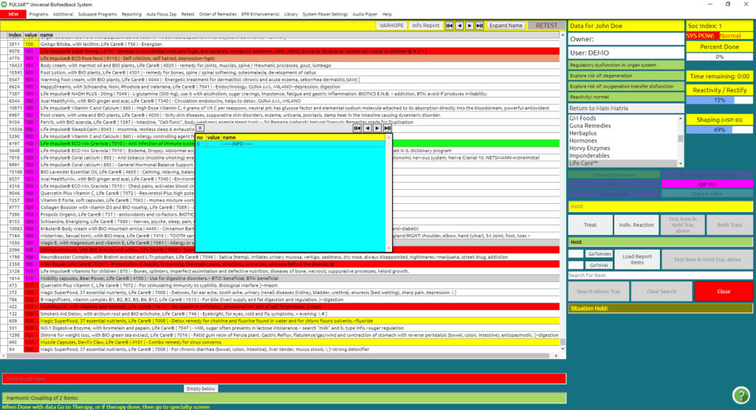
The INFO box shall empty.
You can now drag and drop anything you wish in the INFO box in order to make a cocktail therapy. If you are working as a system tray function for multiple Zapping, it is a good idea to add up to a maximum of eight items in the blue INFO box.
You can repeat this process as many times as you wish.
On the other hand, when working with the blue INFO box as a “Piggyback field” for entering multiple items together, you can add as many items as you wish.
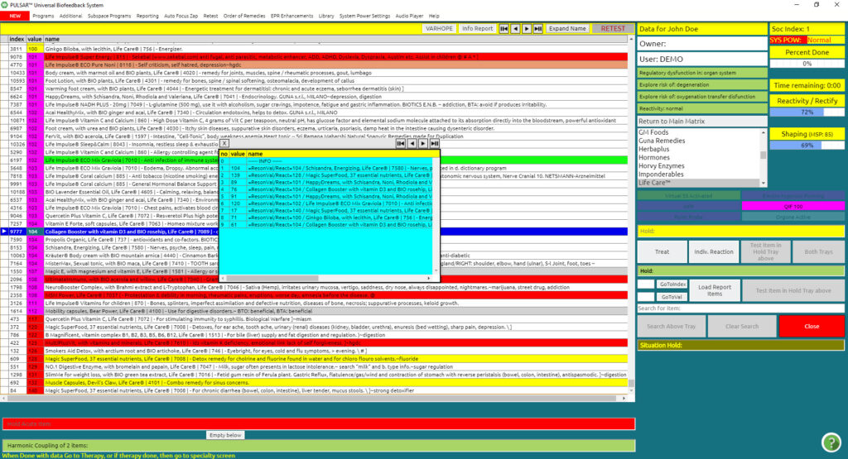

Option:
From the Reporting drop-down menu, you have the option to also load the top 200 remedies from the matrix to the INFO box, or the bottom 100 items.

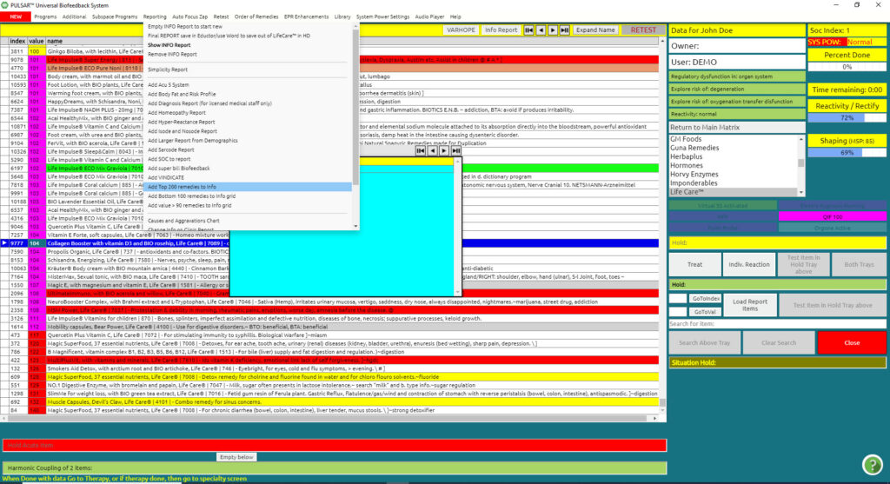

Once you click on the “load report” button, you will notice on the purple tray “Report items loaded” and now the button shows “unload items”
This means that the items in the blue INFO box are now loaded for
- Treating,
- Zapping,
- Testing (individual reaction of the group of items),
- Test item of hold tray above (that is the report items loaded in the blue info box) or piggyback training
You may click from the Auto Focus Zap drop-down menu, Auto Focus Zap 3 min, or Auto Focus Zap 9 min. This will switch the Treat button on the side to either ZAP 3 min or ZAP 9 min.
By having the report loaded, you may either Treat (which is a few seconds), ZAP 3 Min, or ZAP 9 min., or just the fact that the items are loaded, they work as piggyback training during your entire session.

Additionally, you may choose to do an Individual Reaction on these loaded items, it will give you an average profile of the group of items tested together in the INFO box, Click Test Report.
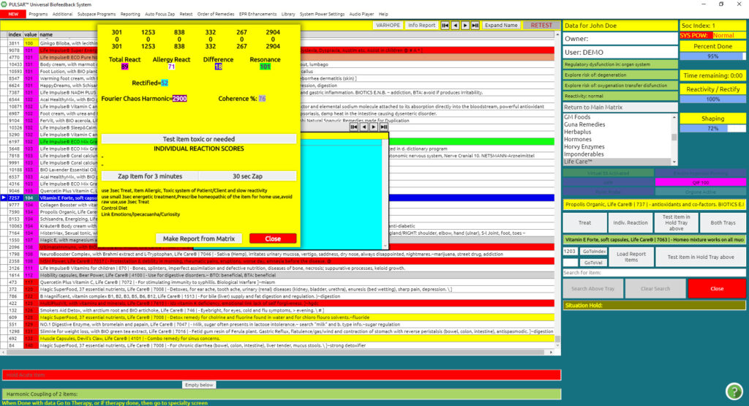

Here you can interpret Results, you have the option to do a 30-sec zap, or you can do a 3-minute zap. We have added a “Custom time” for zapping where you can set the length of the gap between 1 and 15 minutes, on the slider that appears on the right side of your screen:

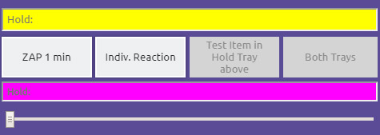

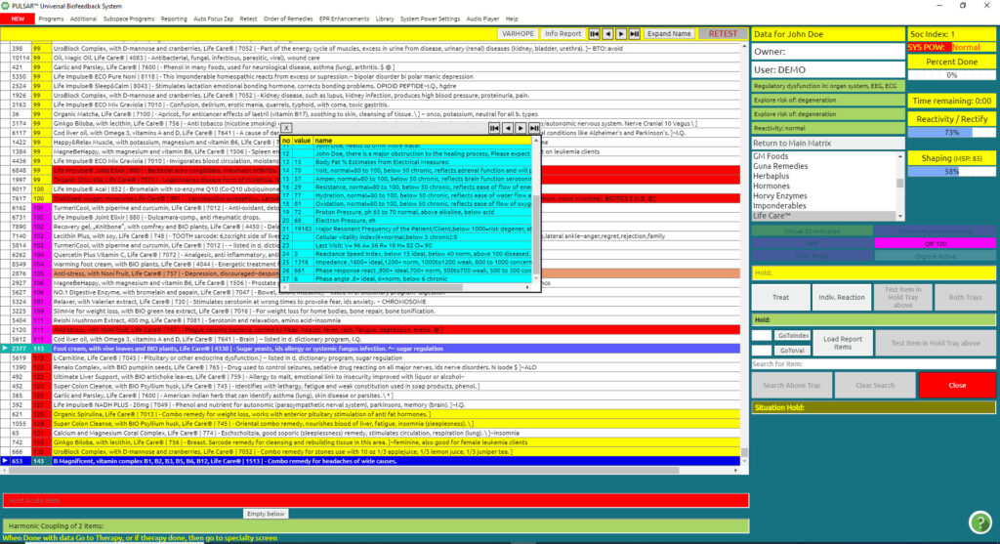

As mentioned in the purple tray, the button Test Items in Hold Tray above is also activated so as to test against filters. This will give you more background information concerning the items you are testing.

Chain Reaction Function

The Chain Reaction Function is one of the latest features that the ED.X and NUCLEUS present. It assists greatly in the therapy, making the therapy right from the start more focused on what you wish to work on, getting to the basic cause and issue of the person and the age at which the issue began, very quickly, precisely, and only within a few seconds after testing.
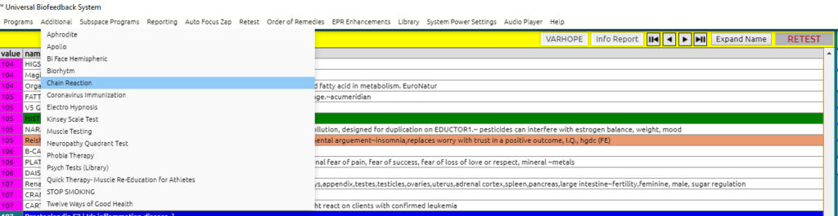

From your main program, you first want to search for the item of the main concern/issue that your client may have
Let’s say in our example it is eczema.
Put the word eczema in the search for item field

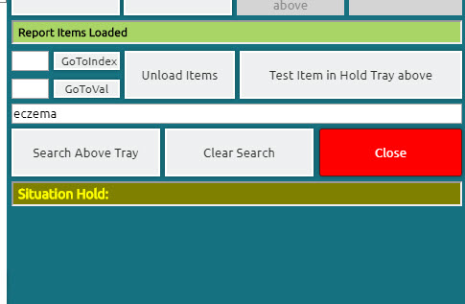
And
Search above the tray
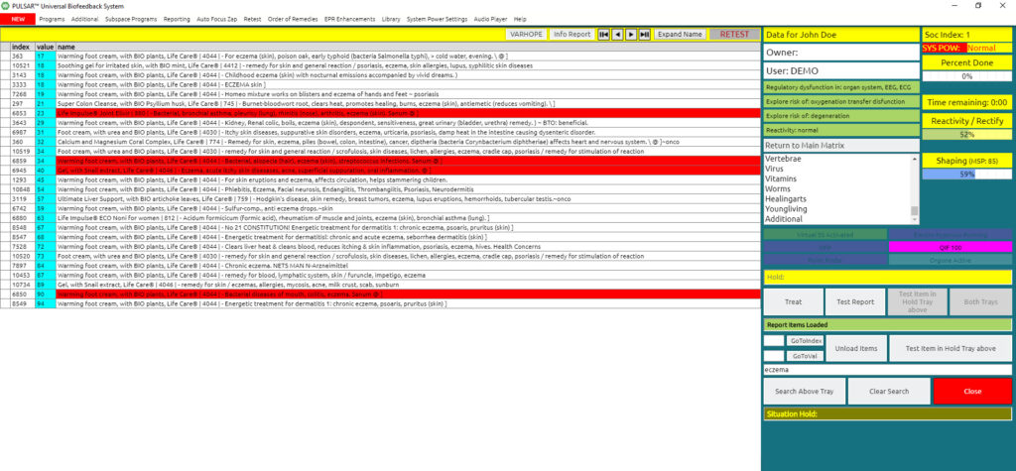
By searching the area of concern (in our example “eczema”), items reacting concerning our issue are filtered in the matrix. We notice the item that comes up with the highest reactivity value is 99 in our example. Please remember or keep this number in thought.
The next step you would want to do is
Return to Main. From the subfilters on the side

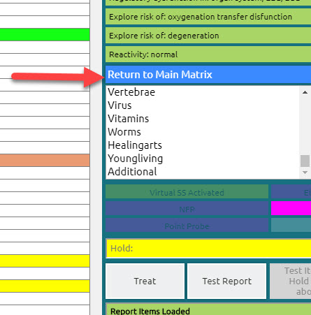

This will take you back to the main matrix panel.
The above panel appears on top of the blue info grid panel.
Put the highest reactivity of the item of concern in the third box where it mentions the Highest concern value. In our case, I will put 99 as per our above eczema example.
Automatically it will tell me that the main issue now for the area concern (eczema) began at the age of 12 and that we can find the causes of our issue within the reactivity values of 32. Which appear in the area below.
At this point, we can look at all the items with a reactivity value of 32 to see what our main issue was at that period in the person’s life. Additionally, we can discuss with the client possible difficulties that occurred at that specific age of 12 as per our example.

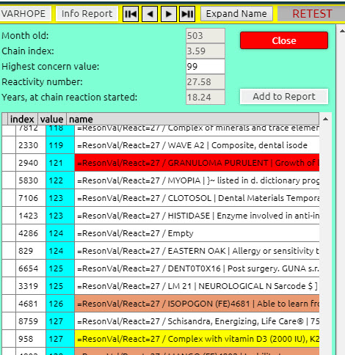
Add to report
This will add all the items with a reactivity value of 26 into the blue info grid box to work as a piggyback field therapy throughout your session.
Load report items on the middle side of your screen so that you load your items in your blue info grid box to your piggyback therapies. : Report items loaded” will appear on your purple tray on the side.

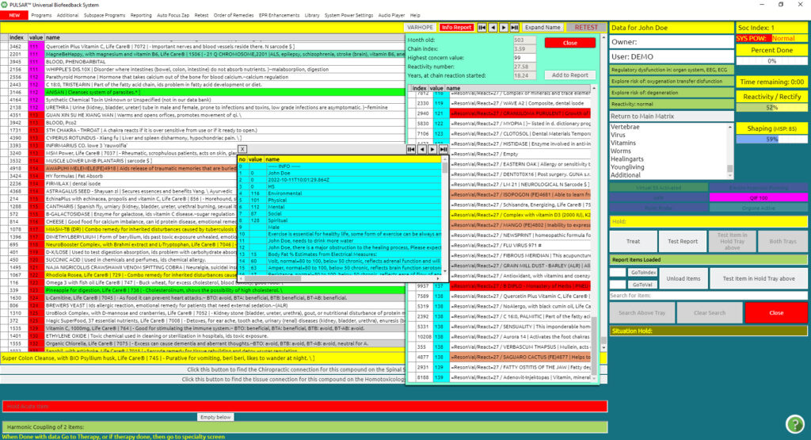

So now you are ready!
This is an excellent tool to get focused on your therapy, right from the start, on the root cause of your issues. It helps you to start your discussions with your client concerning the age of when it all got started.

Columns in the main matrix

The Index column reveals the individual index number for over 10,000 specific items. Each item is assigned a number in the main Matrix.
This number can be used to search for a specific item on the Go to No box on the right side, provided you know the Index number.
The Value column indicates the degree of reactivity to a specific item. These values are calculated during the TEST process and they change from session to session.
The Name column reveals the name of each individual item with a brief description. These items are energetic signatures programmed into the software for the purpose of training and re-educating the body.
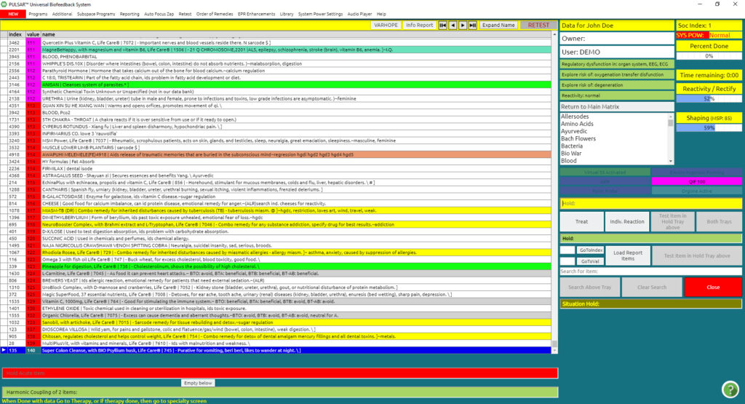

The Value column (second column in the Matrix) is color-coded for an easy interpretation of the degree of reactivity to any specific item.
These values are calculated during the TEST and they are unique for each session and client, depending on their reactivity at that specific time of testing.
The items with the highest values (reactivity) indicate the area of focus, stress, and/or interest. Depending on the nature of the item, it can also provide information about the reasons behind a reaction.
Keep in mind that apart from the electrical reaction, SOC results also influence the values and reactions to the items in the matrix.
These values can also be searched in the Go to Value box on the right side if you wish to locate a specific value. This is a new feature that can be used in the Chain Reaction program, which you can refer to in another video/chapter.
The following is a general guideline concerning the values:
250 or above reveals high reactivity.
Any number above 100 is significant, current, or acute.
50 to 100 is in the “normal” range.
Below 50 reveals low reactivity, potential exhaustion, and possible chronic or long-term stress.
The Value Column is also color-coded for easy interpretation of reactivity:
Red: These values indicate the most reactive items to which the person’s energy field showed the most significant response. (The reactivity is more than three standard deviations from the norm).
Pink: These values indicate slightly less reactive items. (The reactivity is more than two standard deviations from the norm).
Yellow: These values indicate slightly fewer reactive items than the Pink ones. (The reactivity is more than one standard deviation from the norm).
Blue: These values indicate the reactivity with little or no response. Items above 100 may have significance.
The values are reactivity responses of the body to either present, past, or future needs or stressors. Keep in mind that reactions are not fixed, and do vary.
Before going to Individual Reactions, which is a more in-depth method for electrical investigation, it is advisable to go to the Risks profile, in order to establish priorities and interpret reactions. The Risk Profile represents a correlation of all reactions into categories.
Please keep in mind that a strong reaction to a main matrix item signature named after a disease is not a diagnosis of that disease, but rather a clue to compare against the rest of the matrix reaction profile.
Repetitions of strong or high reactions of items within the Main Matrix, of the same nature, can be an indicator of the area of focus for your session.

Main Matrix

Working directly from the main matrix:
From the Main Matrix screen:
Click Item of Choice from the Main Matrix (this will highlight the item)
Click Treat (Train)
This will deliver a seven-second frequency of the selected item (the button is on the right side of the screen, below the sub-files, under the yellow Hold Tray).
To select a longer frequency Training Protocol:
Click Auto Focus Bio-Resonance Zap (from the top menu bar)
Click Auto Focus Zap 3 min
The Treat (Train) button is now transformed to Zap 3 min

– Or –
Auto Focus Zap 9 min
The Treat (Train) key is now transformed to Zap 9 min
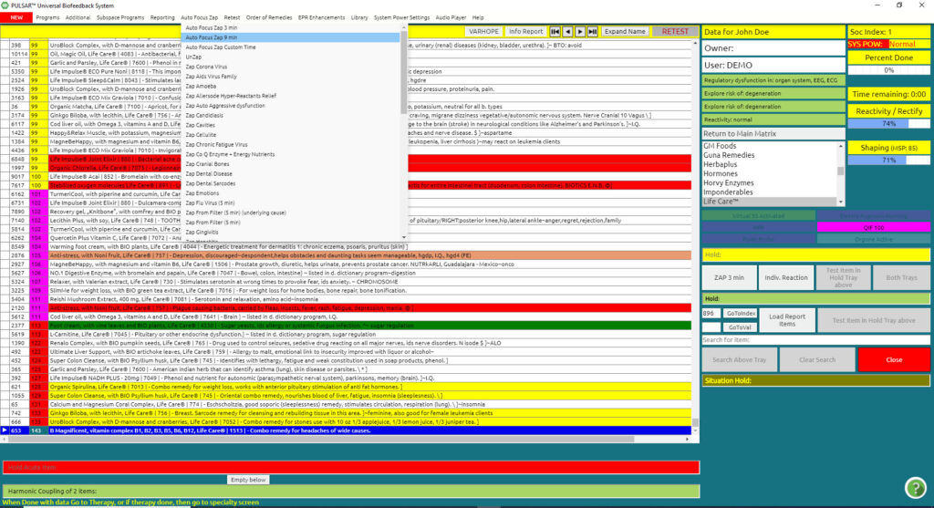
Note:
Remember to return the Zap 3 min or 9 min button to its regular Treat (Train) button, when complete with the 3 or 9 min. selection. To do this:
Click Auto Focus Bio-Resonance Zap (top menu bar)
Click Unzap

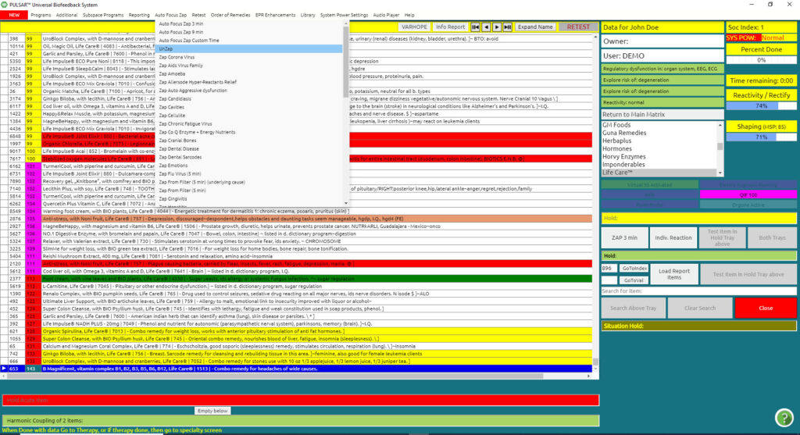

Manfly
Engaging Manfly will assist in keeping your client’s energies separate from your own while working.
Manfly can be accessed as follows:
Programs/Universal Biofeedback Therapy on the Main Menu
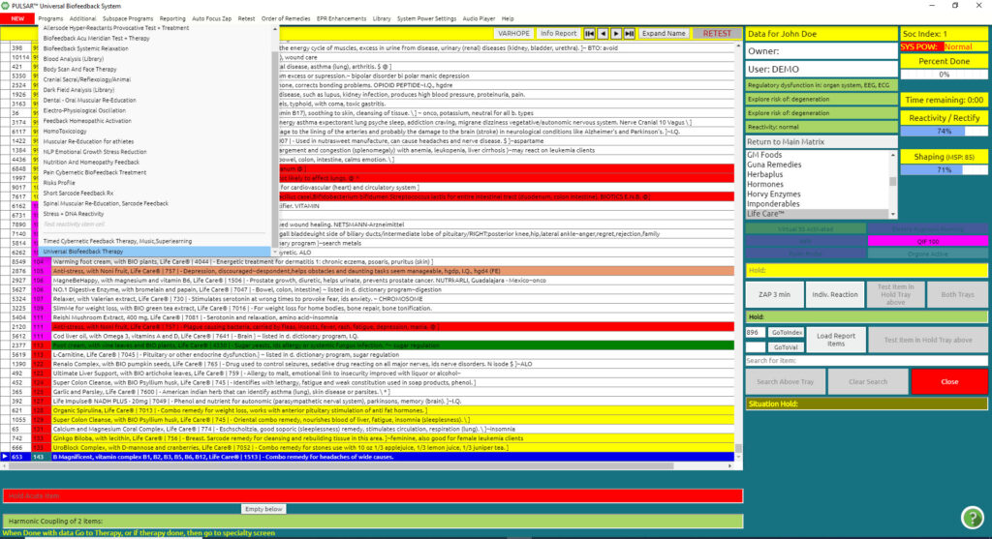
Multi-Media on the bottom Task Bar
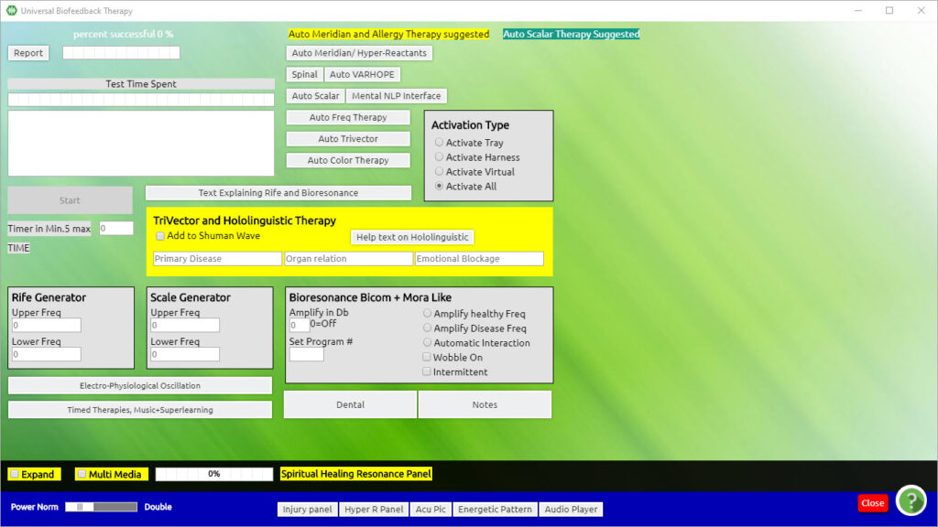

On the bottom left of the Universal Biofeedback Therapy screen, posted in the yellow bar, you will see Multi-Media. A Pop up box will appear.

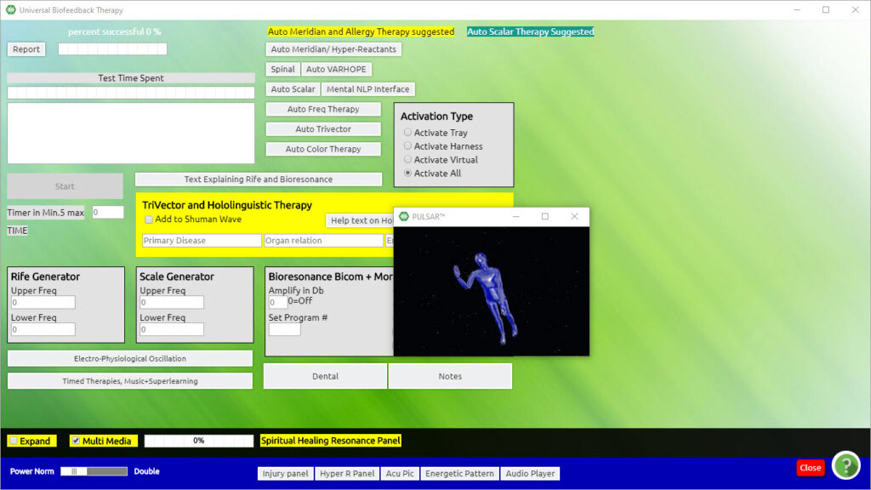

Now minimize the pop-up box by clicking anywhere on the therapy screen, so that it will run in the background.

VARHOPE Score Interpretation
The VARHOPE panel first appears by clicking TEST in the main panel, after you have gone through the process of Calibration. They are the initial reactivity numbers after the first handshake of the Calibration.
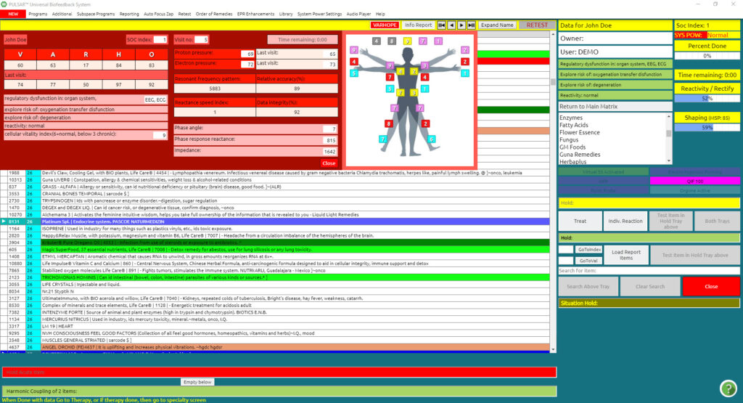
You can also access the VARHOPE screen, from the VARHOPE button
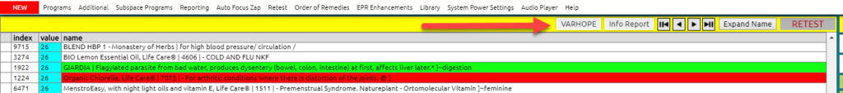
The VARHOPE values (appearing in the red access panel) are for educational purposes. They are an indication of energetic parameters. Low VARHOPE values generally indicate an energetic weakness i.e. stress. These values may also give you information about the client’s lifestyle habits.
Information such as client name, number of visits, and last visits VARHOPE values is also mentioned on this panel. There is also information on “regulatory dysfunction”, “explore the risk of” and “reactivity” fields that can give you hints and ideas on how you can plan your session.
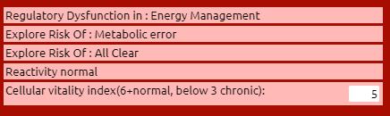
Regulatory Dysfunction is a primary electrical concern that needs to be addressed that day. Common examples that may come up include spinal energy flow, EEG, ECG, and metabolic error dysfunction.
The Explore Risk items are secondary electrical concerns of that day that also need to be addressed.
Reactivity response ideally may be either normal, hyporeactive which is slow reactivity, under the normal, or hyper-reactivity indicating over the normal reactivity. Reactivity Dysfunction may indicate both hyper and hypo reactivity.
In order to have a good understanding of the readings, it takes experience and good knowledge of each parameter and combination to look for.
Let us see however the Interpretation of the VARHOPE values as follows:
V = Voltage:
Energetically reflects stress related to adrenal function and willpower
This shows us possible chronic fatigue or fatigue in general.
The normal range is 80 – 100, Below 50 is chronic.
A = Amperage:
Energetically reflects stress related to brain function, serotonin, life force
The normal range is 80 – 100, Below 50 is chronic.
R = Resistance:
Energetically reflects overall stress related to ease of energy flow in the meridians of the body
The normal range is 80 – 100, Below 50 is chronic.
H = Hydration:
Energetically reflects stress related to the body’s water absorption on a cellular level.
Not necessarily how much water one may drink but actually what they absorb.
The normal range is 80 – 100, Below 50 is chronic.
O = Oxygenation:
Energetically reflects stress related to the ease of oxygen flow in the body reflected in cellular vitality.
This can be interpreted into oxygen level, blood issues, hyperventilation, nutritional issues
The normal range is 80 – 100, Below 50 is chronic.
P = Proton Pressure:
Energetically reflects stress related to the body’s energetic pH.
The normal range is 65 – 70.
The overall energetic pH is considered to be the most balanced when the numbers between Proton Pressure and Electron Pressure are within 10 points or less of each other.
E = Electron Pressure:
Energetically reflects stress related to the whole of the body’s electrical functioning. This may be an energetic indication of the number of available electrons.
A good range is 70 – 75.
Cellular Vitality:
Associated with the present energy, as estimated electrically for the cell. Components of cell vitality are linked to oxygenation, protein digestion or blood issues/anemia, and essential fatty acid intake.
6 and above is normal, whereas below 3 is chronic.
Resonant Frequency Pattern:
Represents the reactivity of the nervous system, tri vector signatures, and stored stress such as from unprocessed emotions, aging, sugar intake, or a spiritual issue.
Below 1.000 is associated with a risk of degeneration, and above 15.000 is possible nervous energy or psychic pain. When the Resonant Frequency Pattern is out of the normal range, it is recommended to train via the ECG and the ANS (Automatic Nervous System training programs).
Reactant Speed:
Represents the speed at which the body resounds, such as to pathogen tri vector signatures.
Below 15 is ideal, below 40 is normal, and above 100 is stressed.
Phase Angle:
Represents the ability of the body to regenerate cells as a cellular aging index.
8 plus is ideal, 6 is normal and below 3 is chronic.
Phase Response:
Represents the ability of all the systems of the body to work together.
900 plus is ideal, 700 is normal and below 300 is of concern.
Impedance:
Represents the ability of energy to flow around and through the body.
1600 is ideal, below 1200 is weak and below 800 is of concern.
At the end of each session, you can go re-test the VARHOPE improvement made during the therapy.
From the main menu go to Retest
Click on Test VARHOPE improvement

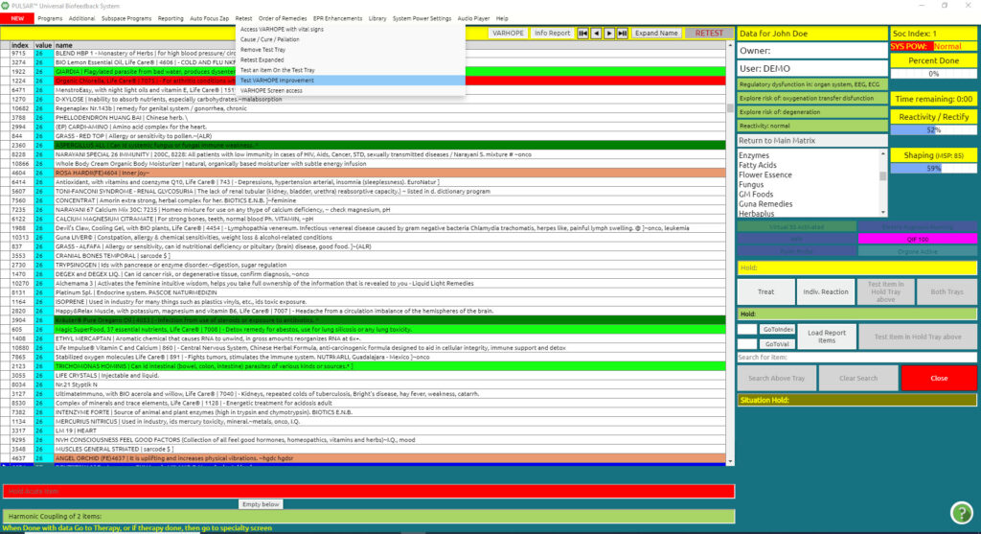
This will do a 1.5 min Retest and give you new values on your VARHOPE along with Today’s Improvement Percent.
This percentage represents how much the person has reacted and improved electrically from their session.

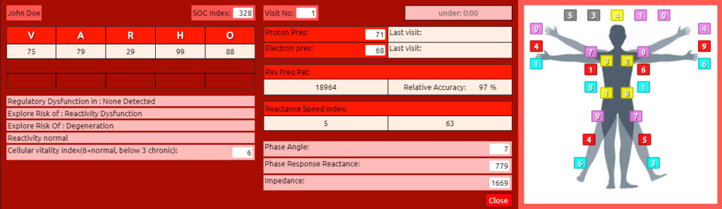
Please keep in mind that a low or even negative percentage value of improvement does not mean that the session was not good. However, it may mean that the patient may need some time, a day or two, for the body to self-adjust electrically and absorb the therapy that they received.

Alarm reaction

Please be aware that if an Alarm Reaction occurs at any time during your session, this simply indicates that a stress response needs to be addressed.
There are 5 key reasons that alarms may occur:
The relaxation and/or re-education of routes of elimination were not adequately supported, either from Short Sarcodes (Chapter 3), or Iridology and Body Viewer (Chapter 4).
Too many relaxations and muscle re-education training were performed without proper preparation.
The client’s body has had enough training in that area and is done for the day.
The client may need more support with minerals, amino acids, and other nutrients.
You have received reactions from a level the client is not ready to work with today, such as from emotional stress.
If a client alarms excessively, the session may have exceeded the tolerance level of the client, and you should proceed with caution.
Double Click on the red Alarm Reaction indicator (wherever it may show in any of the Training Programs) when complete it will either indicate Alarm, No More Therapy, or Alarm Response Corrected.
If the response is corrected, continue the training protocol you were doing.
If the response is not corrected, discontinue the training protocol you were doing and move on to another area of the program.
Or-
If this panel does not have the possibility of addressing the Alarm Reaction training protocol, you will need to rectify it by returning to the Main Matrix screen.
On the Main Matrix screen, you will find a flashing Alarm Reaction button on the upper right side of the screen.
Double Click Alarm Reaction
Click OK in the pop-up box
In the center of the red VARHOPE Panel, the message Correcting Alarm Response will appear.
After a short training time, it will change to either Alarm Response Corrected or Alarm Response Not Corrected.
If the response is corrected, continue the training protocol you were doing.
If the response is not corrected, discontinue the Training Protocol you were doing and move on to another area of the program.
Double Click the background of the red VARHOPE panel to remove
If a box suggests: Please use Patient (Client) Superconscious Panel:
Click OK
(Refer to the Table of Contents for instructions on using the Patient (Client) Superconscious Reduction Panel)

Chapter 3

Risks Profile – Mineral Panel
RISKS PROFILE – ORIENTAL HERBS, MINERALS, AMINO ACIDS, AROMA THERAPY, PERVERSE ENERGY
The following Training Protocol can be performed for any of these programs: Minerals, Oriental Herbs, Amino Acids, Perverse Energy, Aromatherapy
From the Risks Profile screen:
Click on either Oriental Herbs, Minerals, Amino Acids, Aroma Therapy, or Perverse Energy (top of the panel)

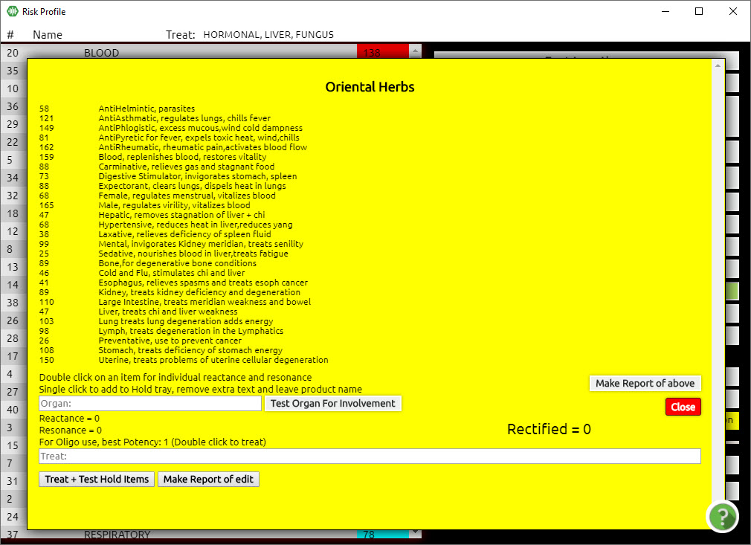

Any item with reactivity over 100 is significant and should be treated.
Double Click on each high reactivity item (one at a time) until it is rectified to 85 or above.
– Or –
Click on a high reaction item, it will be added to the bottom hold tray (up to five may be added).
Click Treat+Test Hold Items to initiate the training protocol for all the items in the tray. Rectify to 85 or above.

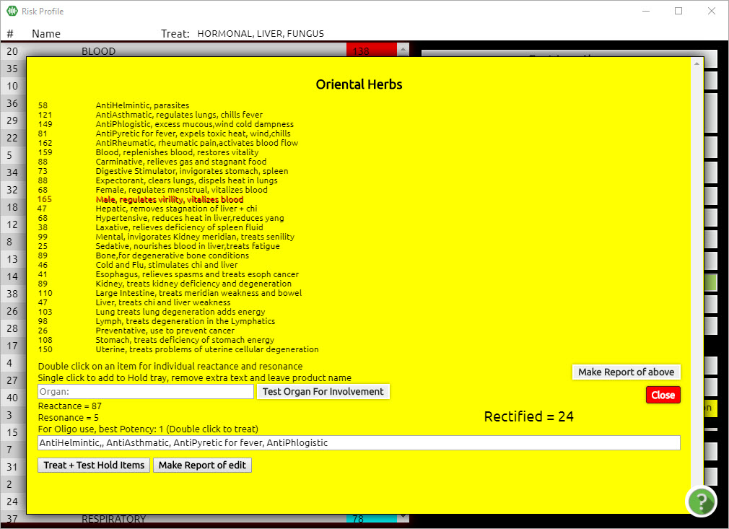

Click Close

TIP:
Minerals play an important role in the biological response to stress. Therefore, being adequately mineralized enables the client to respond not only to stress itself but in general, including Biofeedback.
Training with the mineral tri-vector signatures can often have a positive relaxation effect and is highly recommended in each session. If all or most mineral values are high, suspect:
Poor diet
Low stomach acid
Malabsorption of the small intestine, or a combination of all three.
You can test the Mineral reactivity to a specific Organ or gland sarcode tri vector signature by entering the organ name in the white box (Organ:).

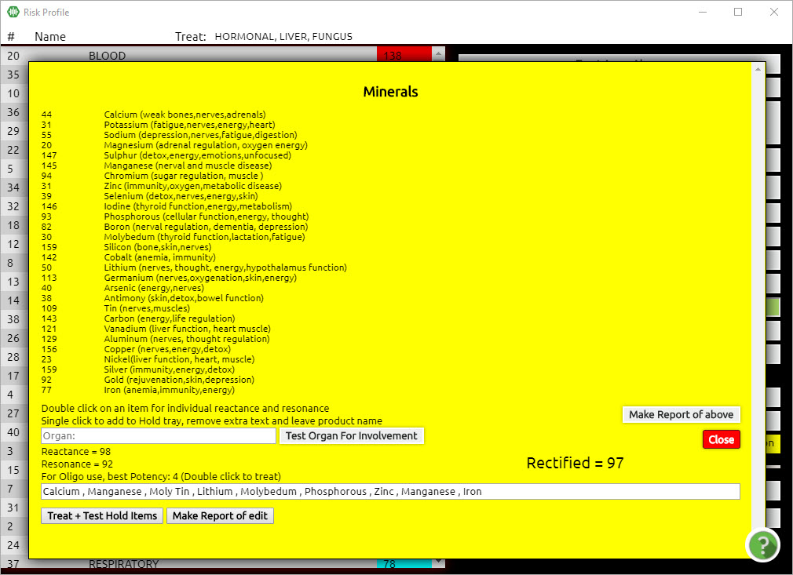

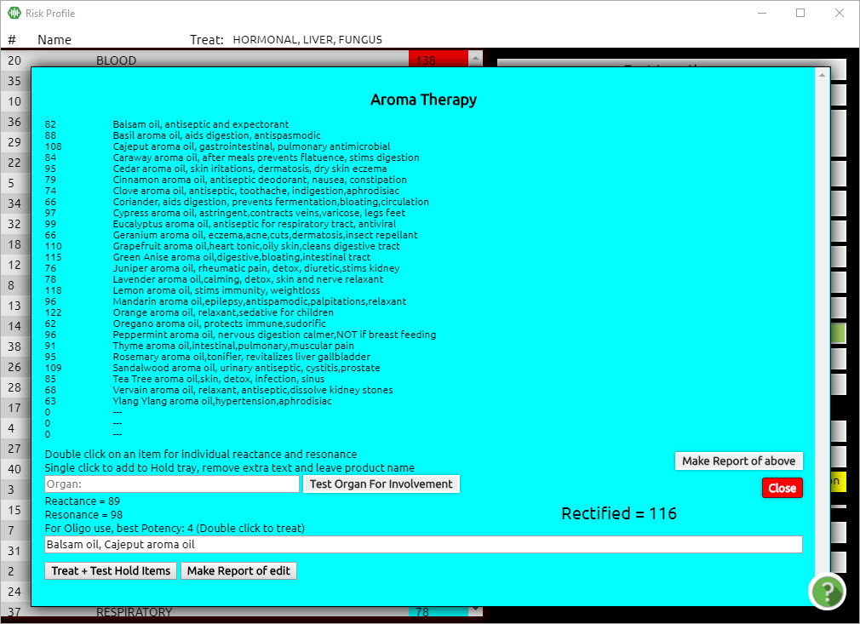

Oriental Herbs and Aroma Therapies are used for prevention. High reactivity values indicate strong reactions that would be good to consider treating.

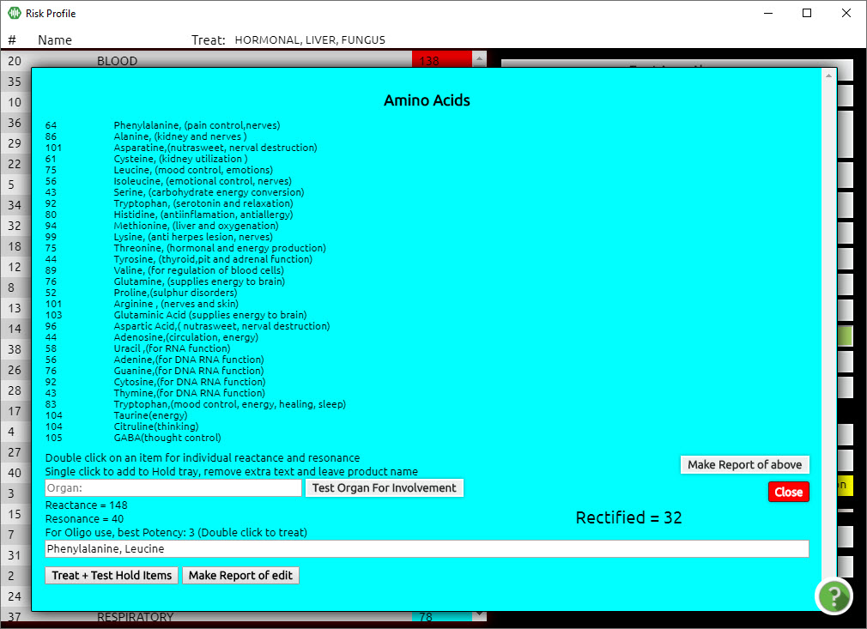

Amino Acids are compounds that play many critical roles in the body and are often referred to as the “building blocks of proteins”. They are necessary for vital processes like building proteins and synthesizing hormones and neurotransmitters.
Reactions to Amino Acids may show us reactivities and negative impacts on our nervous, reproductive, immune, and digestive systems.
Treating high reactivity numbers will assist in reducing stress in these areas.

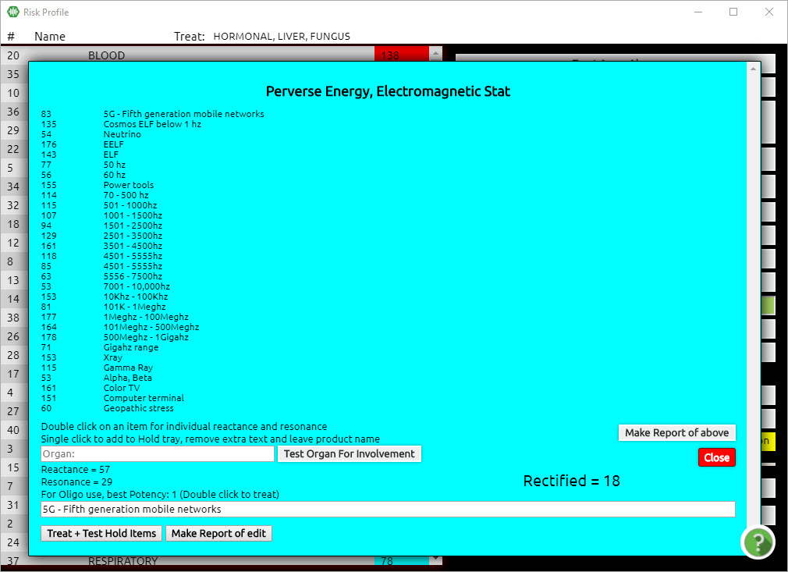

Reactivity values on Perverse Energy, and ElectroMag Stat indicates stress in these areas. Discuss with the client about possible exposures.
Due to the high rate of electromagnetic smog exposure, it is always a good idea to go through this panel to reduce your client’s stress from radiation exposure.

Risks Profile – Virtual Doctor Test
By choosing any item from this list and then clicking the Virtual Doctor Test, you can see a set of additional reactive tri-vector signatures of items in relationship to the “risk” item tested.
This panel will show you the Primary and Secondary Causes and Cure related to the stress/risk item you have chosen, as well as the Possible most stressed organ (most reactive sarcode tri-vector signature).
You will also have the option to begin training from this panel by clicking on the reactive items that are displayed.
The following Training Protocol can be repeated for any item in the Risks Profile.

Click on any high reactivity (red) item to initiate a training protocol. The item that will be tested will appear in the purple tray in the middle of the panel.

Click Virtual Doctor Test
A new screen will appear indicating the Primary and Secondary (energetic) causes and cures (remedies) related to the selected item from the Risk Profile panel, as well as the Possible most stressed organ.
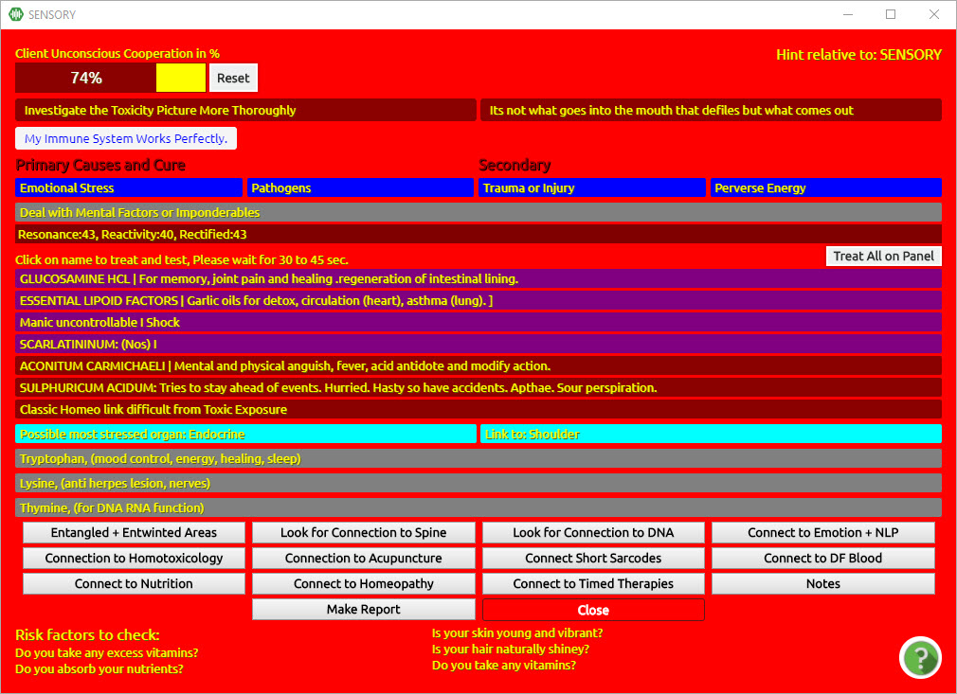

Click on any line for a 3-second training protocol; repeat until Rectified is 85 or above.
– Or –
Click Treat All on the Panel to begin a training protocol for each item on the screen.

Risks Profile

This program will reveal specific issues that are categorized for your client. Retraining can be performed here. However, before considering the individual test results, it is preferable to build a foundation or framework of the basic issues and priorities. This panel will be able to guide your investigation of the individual reactions.
From the Main Matrix screen:
Click Program (top menu bar)
Click Risks Profile (drop-down list)
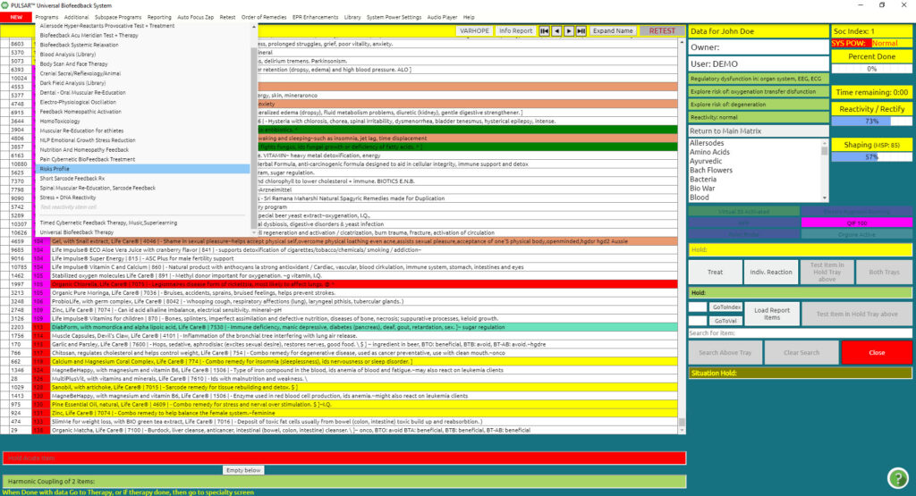
Double Click the item with the highest reactance in the left column and it will be added to the top hold tray.
Do the same for the next 4 highest reactants (thus adding a maximum of 5 categories to the tray).

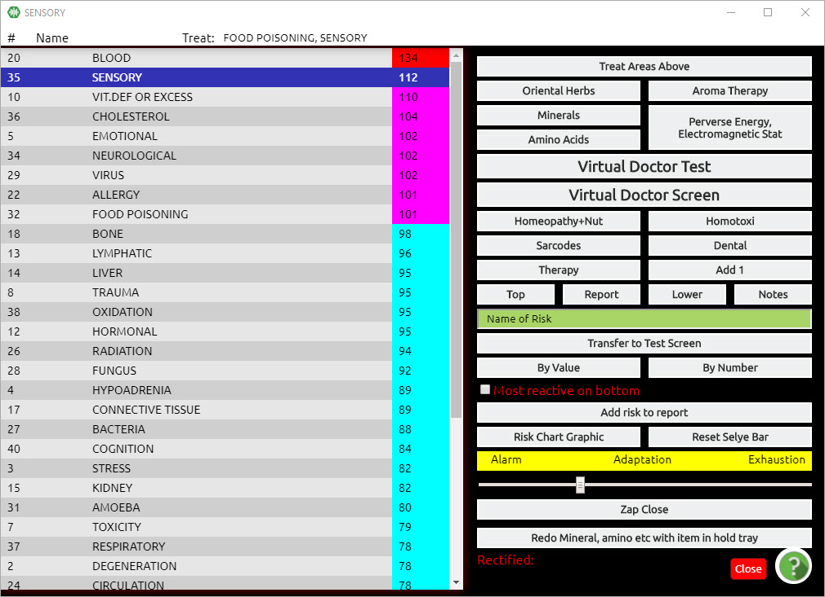

Click Treat Areas Above to initiate a Training Protocol for these specific Risk factors.
Pay particular attention to where your client is responding on the Selye Bar, as this will determine how they are reacting to their stressors.
Ideally, the client would be in the “Alarm” phase, meaning that they are responding to stress with strong reactivity.
The “Adaption” phase suggests that the client may be getting used to the stress and is not responding with strength today, or possibly symptoms are not appearing.
The “Exhaustion” phase can suggest fatigue, or that the client may be depleted and no longer able to respond to stress.
Adaption and Exhaustion phases are the basis of a chronic stress pattern. These phases can be free of medically diagnosable symptoms, as the body has no energy left to respond. A good example is a chronic fatigue.

Short Sarcode Feedback Rx

The Short Sarcode Feedback Rx program is a very useful application giving you many options, depending on what you want to work on.
Note: One of the main reasons why you may want to go into this program first, before doing anything else, is to load into your report basic findings from the testing, which can guide you during your work, while also being piggybacked through the entire session.
From the Main Matrix screen:
Click Program (top menu bar)
Click Short Sarcode Feedback Rx (drop-down list)

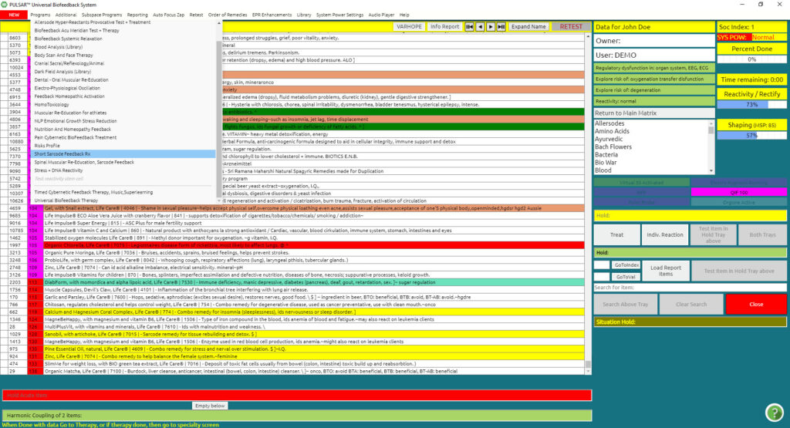

The following panel shall appear:

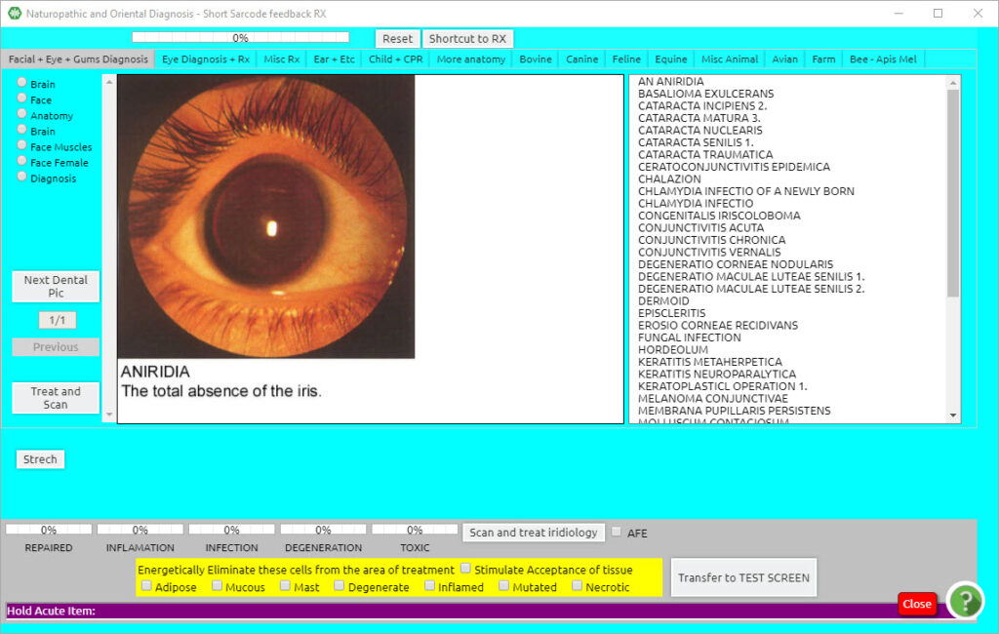

Click Shortcut to Rx (upper middle button)
Click Load (in the middle of the panel) and take note of all the items.
Click Close (in the middle of the panel)
By loading this information into your report, you have Piggybacked the information, so that it can be addressed throughout your entire session every time the Pulsar working panel is shown.
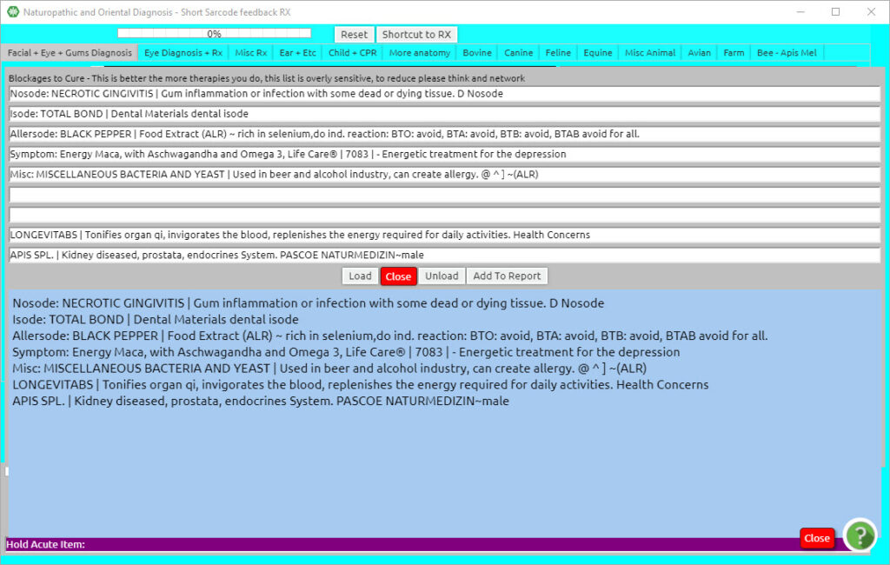
You will also notice a number of tabs on the top part of the Short Sarcode main panel:
- Facial + Eye + Gums Diagnosis
- Eye Diagnosis + Rx
- Misc Rx
- Ear + Etc
- Child + CPR
- More Anatomy
- Bovine
- Canine
- Feline
- Equine
- Misc. Animal
- Avian
- Farm
- Bee – Apis Mel

From the middle part to the right, the tabs refer to animals. This is where you can work animal specific.
Let us go into each tab so you see how you can work and apply them to your session.
Note:
Depending on the size of the display of your laptop, you may need to scroll down to see that, at the bottom of each tab, you have an indication for Repaired, Inflammation, Infection, Degeneration, and Toxic in a percentage bar.
When you do a treatment, your objective is to reach at least 85% on the Repaired bar, while the other bars (Inflammation, Infection, Degeneration, and Toxic) should be at least 10% lower than the Repaired percentage. For some clients, especially first-time clients, it may take some time to achieve this.

You also have the option to add the following add-ons to the therapy:

- Adipose
- Mucous
- Mast
- Degeneration
- Inflamed
- Infected
- Mutated
- Necrotic
- Click Ear + Etc (top menu bar).

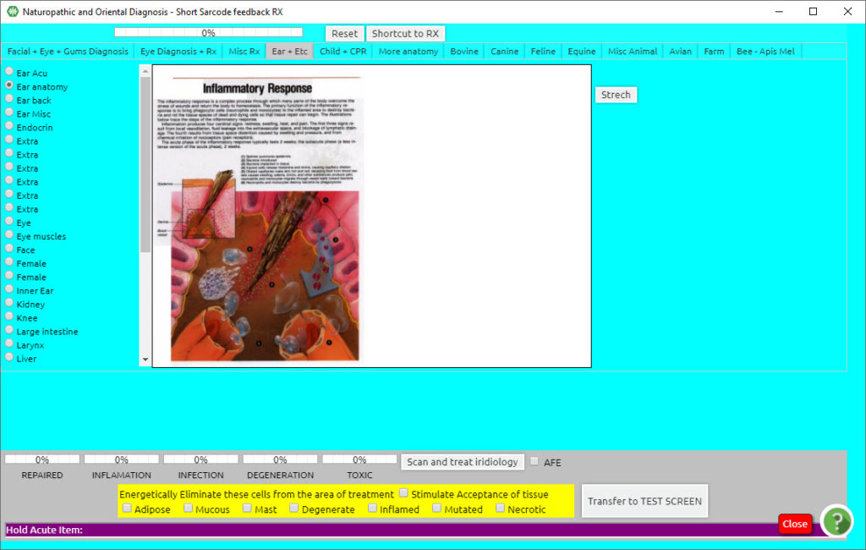

The initial default panel will show an Inflammatory Response. It is always a good idea, when entering this panel, to lower the inflammatory response of your client.
If you select one of the items on the left, you won’t be able to return to the Inflammatory Response, which is set as default when entering this panel.
DC/ the grey background of the Inflammatory Response screen to initiate a training protocol for any stress associated with inflammation. Once initiated, the screen will be scanned, showing that it has been activated. The value indicators at the bottom of the panel provide information based on reactivity.
Once you rectify the Inflammatory Response, you can choose any of the items from the left and proceed with therapies.
For all the training programs in Short Sarcode Feedback Rx, a good rectification value for the Repaired category is 85% or more, or the Repaired category must be at least 10% higher than the other categories (Inflammation, Infection, Degeneration, and Toxic).
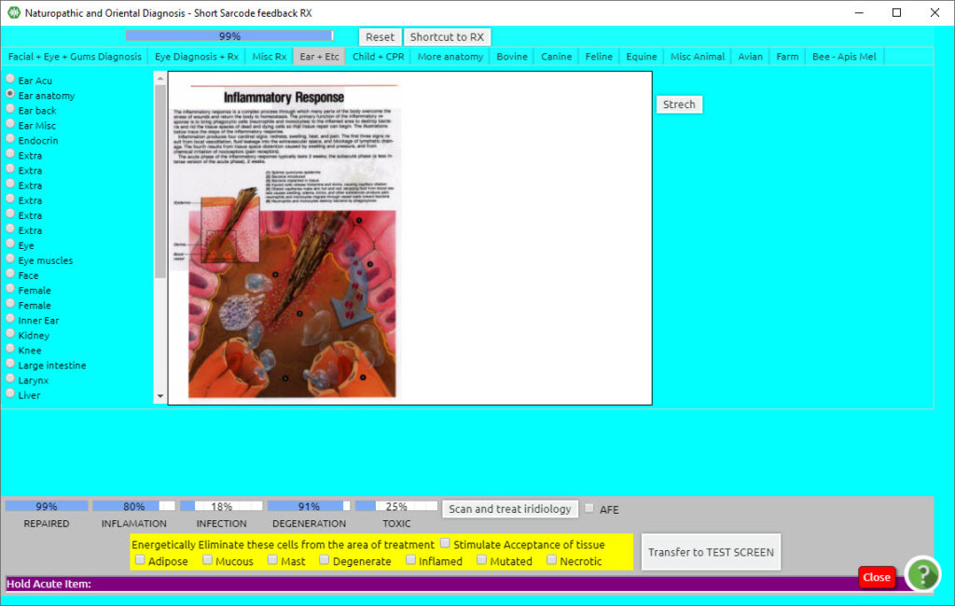
Click the Lymph button on the left side of the panel.
Double Click on the white background of the screen to initiate a training protocol for all parts of the lymphatic system shown on the panel. The value indicators at the bottom of the panel provide information based on reactivity.
Click Lungs on the left side of the panel with the small radio button.
Double Click on the white background of the screen to initiate a Training Protocol for all parts of the lung shown on the panel. The value indicators at the bottom of the panel provide information based on reactivity.
You can continue working in this way to balance stress associated with all the major organs of elimination. Consider: Lymph, Lungs Kidney, Small Intestine (including Liver), Male or Female Organs, and Endocrine as these will cover the major organs of elimination.
Note:
All screens within the Short Sarcode Feedback Rx panel work in the following way.
Each Training Protocol is engaged by simply double-clicking anywhere on the white background of the chosen panel. This provides a training balance for all of the areas shown in the panel.
Clicking on the label (or directly on a specific part of the image) initiates additional specialized training for that area.
This is the first tab. It mainly concerns issues of the eyes and dental, with a few other options as well.
The pictures showed depending on what is selected on the list on the right. By default, it is on the first selection of Aniridia.
If you have an eye diagnosis, you may select the issue directly (i.e. cataract).
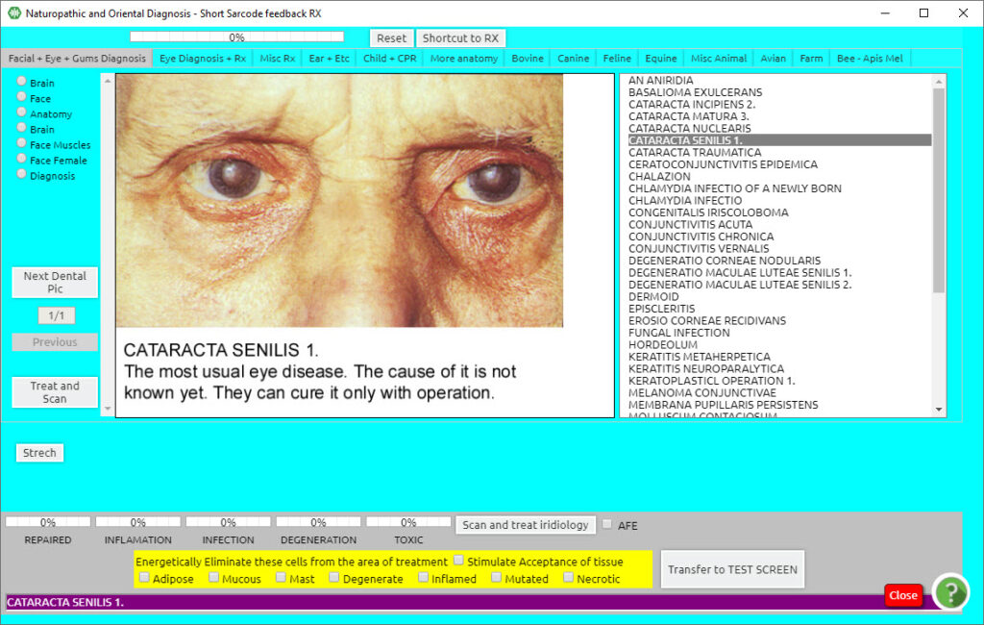

Double Click in the white area to treat, or Click on the button on the mid-left side “Scan and treat”.

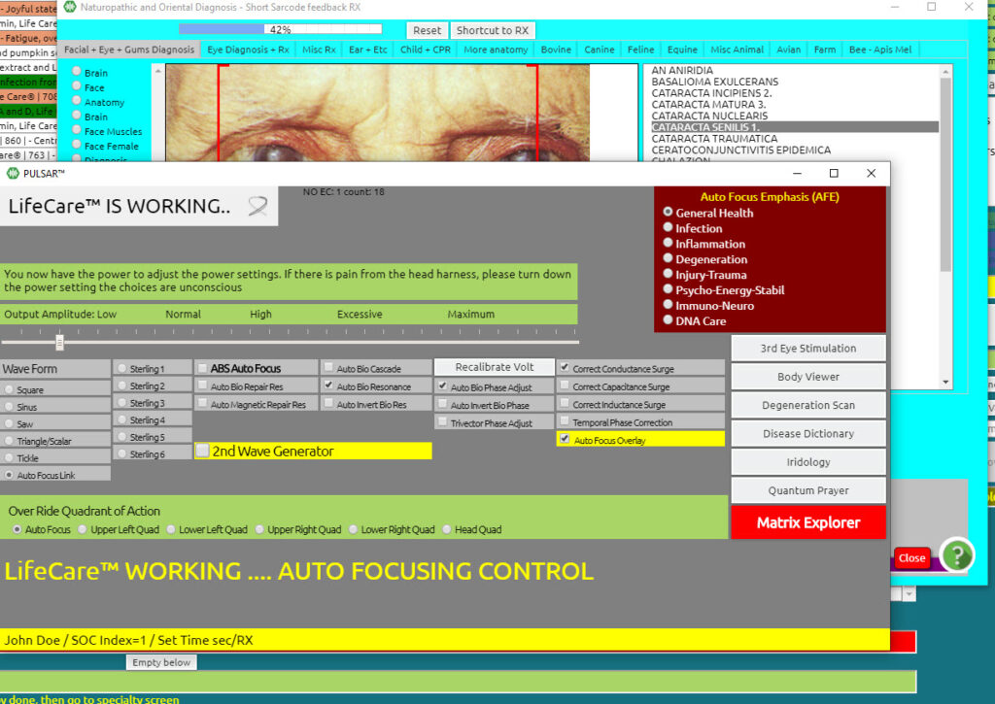
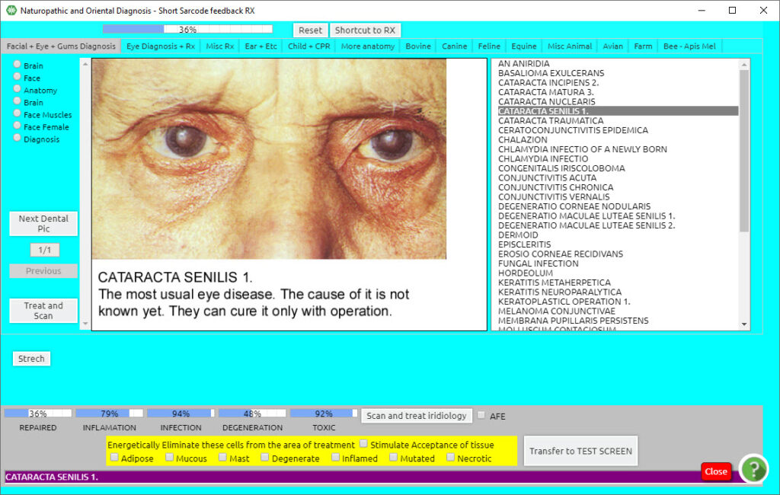

After you Treat and Scan, at the bottom of the page you will obtain information concerning the percentage of repaired, inflammation, infection, degeneration, and toxic.
Your objective is always to have at least 85% on the repaired bar, while at the same time all other bars (inflammation, infection, degeneration, and toxic) should be at least 10% lower than the repaired percentage. Repeat as many times as you reach your objective, or depending on the available time.
Furthermore, on this tab, you can also work on gum and Dental issues. By selecting “Next Dental Pic” on the mid-left part of this panel, you will notice pictures of gum/dental issues.

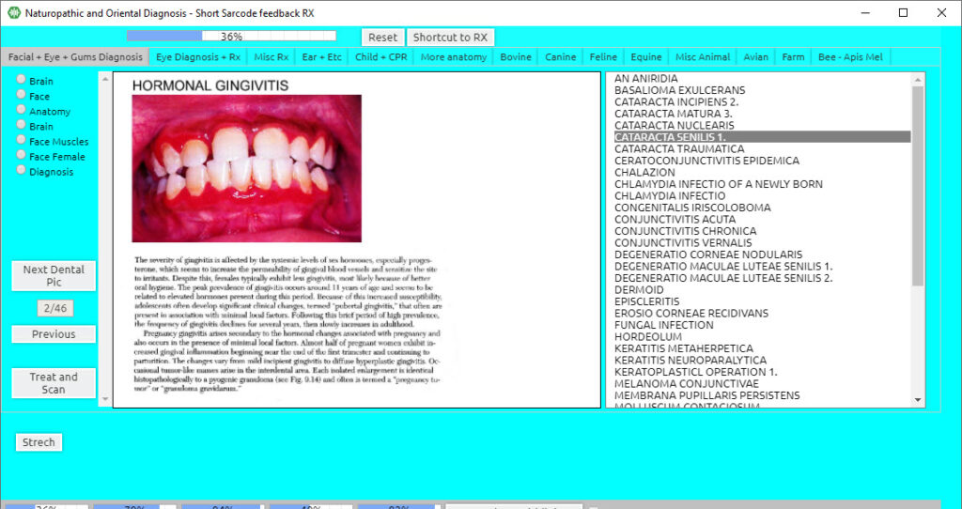

There are 46 pictures, you can go to next or previous till you reach the item you wish to work on.
Other items to work on this panel, on the top left you may select:

- Brain
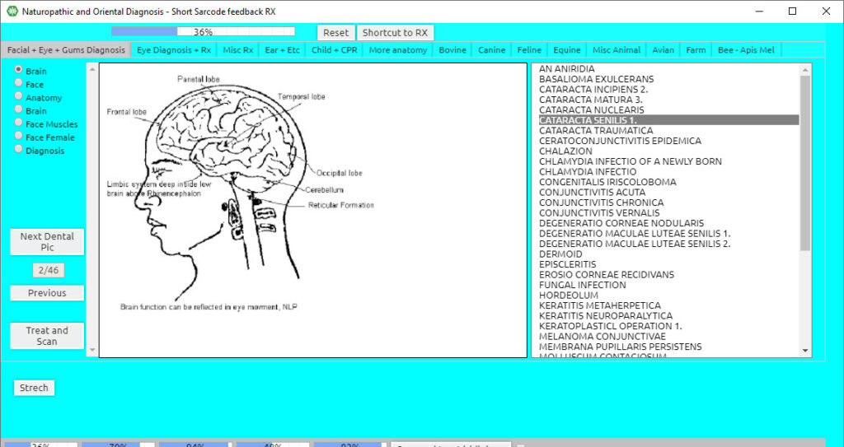

You can either work on a specific part of the brain by double-clicking on the name of the part of the brain, or you may double-click on the white area to work on the entire brain.
Again, please notice the rectification values on the bottom and repeat as needed.

- Face
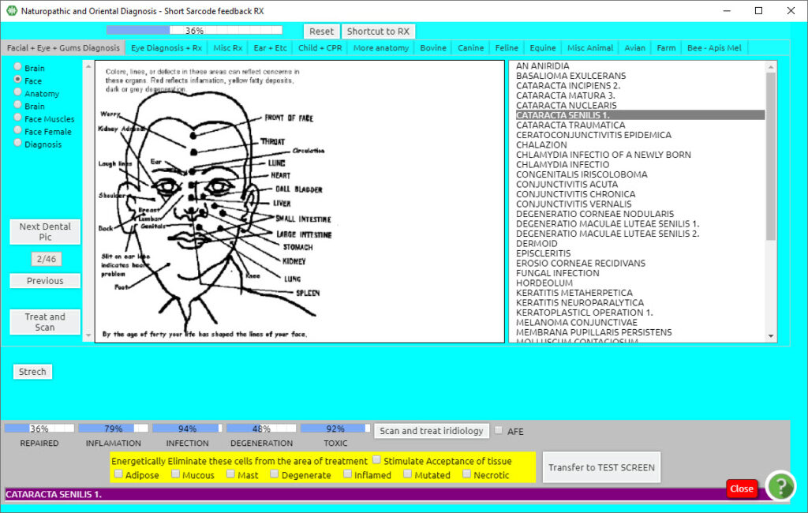

Here you can work on the areas of concern through the face. Our faces show much information through lines, aging, spits, and discolorations, issues of health concern. You can work on specific areas by clicking on the word, or you may double-click in the white area, whereby you can work on the face and health in general.
Again, please notice the rectification values on the bottom and repeat as needed.

- Anatomy
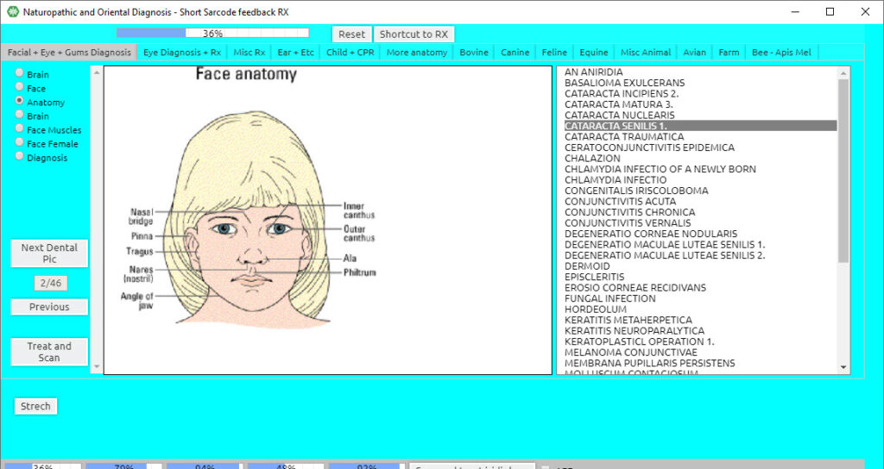

Here you can work on the areas concerning the anatomy of the face. You can work on specific areas by clicking on the word, or you may double-click in the white area, whereby you can work on the facial anatomy in general.
Again, please notice the rectification values on the bottom and repeat as needed.

- Brain
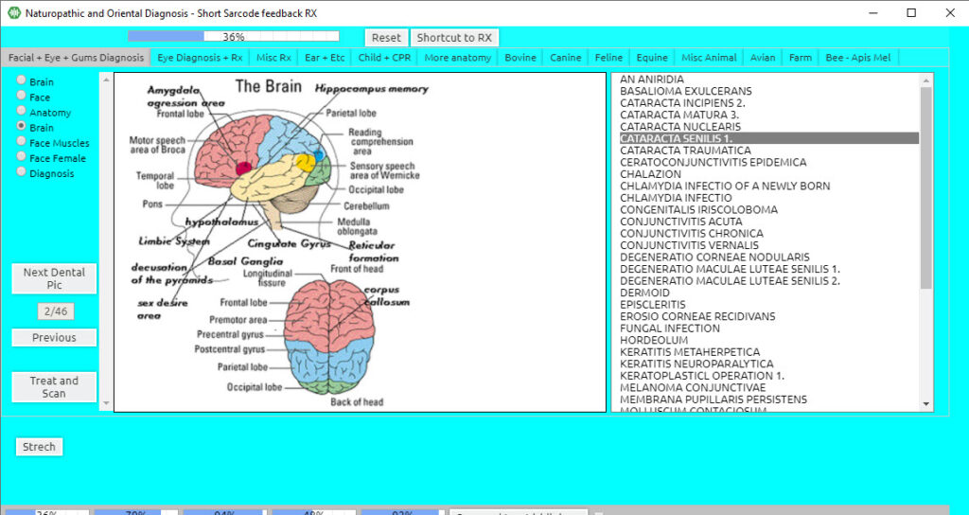

Here is yet another option to work more specifically on the areas concerning the brain. You can work on specific areas by clicking on the word, or you may double-click in the white area, whereby you can work on the brain in general.

Again, please notice the rectification values on the bottom and repeat as needed.

- Face Muscles
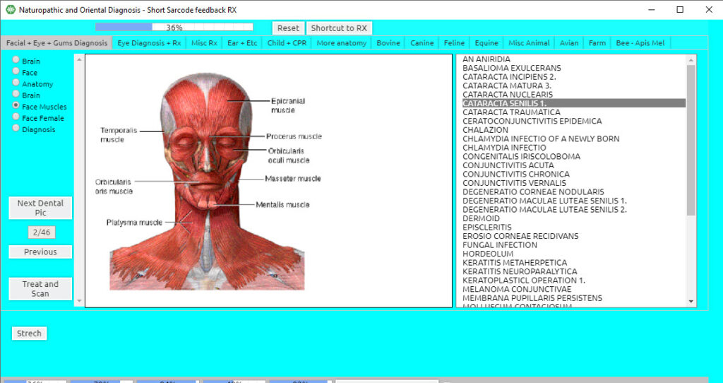

Here, you can work on the facial muscles, smoothing out lines and tension on the face, cranium, or TMJ area. You can work on specific areas by clicking on the word, or you may double-click in the white area, whereby you can work on face muscles in general.
Please check the rectification values on the bottom and repeat as needed.

- Face Female
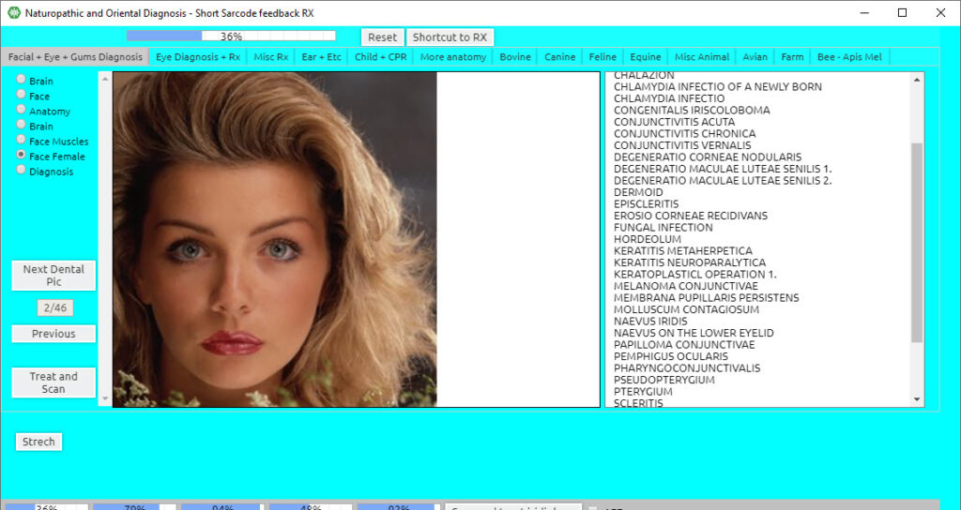

Here you can work on the face in general, areas of concern for anti-aging, spots, skin, or any other issues, smoothing out the issues on the face. You can work on specific areas by clicking on the word, or double click in the white area, whereby you can work on the face in general.
Remember to check rectification values on the bottom and repeat as needed.

Diagnosis
Here you can work on any part of the brain in general or areas of concern. You can work on specific areas by clicking on the word, or double click in the white area, whereby you can work on the brain in general.
Remember to check rectification values on the bottom and repeat as needed.
Click Eye Diagnosis + Rx (top menu bar)

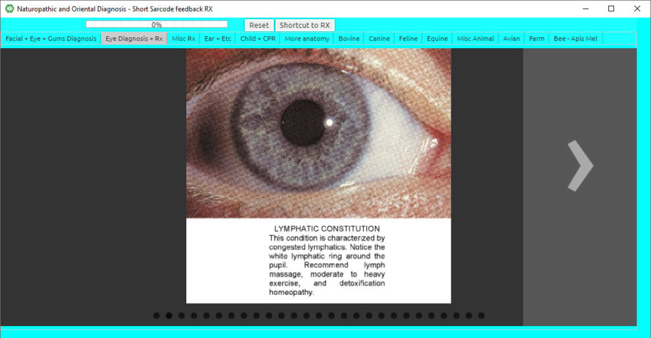

Press the second tab on the top menu of the Short Sarcode panel, and you will enter Eye Diagnosis + Rx.
Within this panel, you may click on the left or right side of the picture where there is an arrow indicating to either move the panels forward or back. Within this panel, you can work on the area of concern depending on the issue.
Remember to scroll down and check rectification values on the bottom and repeat as needed.
Click Misc Rx (top menu bar)

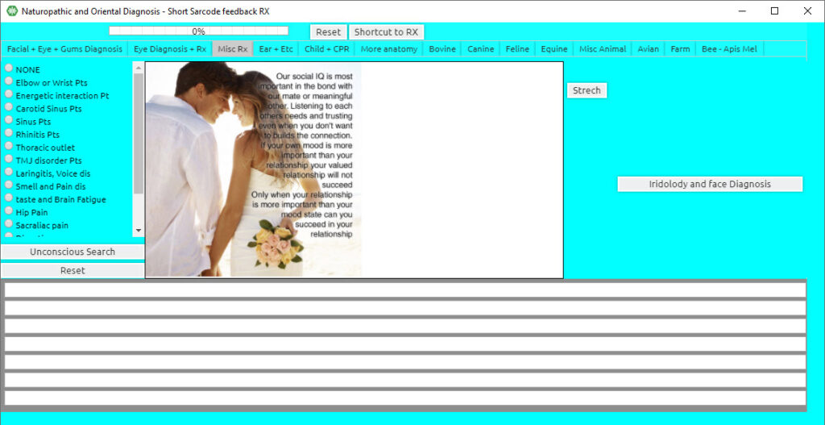

The third tab on the top menu of the Short Sarcode panel is Misc. Rx. You can use this panel in several ways.
By clicking Unconscious Search several times, you obtain information that has been taken from the testing process in the beginning. This gives you hints on what needs to be worked on during the session, while also loading the items to piggyback for the entire session.
Furthermore, by loading these items, we create an area of focus while doing our treatments in Short Sarcodes, and we are also layering in information as we progress in our sessions.
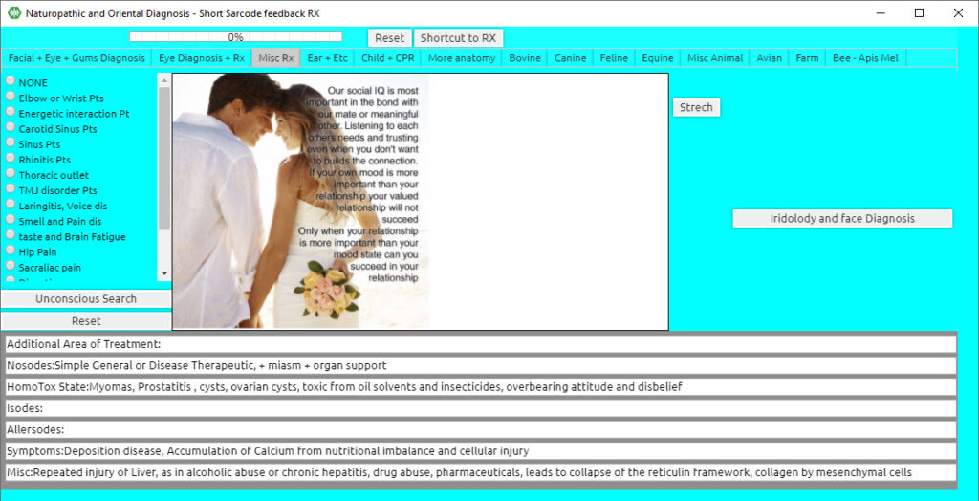

On the left side of the panel, you can see various areas on which you can focus.

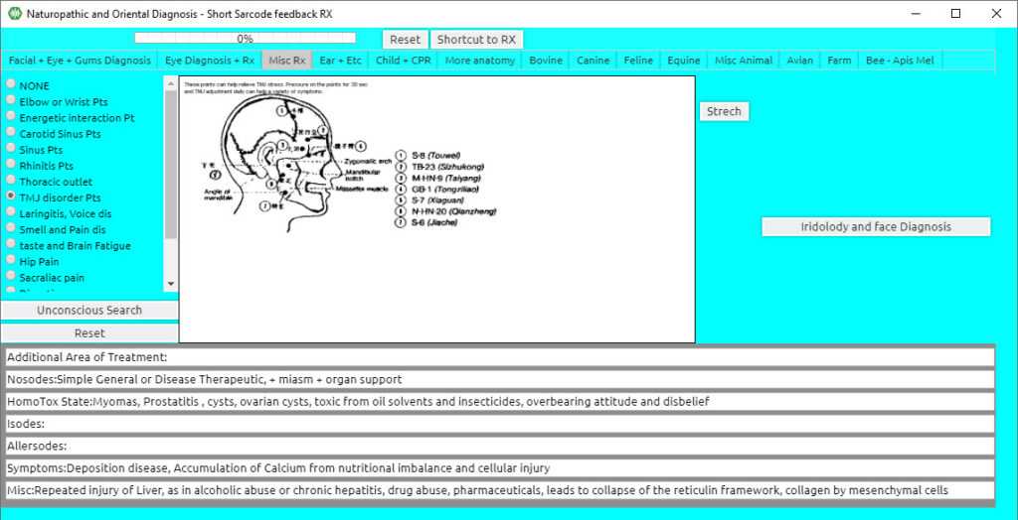

Choose the item you wish to work on, depending on the area of concern (for example TMJ). You can either treat specific areas till rectified or the entire area in general.
Remember to check rectification values on the bottom, and repeat as needed.
On the right side of this panel, you shall notice a button “Iridology and face Diagnosis”. By clicking it once the following appears:
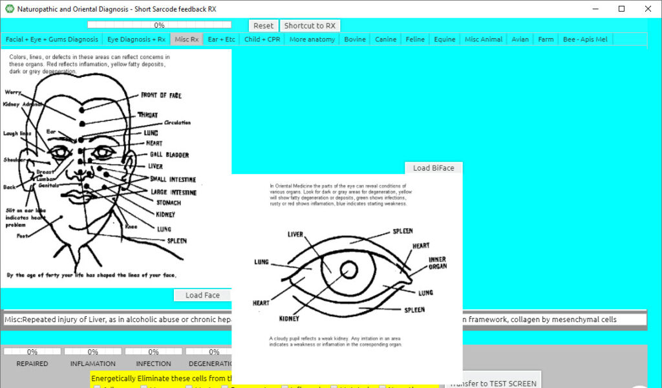

Here, you have the option to work on your client’s health through Facial points, while also being able to load a picture of the face and the Biface. We will get into that in another chapter and video.
Click Child + CPR (top menu bar)
Click the fifth tab in the top menu Child + CPR.

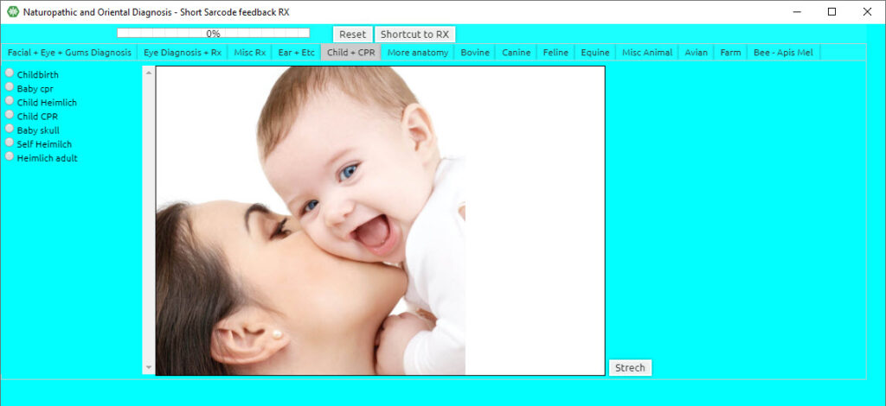

This panel is child-specific, for childbirth, in addition to useful information containing CPR for children while also adults. You can enter the various options on the left side of this panel.
HINT: the various options in this panel can also be used as the treatment of birth trauma, past trauma from choking or CPR, or preparation for birth. However, care must always be taken when treating a pregnant woman. People treating pregnant women must have certification and experience.
Again, please scroll down and notice your rectification values on the bottom and repeat as needed.
Click More Anatomy (top menu bar)

Click the sixth tab on the top menu bar of the Short Sarcodes, More Anatomy.
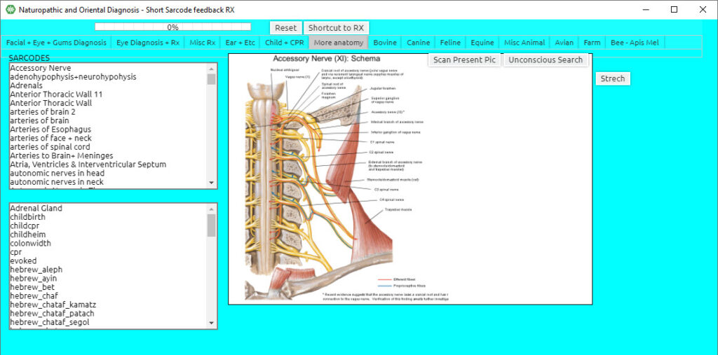

This panel contains full anatomy and is very useful when you want to be specific on your therapy, or you can also do ‘Unconscious Search’, located in the top right section under the top menu bar.

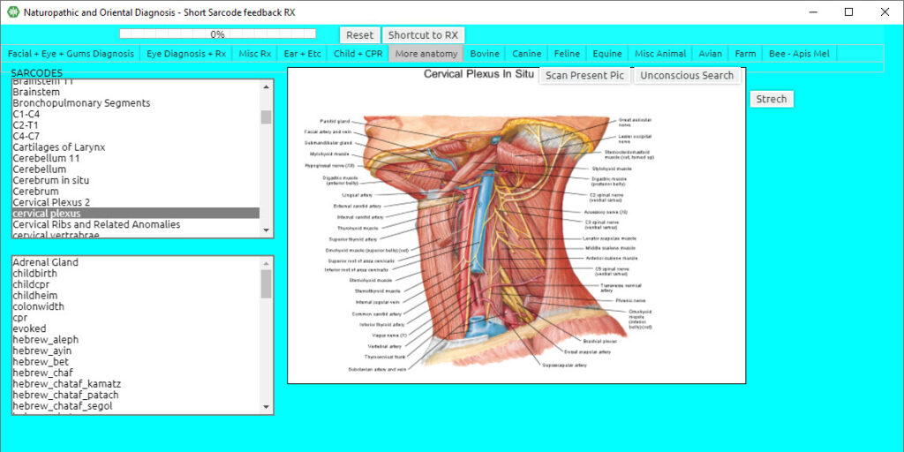

Treatment can be done either specific to the area of concern by clicking the specific word, or in general by clicking the white area.
Remember to check rectification values on the bottom while doing your therapies and repeat as needed.
The remaining tabs are animal-specific and work in the same manner. However, you shall notice that there are two scroll bars on the left side. The top scroll option is organ related whereas the bottom scroll bar is issue related.

Click Bovine (top menu bar)

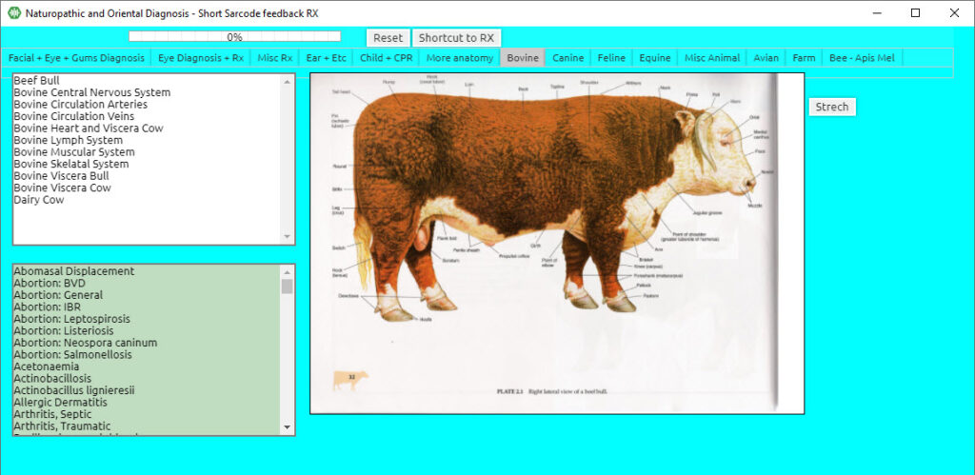
Click Canine (top menu bar)
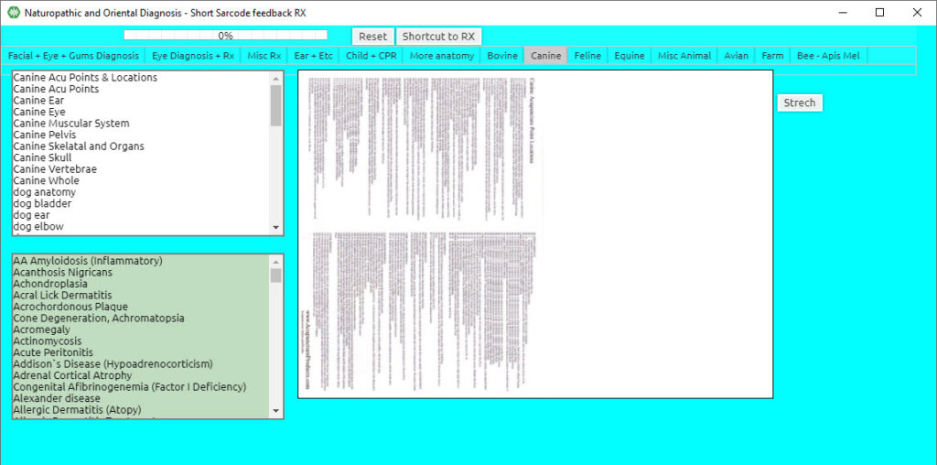
Click Feline (top menu bar)

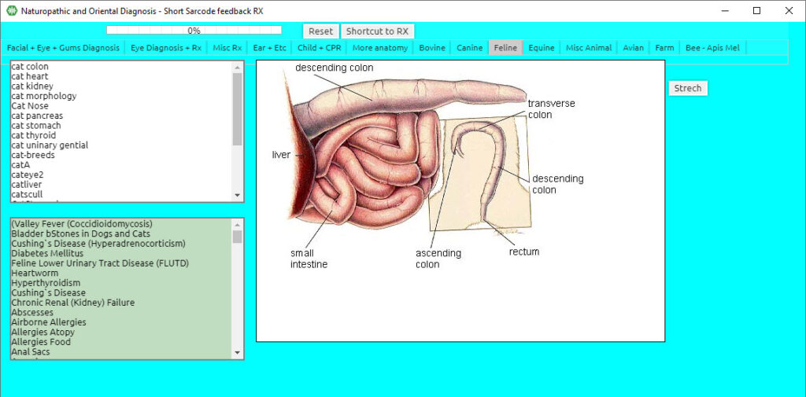
Click Equine (top menu bar
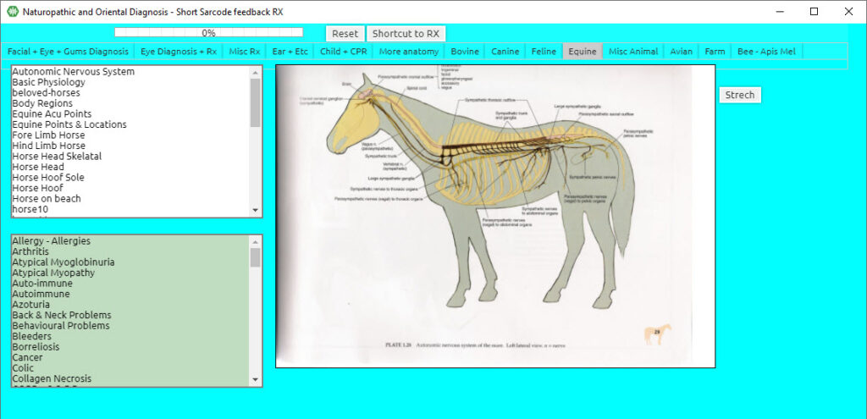
Click Misc. Animal (top menu bar)
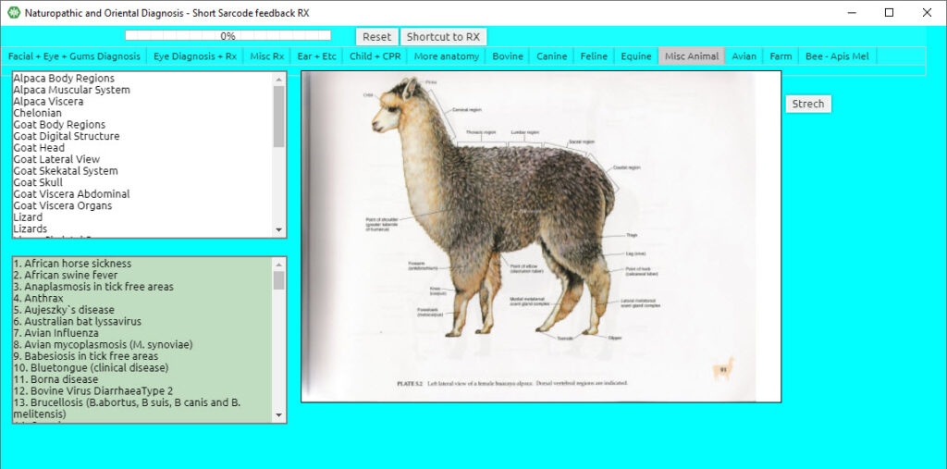
Click Avian (top menu bar)
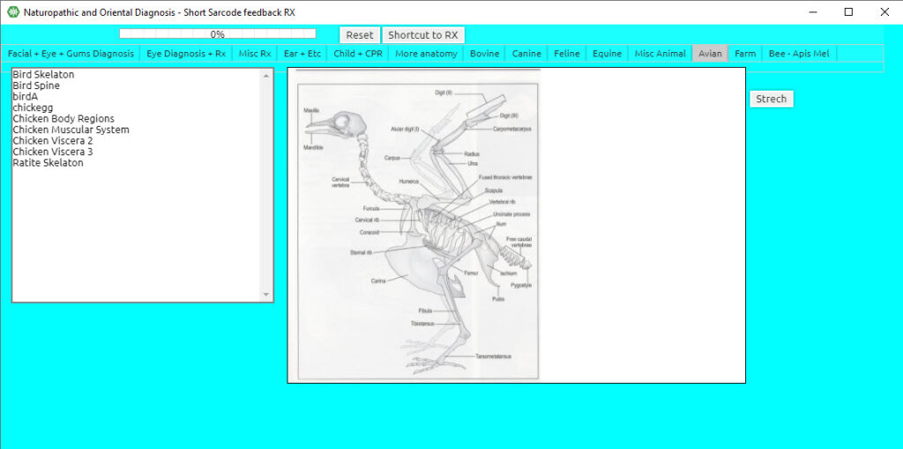
Click Farm (top menu bar)
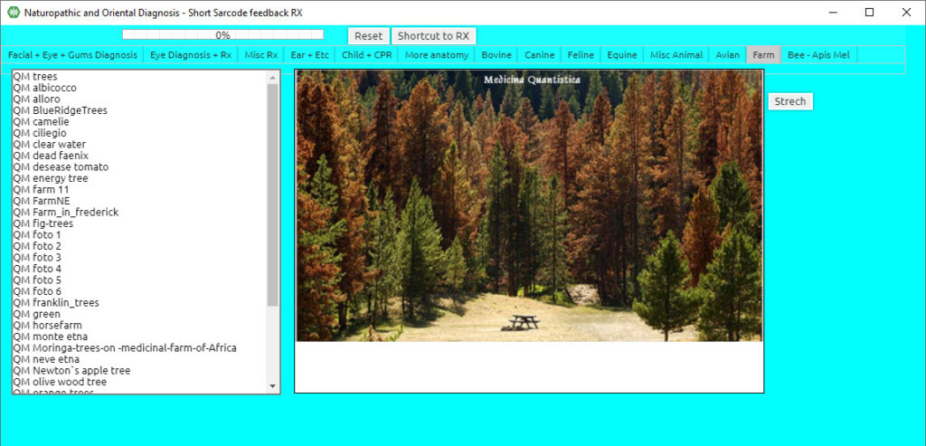
Click Bee – Apis Mel (top menu bar)
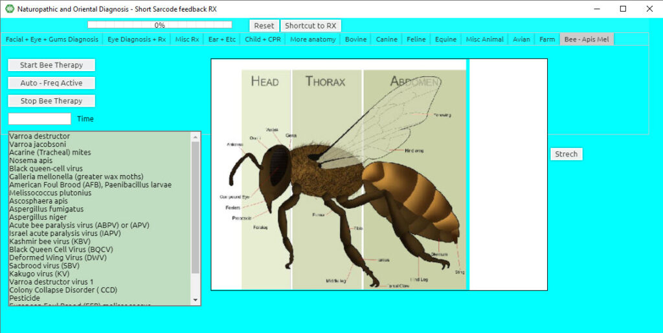

Chapter 4

Bodyviewer Training Program Activation

The Body Viewer Program is only available when your device is connected to the computer.
HINT: It is always best to open the Body Viewer and Iridology panels before opening the Disease Dictionary program to prevent the programs from freezing.
From the Main Matrix screen:
Click Subspace Programs (top menu bar)
Click Body Viewer (from the drop-down list)
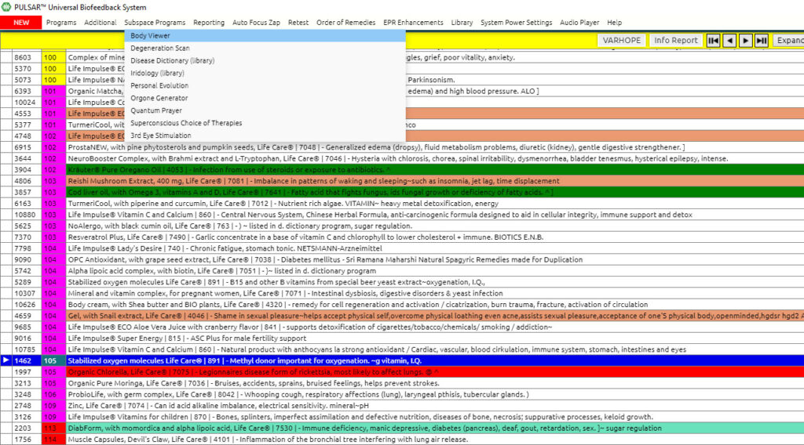
– Or –
Wait until the Body Viewer icon appears on your taskbar.
Click Program Start (top menu bar in the Body Viewer)
Click Load Unconscious Choices (start INFO exchange)
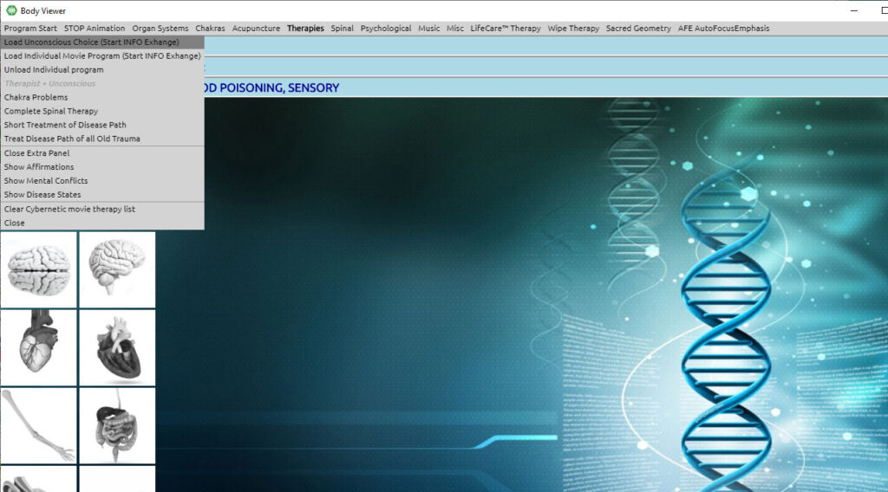
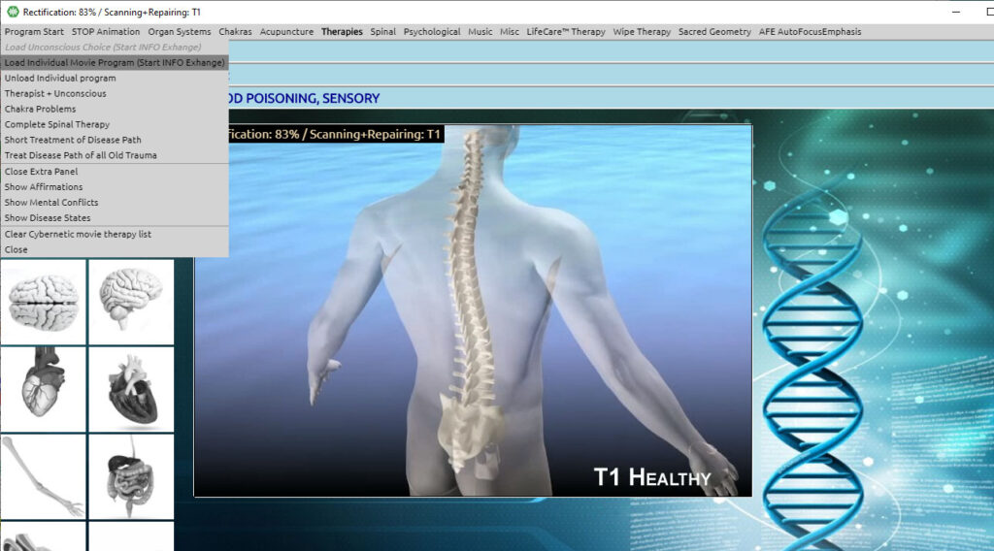

Click Load Individual Movie Program (from the drop-down list). Allow the graphic to complete.
Click Therapist + Unconscious (from the drop-down list)

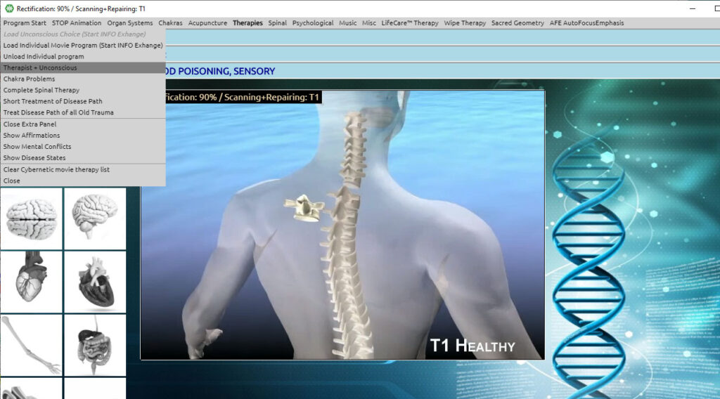

Click Treat Disease Path of all Old Trauma (from the drop-down list)
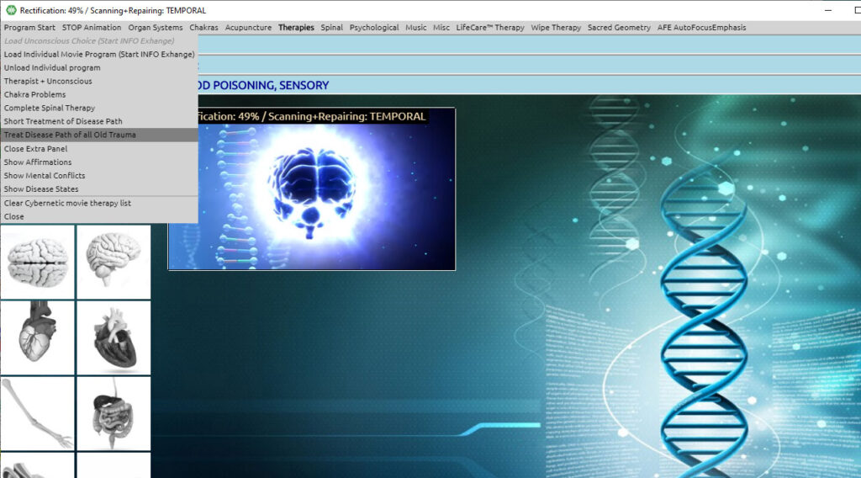

Click the Consciousness icon on the bottom task bar to let the program run in the background and go back to the main ED.X and NUCLEUS programs.

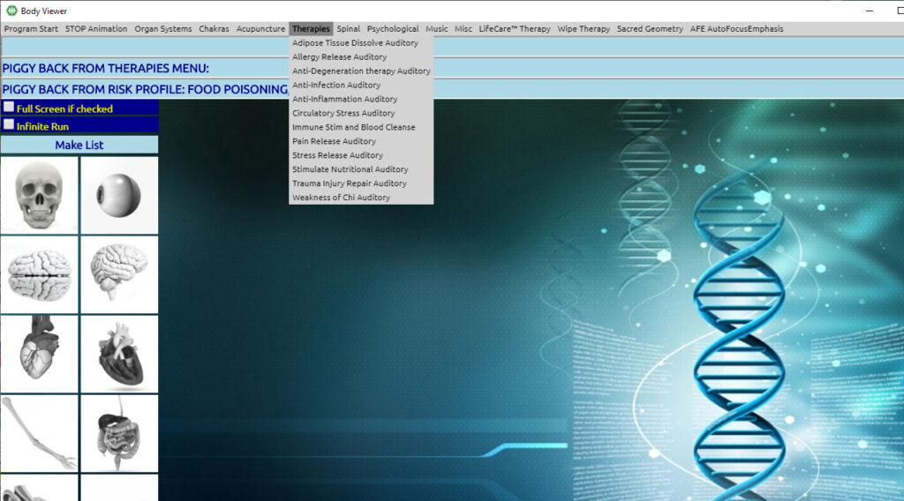

Once you have completed this initial protocol, you are ready to start SELECTING THERAPIES from the Body Viewer.
Organ Systems (top menu bar)
- You have many choices on the Organ Systems list, so pick the organs that you consider most relevant for the treatment.
- When you click on any item, it will be loaded into the blue PIGGY BACK bars at the top of the screen.
- Consider loading all the major organs of elimination as a beneficial Training Protocol.
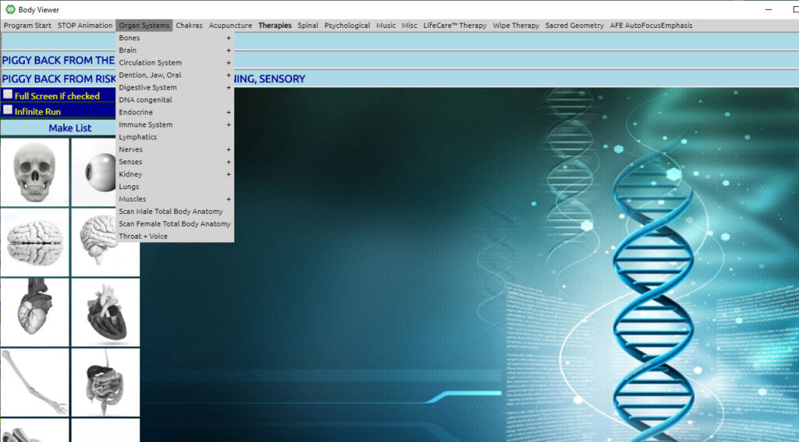

- Click Chakras (top menu bar)
Follow the same procedure as above.
Consider selecting Long Scan Chakra.
- Click Acupuncture (top menu bar)
Follow the same procedure as above.
Consider selecting Scan Acu Partial System.
- Click Therapies (top menu bar)
Follow the same procedure as above.
- Click Spinal (top menu bar)
Follow the same procedure as above.
Consider selecting Scan Spine.
- Click Psychological (top menu bar)
Follow the same procedure as above.
Consider selecting Emotions and Defence Mechanisms.
- Click LifeCare Therapy (top menu bar)
Follow the same procedure as above.
Consider selecting Aura Cleanse or Foci Detection Automatic.
- Click Sacred Geometry (top menu bar)
Follow the same procedure as above.
Consider selecting Unconscious Choice.
- Click AFE Autofocus Emphasis (top menu bar)
Follow the same procedure as above.

Consider selecting therapy in conjunction with AFE from the main PULSAR Software to achieve maximum effect.

Iridology
The Iridology Program is only available when your device is connected to your computer.
To open the program from the Main Matrix screen:
Click Special Adjunct ED.X and NUCLEUS Programs (top menu bar)
Click Iridology (drop-down list)
– Or –
During any treatment, on the “PULSAR is Working” panel:
Click Iridology (on the bottom right)

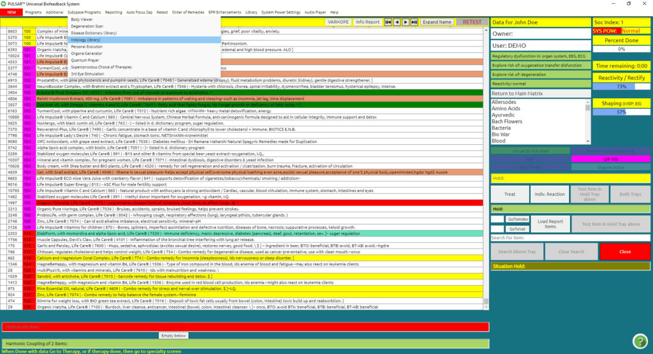

Iridology program will appear with the conscious button on the bottom taskbar, along with the Body Viewer, and will open automatically.

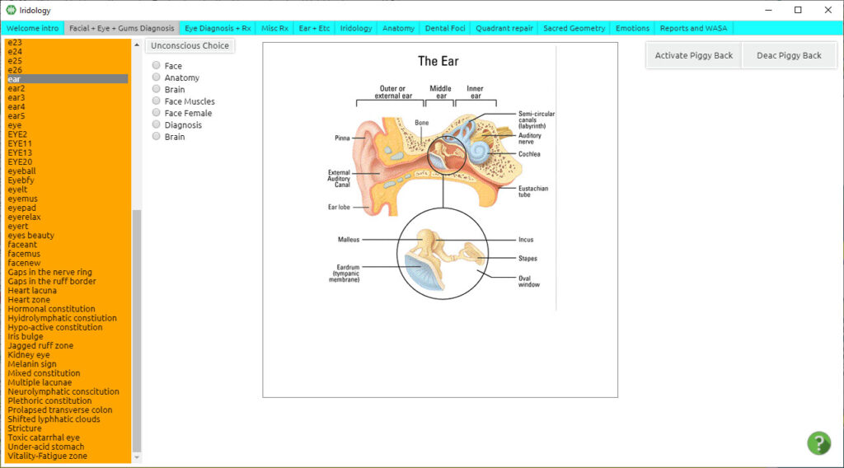
Click Activate Piggyback (on the upper right of the screen)
Click Anatomy (top menu bar)
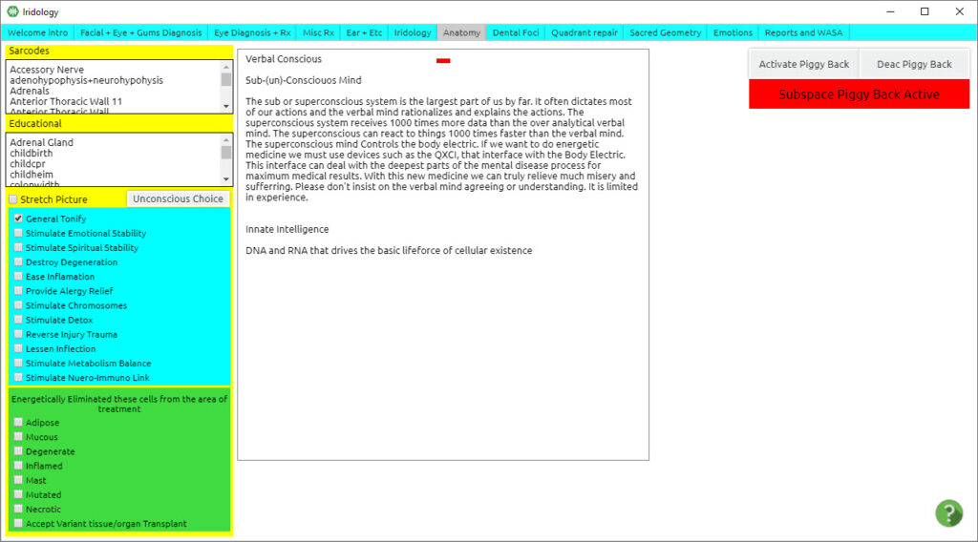

Click Unconscious Choice (on the left side, in the middle of the screen)
Click Activate Piggyback in the upper right of the screen

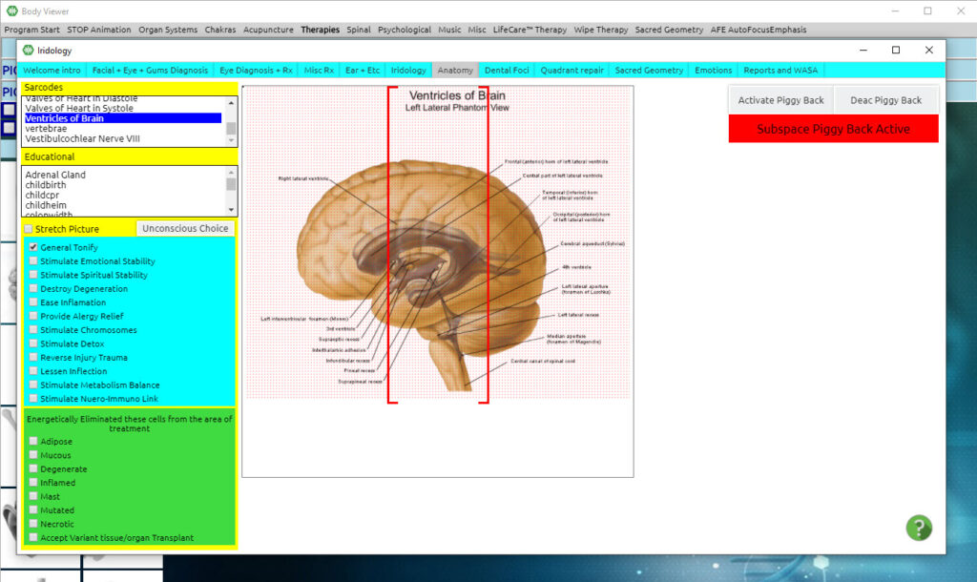

Click Facial + Eye + Gums Diagnosis (top menu bar)
Click Auto Search (left, middle of the screen)
Click Activate Piggyback (upper right of the screen)
Click Eye Diagnosis + Rx (top menu bar)
Click Eye Anatomy (upper left of the screen) or any item you choose necessary
Click Activate Piggyback (upper right of the screen)
Click Misc Rx (top menu bar)
Click Chose any item (from the left column)
Choosing SKIN is a major organ of elimination.
Click Unconscious Search (mid-left of the screen) in order to load unconscious information at bottom of the page
Click Activate Piggyback (upper right of the screen)
Click Ear + etc (top menu bar)
Click Lymph (on the left of the screen) or any choice you feel appropriate
Click Activate Piggyback (upper right of the screen)
Click Iridology (top menu bar)
Click Iridology Choice Visible (upper left of the screen)
Click Lymph1 (from the blue column on the left)
Click Activate Piggyback (in the upper right of the screen)
Click Dental Foci (top menu bar)
Click Auto Search (on the left side, in the middle of the screen)
Click Activate Piggyback (in the upper right of the screen)
Click Quadrant Repair (top menu bar)
Select piggyback choices from the blue bars on the left of the screen
Double Click the area of the diagram you would like the piggyback signals to be directed as an area of additional focus.
Click Sacred Geometry (top menu bar)
Click Activate Piggyback in the upper right of the screen
Click the Consciousness icon on the bottom task bar to return to the main PULSAR program and allow the Iridology program to run in the background.

Chapter 5

Disease Probability and Dictionary
Disease Probability and Dictionary Training Program
Hint: It is always best to open up Bodyviewer and Iridology panels first and thereafter open the Disease Dictionary program to prevent the programs from freezing.
To open the Disease Dictionary from the Main Matrix screen:
Click Subspace Programs (top menu bar)
Click Disease Dictionary (library)
– Or –
During any treatment, on the “LifeCare is Working” panel:
Click Disease Dictionary (on the upper right)
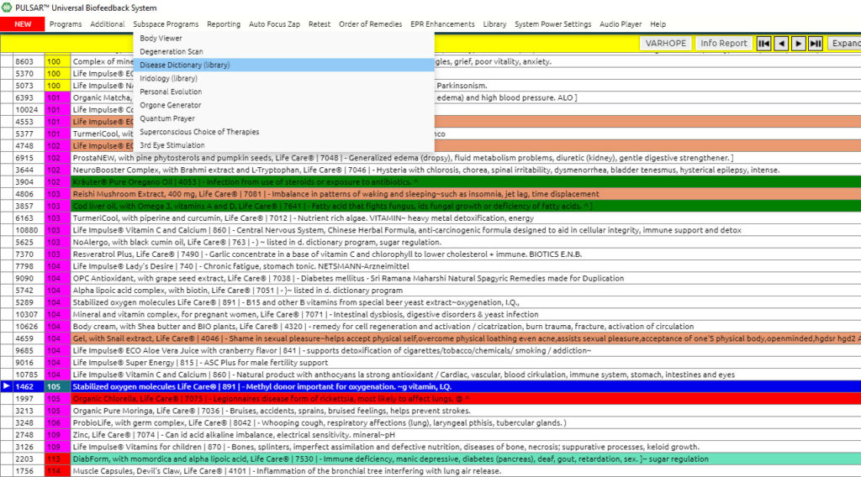

Click Disease Dictionary (drop-down list)

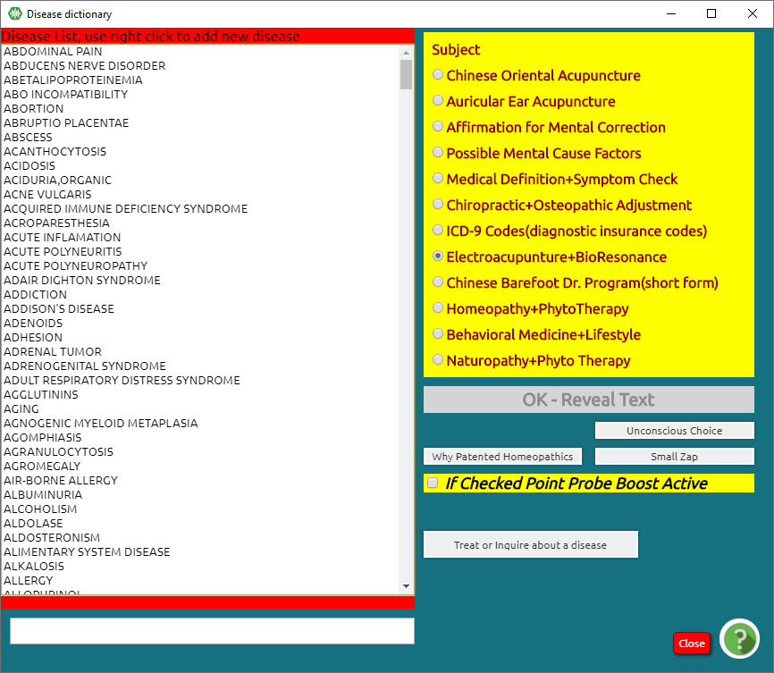

There are two ways to choose the items from the Disease Dictionary:
- Search for the item of your choice in the alphabetic list on the left (for example “Stress” and click on it in order to select it.
- Click on the Unconscious Choice button and the program will choose the item according to the patient’s needs. The unconscious choice item will appear at the bottom of the list and will also be highlighted in the list.
Now you can select the type of therapy you wish to do in the yellow box on the right-hand side of the panel.
It is automatically set on Chinese Oriental Acupuncture, but it is recommended to choose ElectroAcupuncture+BioResonance.
Click OK – Reveal Text
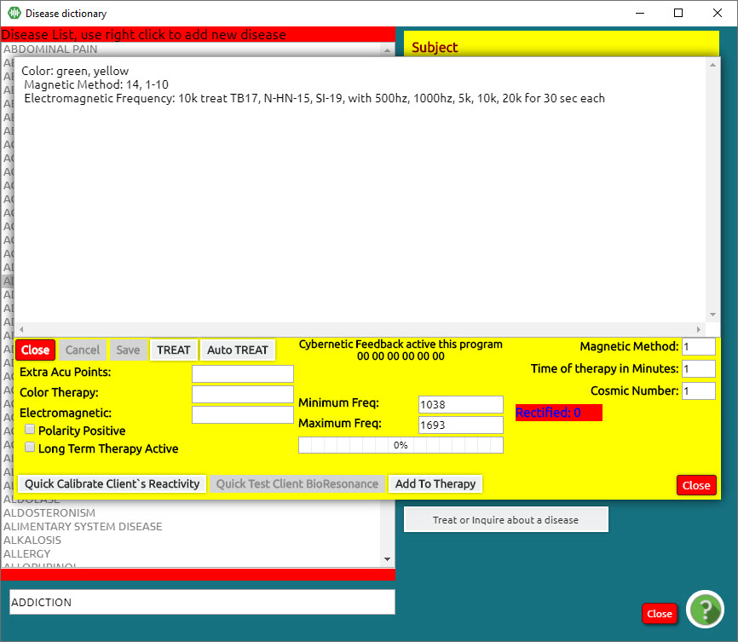

Click Quick Calibrate Client’s Reactivity
This will do a quick calibration on the item of choice.
Click Quick Test Client BioResonance
This will do a quick test on the item of choice to show the necessary time and frequencies.

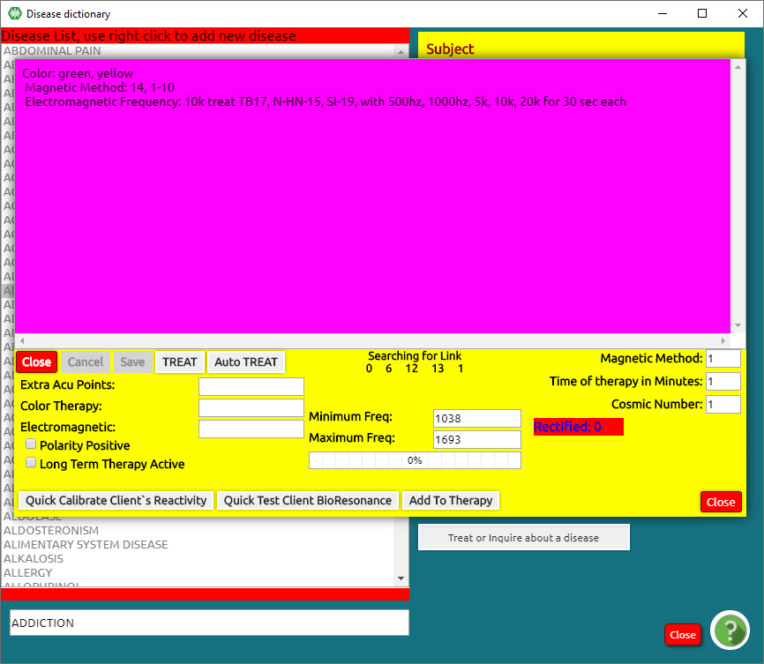

Click Add to Therapy
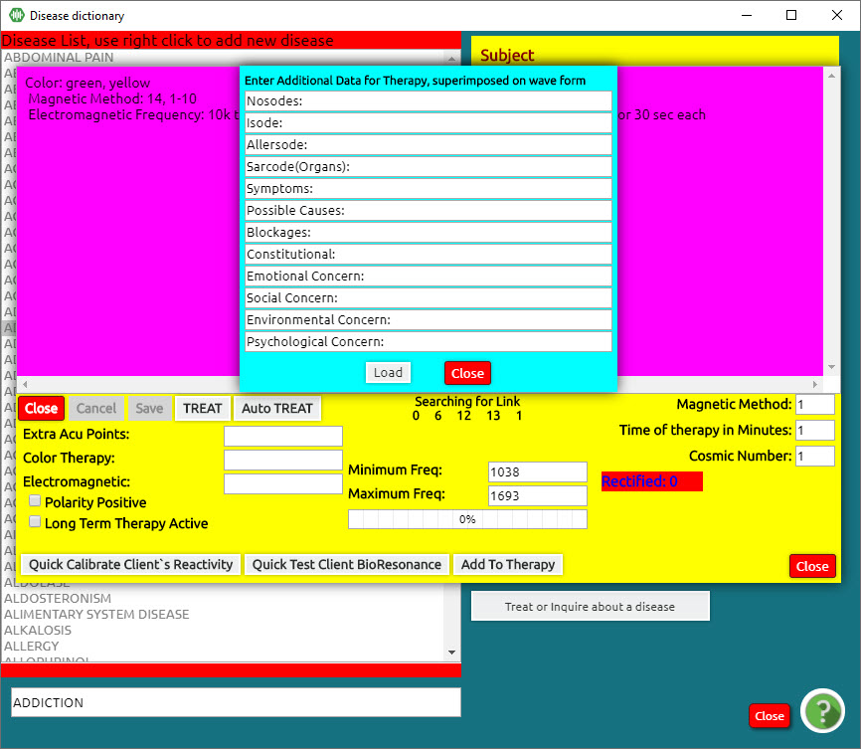

Here you can load additional information to add to your therapy. Load and close.
Click Auto Treat
Click the Consciousness icon on the bottom task bar to let the Disease Dictionary training protocol run in the background.

Chapter 6

Close Out of Programs
Step 1.
- Close any opened program and return to the Main Matrix screen.
- Close the Main Matrix screen.
- This will bring you to the Main Menu screen
Step 2.
On your Bottom Task Bar, Right-Click and Close:
- Body Viewer
- Iridology
- Disease Dictionary and any Subspace Program you may have opened

Note: Do not close Consciousness on your Task Bar, as this is the main ED.X and NUCLEUS program.

Shut Down Your Device

Click OK
To turn off your ED.X and NUCLEUS press the On/Off Button located at the front of your device.
The lights will go out.
- Never remove the USB cable while the power is still on.

Check Current Rectifications
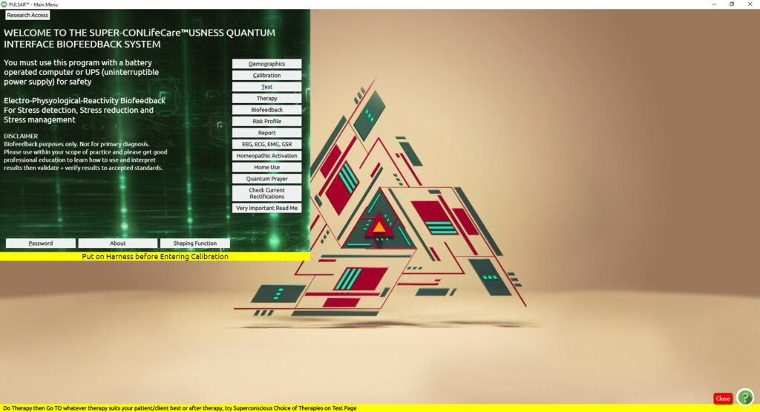
Click Check Current Rectifications (on the lower right side of the Main Menu Screen)
Click OK on the pop-up box
The blue Rectification panel appears.

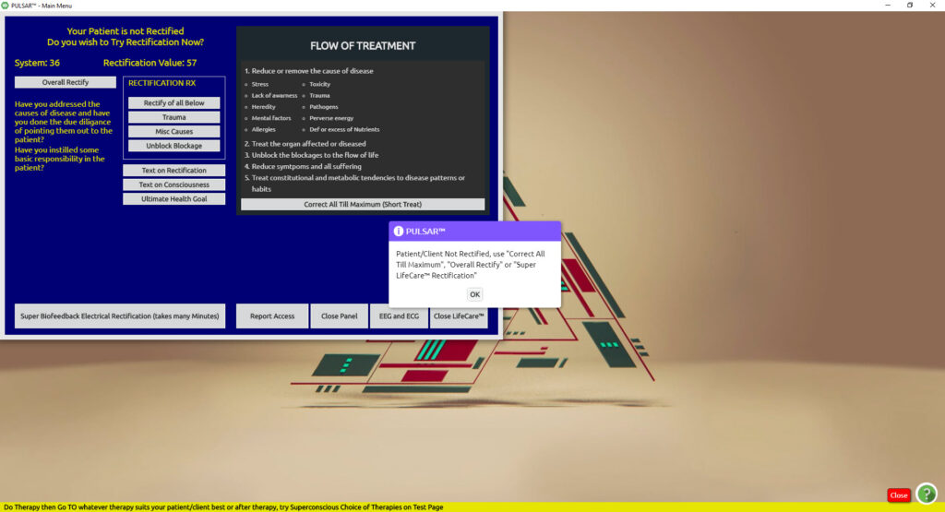
Click Correct All till Maximum (Short Treat)
The panel will change color. When complete, it will turn blue again.

Close Out of ED.X and NUCLEUS SOFTWARE
Right Click and close any items open on the bottom task bar (such as Iridology, Body Viewer, or Disease Probability and Dictionary)
Click Close ED.X and NUCLEUS on the lower right corner of the Check Rectification panel
Click Yes to Are you sure you want to leave?

Closing a session with your client
This is optional but a good idea when closing and finalizing your session with your client. Before you shut down your software and your device, from your Main Panel, after rectifying your session, click on TEST to return to your main matrix panel.
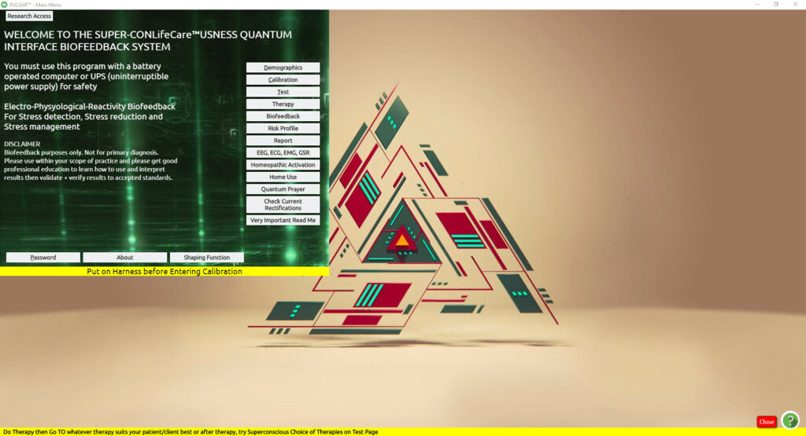
From your main matrix panel, go to the drop-down menu “Retest” and choose the options Test VARHOPE Improvement.
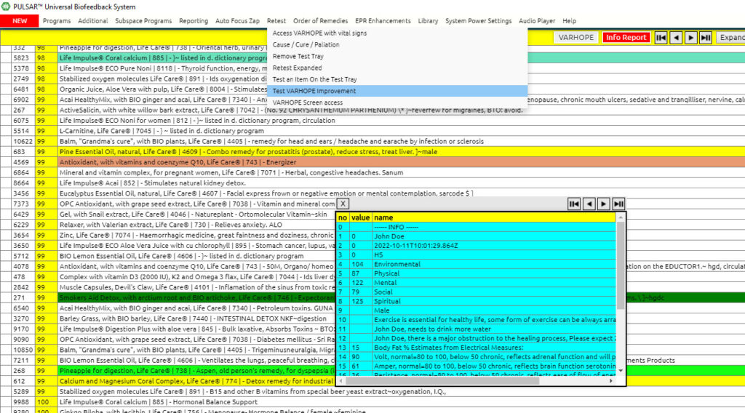

This process takes 1.5 minutes and basically recalibrates your client to get a rectification value on your initial VARHOPE numbers.
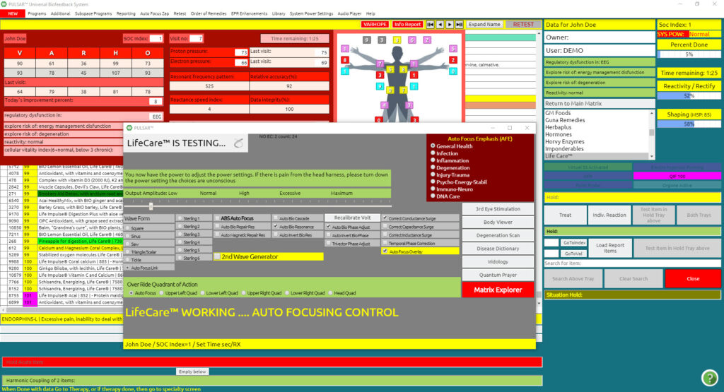
As soon as the retesting process is done, a number appears in the midsection of the VARHOPE panel ‘Today’s Improvement Percent’.
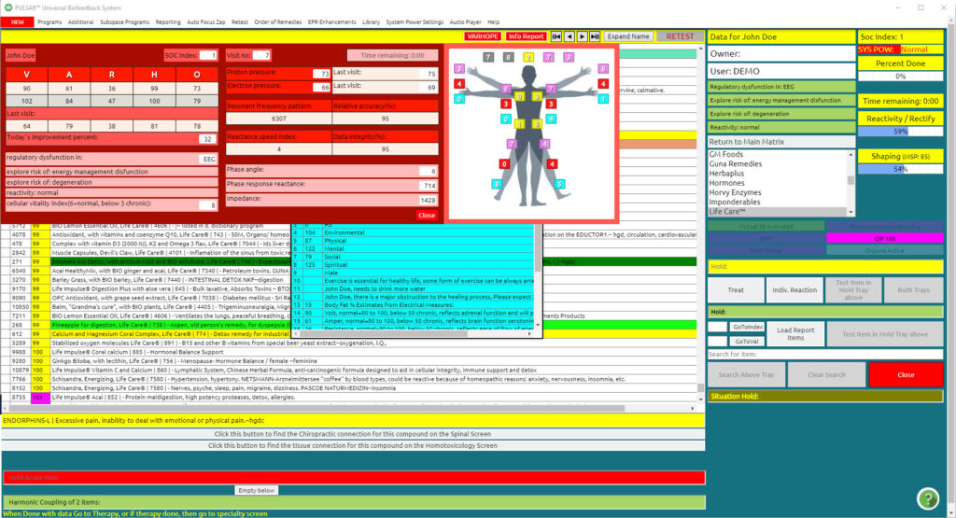
In the above example, the 32% improvement value means that the client is 32% better than when he/she came to this specific point of the retesting. Please remember that the session and therapies are still working on the client for the next 72 hours, meaning improvement will still continue. From my experience, people usually tend to get low improvement values, if the therapy you have done on them was too much, and they need time for their body to adjust, or if they are tired. Rest assured that within the next 72 hours this value shall improve and they will feel the results of the therapy.

Another panel that you may enter to finalize your session is the LifeCare Report. You may find this under your drop-down menu Reporting, scroll down, and you shall see it at the bottom of ED.X and NUCLEUS Report.
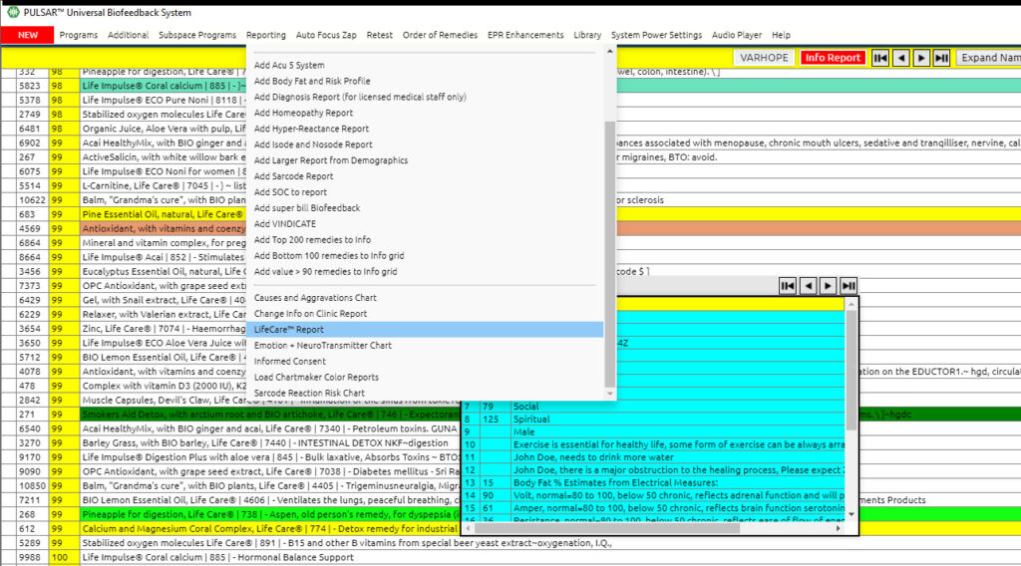

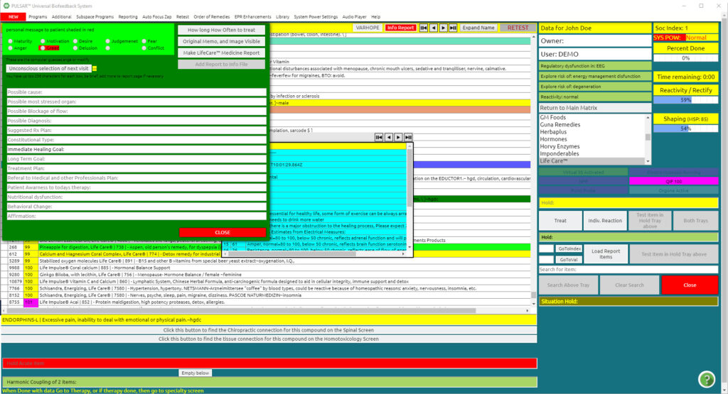
Click on the third selection on the top right of this panel, Make LifeCare Medicine Report.

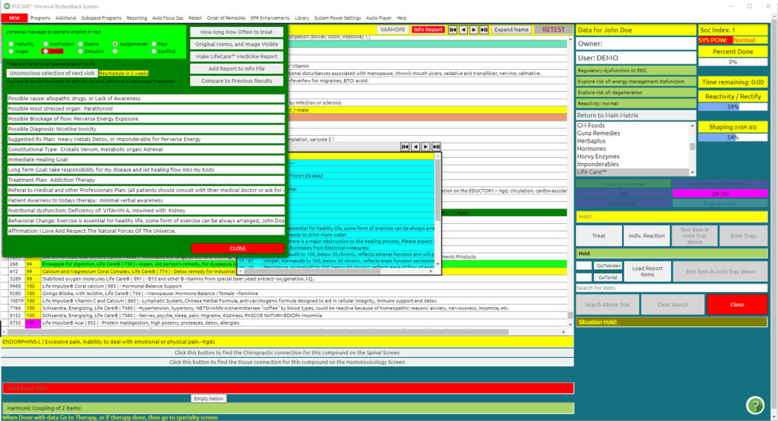
By doing this it will load information in the white lines of this panel.

NOTE: doing this process at the end after “Testing Improvement”, gives you information on what is still needed for the client to do, so you can discuss with your client what may be needed in addition to programming your next visit. If you do this process at the beginning of your session, it will give you an idea of what the client needs in the present session.
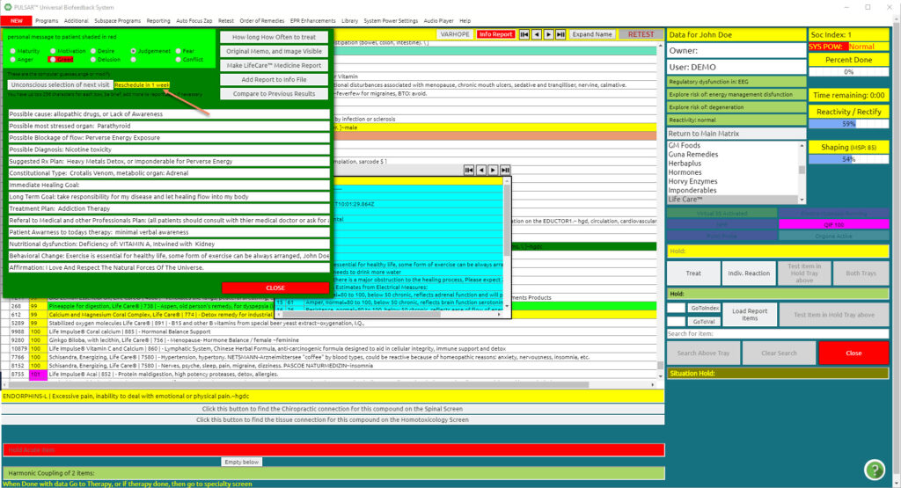
By pressing the “Unconscious selection of next visit”, the device estimates when the client should repeat their therapy for optimum results. Our example above, which gives us 1 week for the next visit, gives us information that the therapy done on them shall take approximately one week to absorb, and for optimum results should be repeated within 1 week again.

Other statistics on this panel is
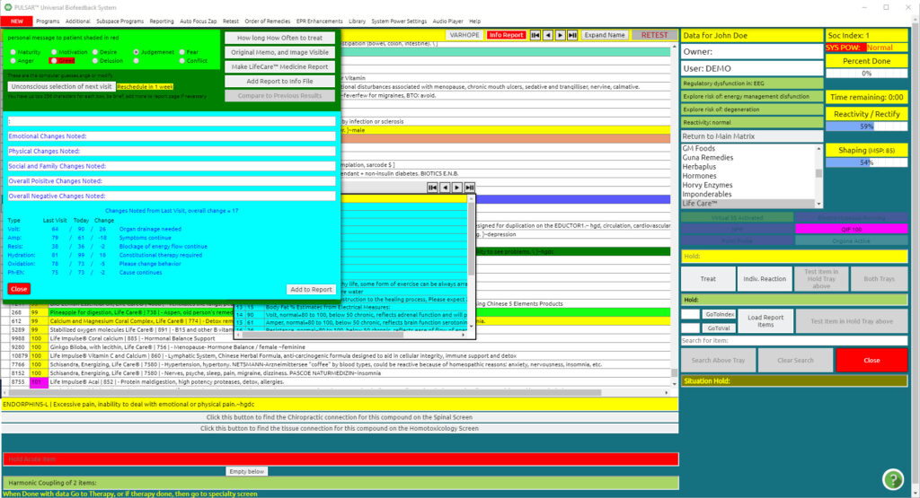
Compare to Previous Results, which is the last option on the list. This option compares VARHOPE values from the last visit.
Continue to close the software as previously explained in this chapter.

Chapter 7

Modifying the SOC Index of a Previous Client

Upon selecting your previous client as explained above, Calculate SOC will appear in bold.

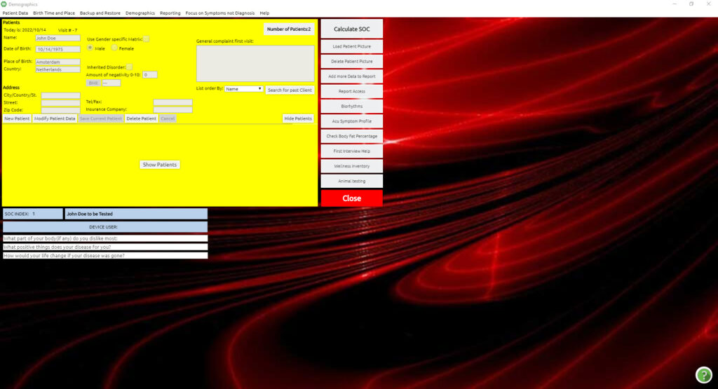
Click Calculate SOC

The SOC Index panel appears. You may alter any part of the questionnaire. When you finish modifying, by clicking CLOSE on the right, your modifications are automatically saved.

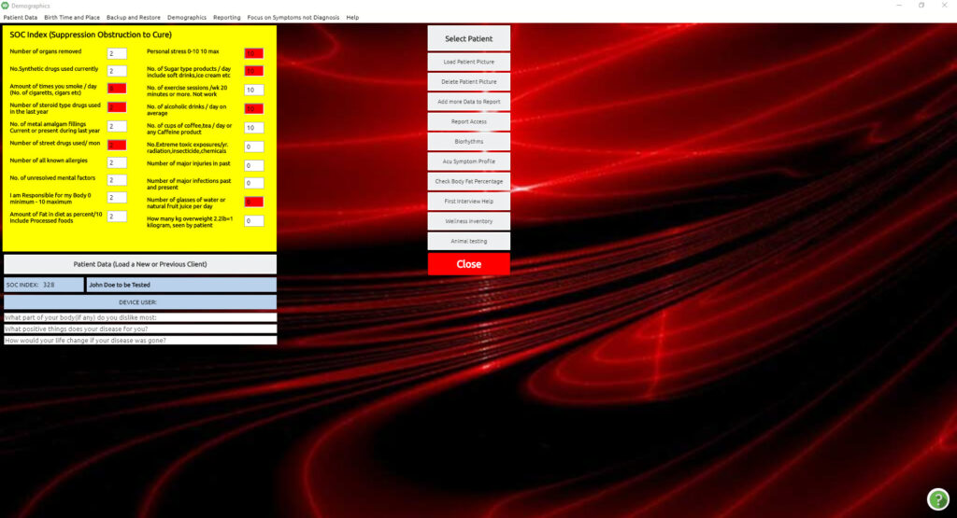

And the Main Panel appears, where you can continue for calibration.

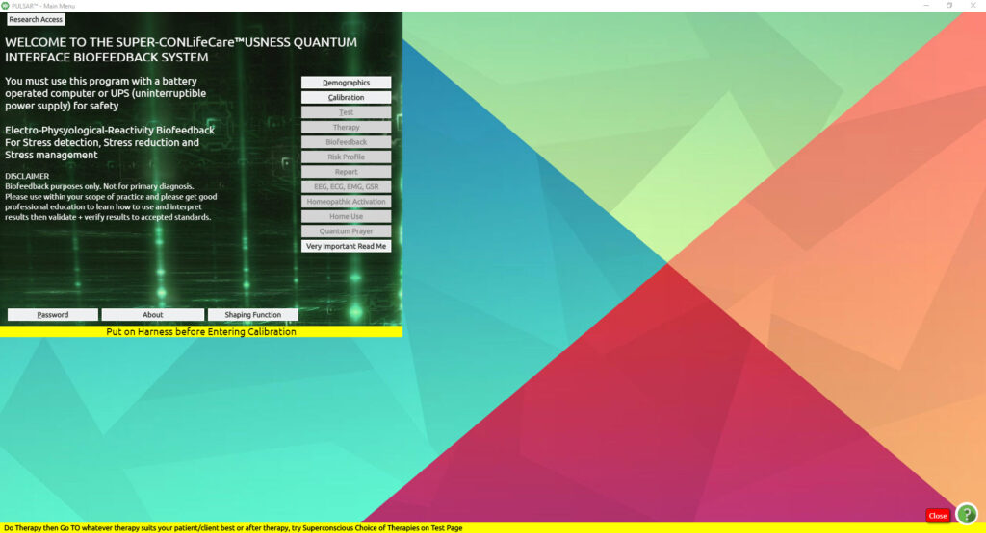

Loading a Previous Client

In order to load a previous client, after the password
From the Main Menu screen:
Click Demographics
As the client is already saved in the software database, you do not need to type the client’s name in the Patient Name area, nor add any information
As we have already mentioned, for GDPR standards, the list of clients is hidden. If you wish to view the clients you can click on “show patients”
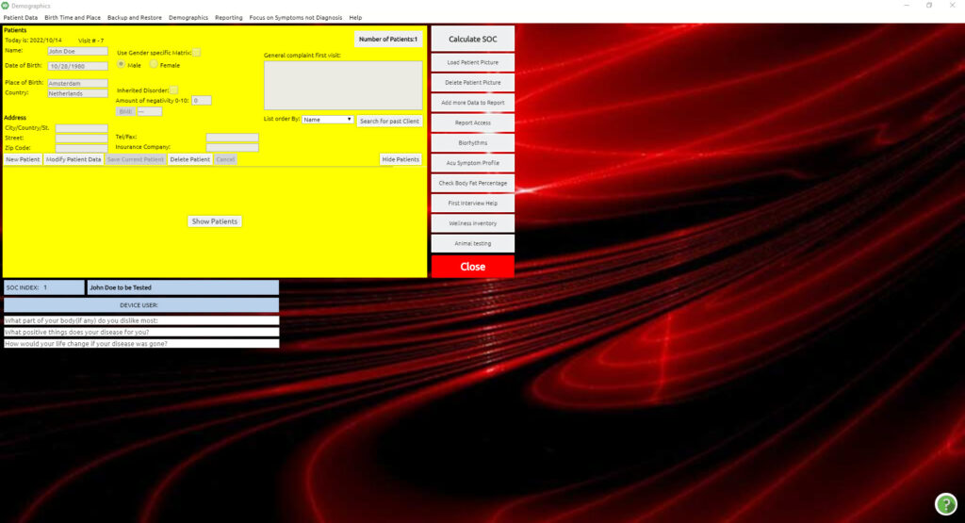
Click Search for Past Client
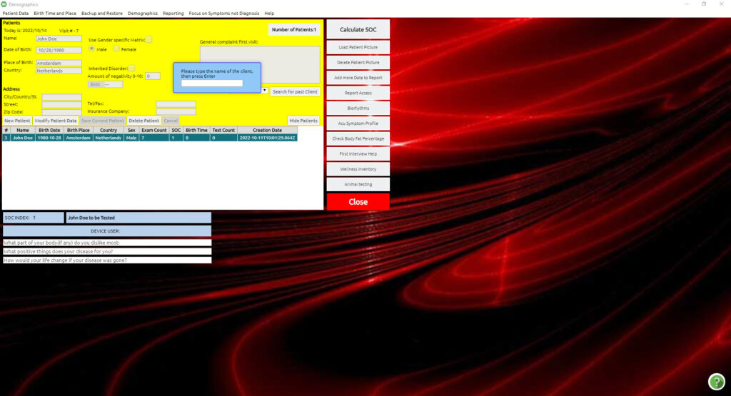

A prompt will come up telling you to “Please type the name of the client, then press Enter”
please type the name of the client and press enter
The details of your selected client will appear.
It is recommended that you review the SOC Index questionnaire at each session to record any changes that may have occurred since the previous session.
To record the new changes, please see Modifying the SOC Index of a Previous Client.

Modifying Birth Date
After you have selected the previous client, and in the case you need to edit either date of birth or place of birth
Click Modify Patient (Client)
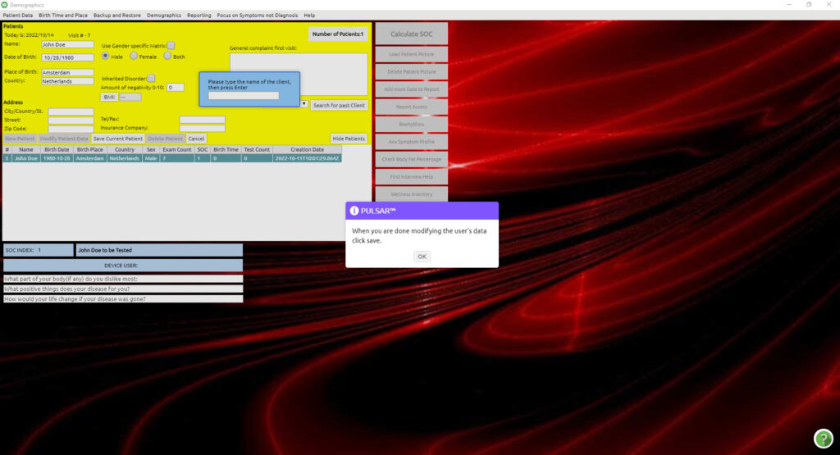
It shall give you a prompt “when you are done modifying the user’s data, click save” and press OK.
You can now edit the birth information in the Patient Data (Client) panel.
Click Save Current Patient (Client).
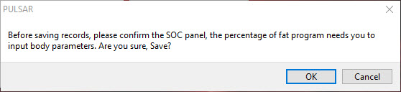

Click OK on the questions.
Click Close.

Chapter 8

Auto Frequency Therapy / Auto VARHOPE
Step 1
From the Main Matrix screen:
Click Program
Click Universal Biofeedback Therapy
Click Auto Freq Therapy
Click Start
This may end up automatically switching to the Auto VARHOPE screen.
If so, continue with Step 2. If not, continue with Step 3.

Step 2
Click all of the items in the lower part of the panel that is relevant to the client.
This will put check marks in the yellow boxes.
(Some will have been selected automatically).
Click Emotion Stress > Electrical Imbalance (until Repaired for Today appears)
Click Auto Aggressive Immune Dysfunction (until Repaired for Today appears)
Click Cellular Vitality Disorder (until Repaired for Today appears)
Click Phase Aberration Present (until Repaired for Today appears)
Click Start Injury Repair (until the message reports Injury Repair Complete for Today)
Click Close
This will bring you back to the Auto Frequency Panel to complete the initial Training Protocol.

Note: Additional information may be typed in the tray next to Describe Injury Fully.
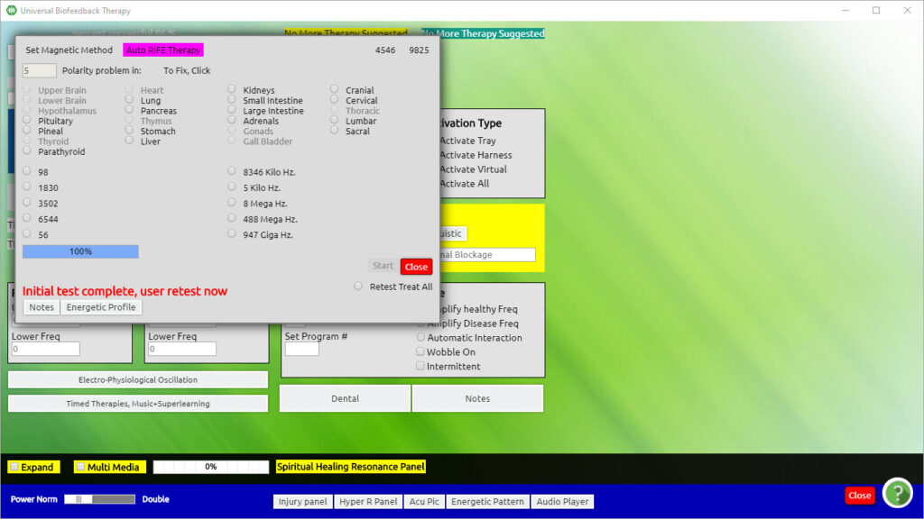
Note:
There is a possibility of up to four buttons that may appear in the mid-right section of the panel. Not all four buttons show up for every client, as the program chooses only what is appropriate. At times, only 2 or 3 of these will be available.

Step 3
Click Retest Treat (Train) All
Wait until the retest is complete.
Items will show up as either corrected or not corrected.
Click on any individual still not corrected. This gives another opportunity to attempt correction.
Click Close
Click Auto VARHOPE (and follow Step 2)
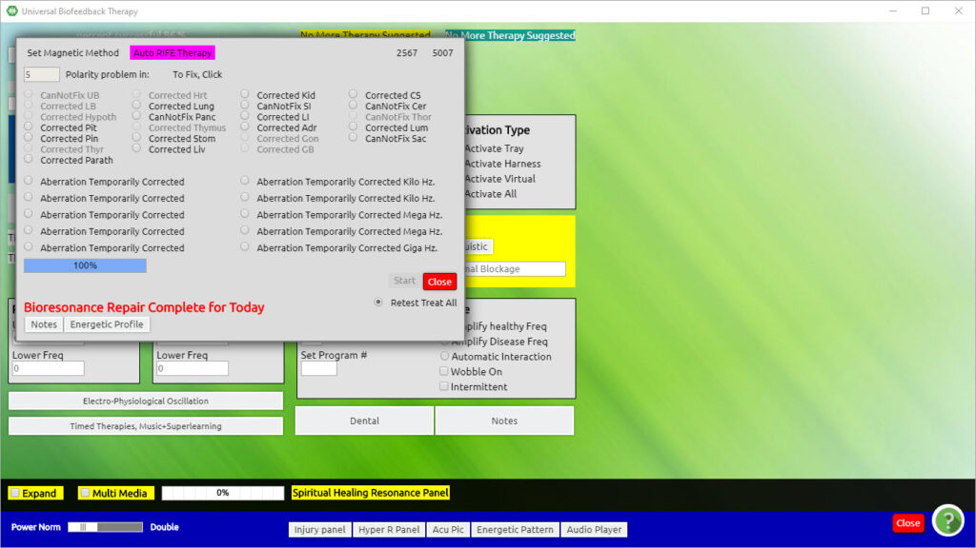

Auto Meridian / Hyper-Reactants
From the Main Matrix Screen:
Click Program (top menu bar)
Click Universal Biofeedback Therapy (drop-down list)
Click Auto Meridian/Hyper-Reactants
Click Start Meridian Therapy (bold black print indicates energetically blocked meridians)
This begins an automatic training protocol for any energetic disturbances in the acupuncture meridians.
Once complete:
Click Retest All. This will repeat an energetic flow through the meridians and initiate further training. A purple screen (the Acu Diag) will appear with information and indications of areas requiring further training.
Click Close on the Acu Diag Panel
Click Close
– Or –
If you wish to continue additional training protocols
Click Acupuncture Pictures and Consciousness Form Test
Click Superconscious Search for Point (in the lower left corner of this screen)
Double Click on the background of the picture or diagram of the panel to begin the training process. Continue clicking until the pop-up box shows This Acu-Point or Points Corrected Energetically.
You may choose to select and run the training process for several of the Superconscious Searches.
Click Close
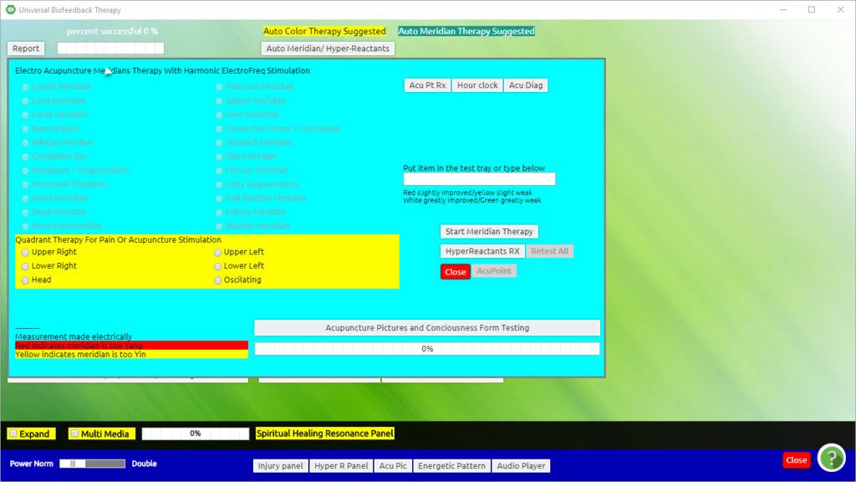

Start Meridian Therapy (bold black print indicates energetically blocked meridians)
This begins an automatic training protocol for any energetic disturbances in the acupuncture meridians.

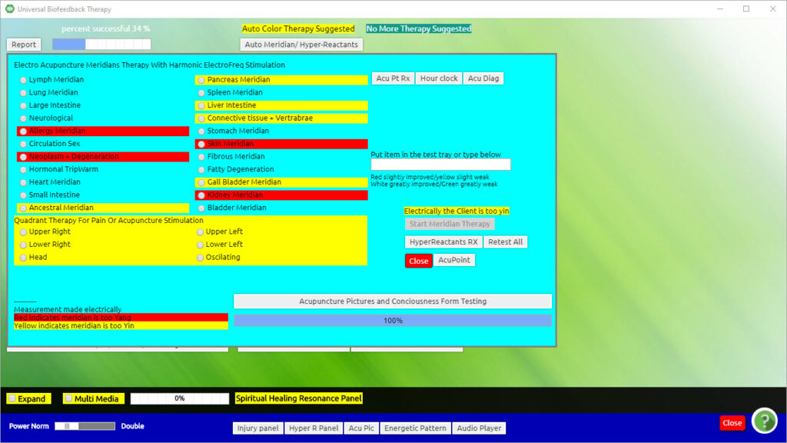

Once complete:
Retest All. This will repeat an energetic flow through the meridians and initiate further training. A purple screen (the Acu Diag) will appear with information and indications of areas requiring further training.
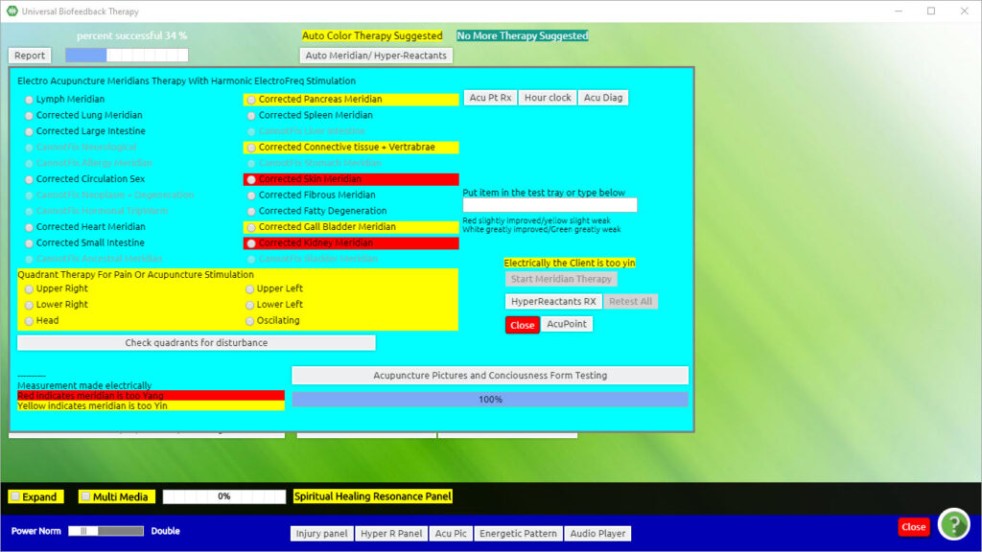
Close on the Acu Diag Panel
Close

Or –

If you wish to continue additional training protocols…
Acupuncture Pictures and Consciousness Form Test
Superconscious Search for Point (in the lower left corner of this screen)
DBL on the background of the picture or diagram of the panel to begin the training process. Continue clicking until the pop-up box shows This Acu-Point or Points Corrected Energetically.
You may choose to select and run the training process for several of the Superconscious Searches.
Close

Auto Scalar

This program is providing training protocols for the subtle energy centers known as the Chakra system. Like acupoints, chakras are specialized energy centers throughout our body where a unique form of subtle life-force energy is absorbed and distributed to our cells, organs, and tissues. The flow of this energy is greatly affected by our personality structure, emotions, and state of spiritual development.
From the Main Matrix screen:
Click Program
Click Universal Biofeedback Therapy
Click Auto Scalar
Click Treat (Train) All
This may take several minutes to train all the Chakras. When it is complete the panel should show the message System in Correct Phase.
Click Close
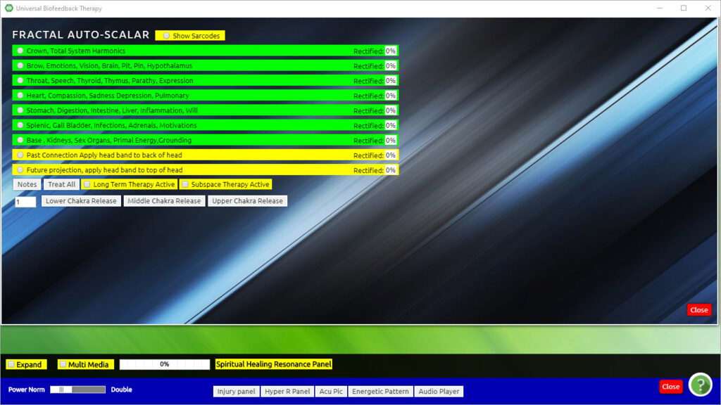

Auto Trivector
From the Main Matrix screen:

Click Program (top menu bar)
Click Universal Biofeedback Therapy (drop-down list)
Click Auto Trivector
Click Use Electro Chelation Boost (this is optional)
Click Start
Click OK on the message in the pop-up box. If complete, a box will appear Trivector Complete for Today
If the process is not complete a message stating so will appear. In order to initiate further Training, do the following:
Click OK on the message
Click Prepare for Special Treatment (Training). Wait for the Start key to become bold again.
Click Start
When the process is complete:
Click Close
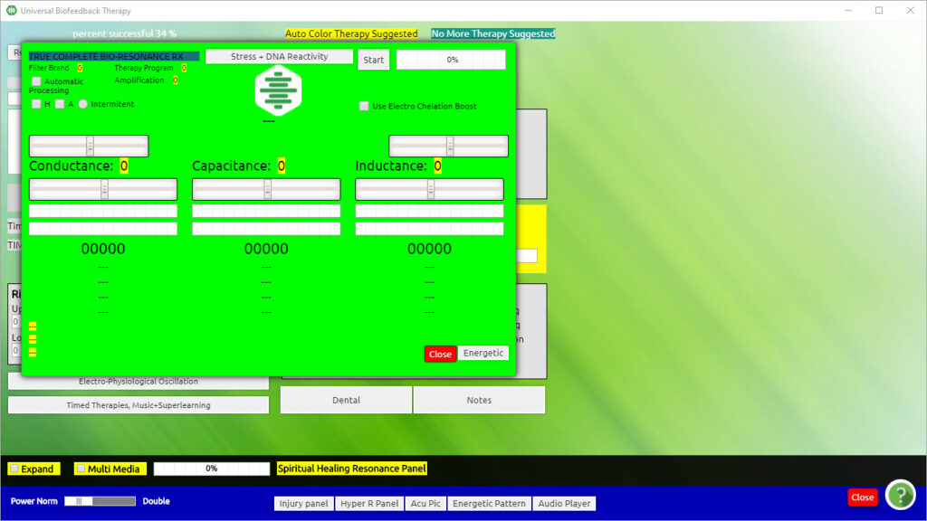
Note: It is possible a message may come up:
“Warning, There is a POSSIBLE Personality Oppression Spirit Superimposition Energetically Detected”.
There will be three options:
Continue
Correct Personality Aberration
Quit and exit Therapy
Click the Continue option in the message box (more in-depth information will be given on this in class)

Spiritual Resonance
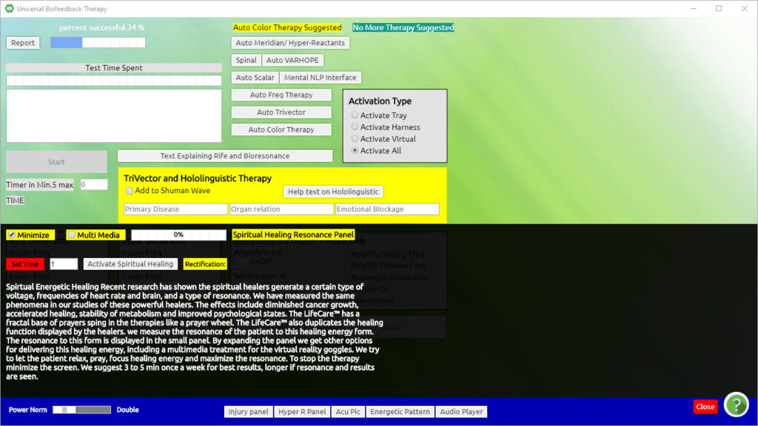
This is a beautiful training protocol that may encourage one’s awareness of the innate healing vibration potential of the body. It will also create a foundation whereby the client can now tolerate a higher rate of frequency. Notice that the power (bottom left corner of the Universal Biofeedback Therapy panel) has now shifted to double after completing this training and will remain double for all the Auto training programs.
From the Main Matrix Screen:
Click Program (top menu bar)
Click Universal Biofeedback Therapy (drop-down list)
On the bottom left side of the Universal Biofeedback Therapy panel, in bright yellow:
Click Expand and it then changes to:
Click Energetic Link
The Spiritual Resonance Training panel appears.
Scroll the time up to one minute (or simply erase 0 and type the numeral 1) in the Set Time box and the Activate Spiritual Healing button appears.
Click Activate Spiritual Healing (Training)
The bar at the top of this panel shows the progression of the training as a percentage of completion.
Once the training has finished, the percentage now represents the rectification value.
If the program completes with anything less than 90% please repeat:
Click Activate Spiritual Healing (Training)

Trivector and Hololinguistic Therapy
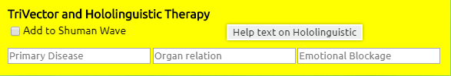
From the Main Matrix screen:
Click Program (top menu bar)
Click Universal Biofeedback Therapy (drop-down list)
At the center of the screen, you will see the green
Therapy panel:
Type in the name of the known stressor(s) in the field of Primary Disease.
For example Stress (if you type in more than one is sure to double space between each one so the system will recognize them as separate items).
Type in which organs are related to that stress in the section Organ Relation.
For example All Organs and Tissues
Type in the Emotional Blockage.
For example Mental Retention of Toxins
Click Add to Schuman Wave
This program runs throughout the session.

Two Suggested Training Programs
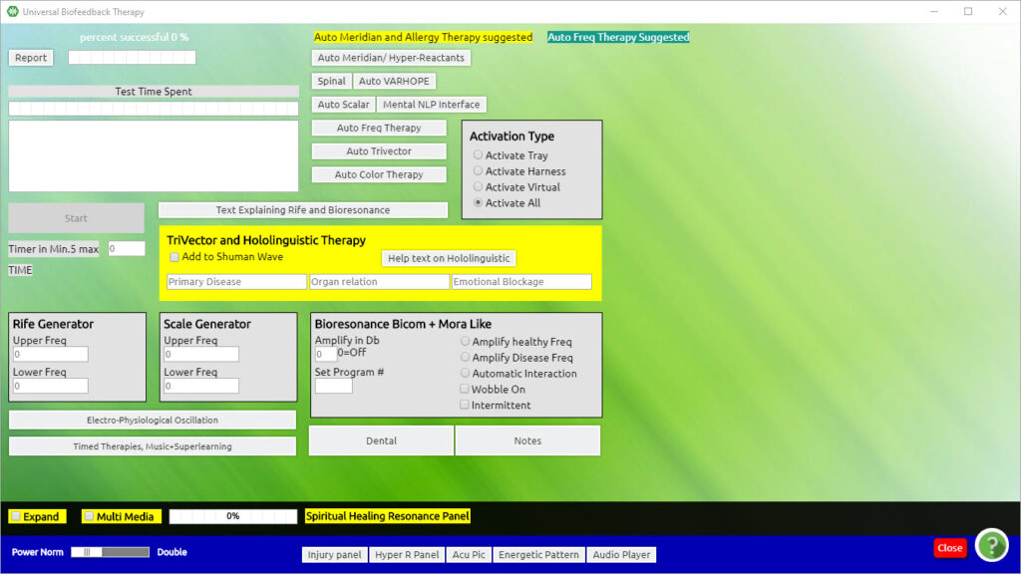
At the top of the screen, you will find two suggested training programs.
These are the suggested Superconscious choices. They are determined by the client’s energy field (through Biofeedback).
The yellow one is the primary Superconscious Choice
Green is the secondary Superconscious Choice.
These colored buttons cannot be clicked on. To select one of the suggested training programs, you must click the appropriate button from the list below.
We will explore some of the main Training Programs accessible through this panel.
Note: In many of the training programs on this page, a particular area will appear highlighted with a specific choice, selection, or suggestion. These are often referred to as Superconscious Choices. They are determined by the client’s energy field (through biofeedback reactivity) and will guide you in training program options.

Auto Colour Therapy
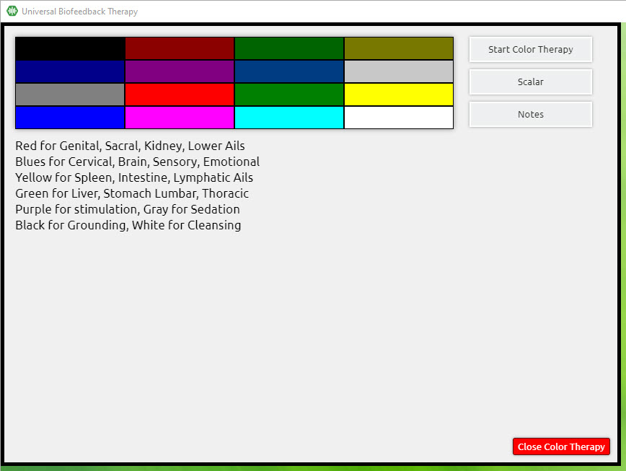
This program will flash through 256 different energetically harmonizing colors, eventually stopping on the most beneficial color.
From the Main Matrix screen:
Click Program (top menu bar)
Click Universal Biofeedback Therapy
Click Auto Color Therapy
Click Start Color Therapy
Click Close Color Therapy
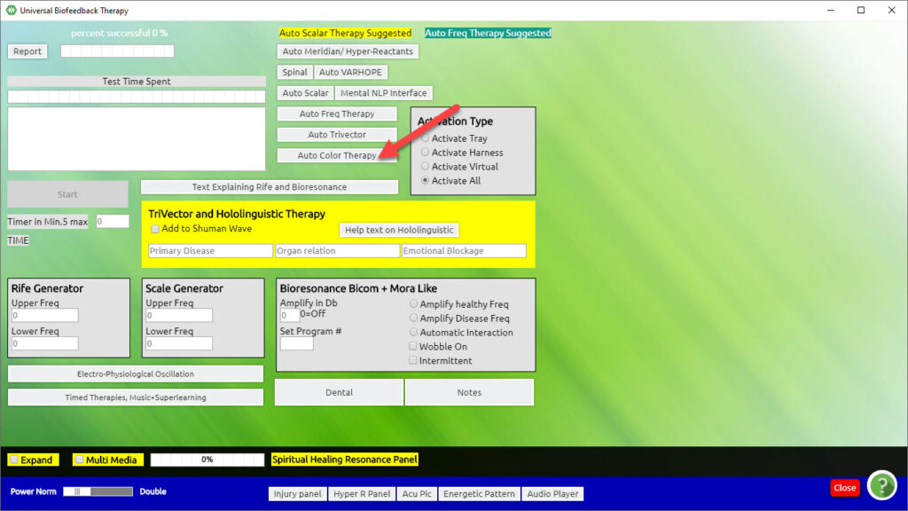

Chapter 9

Superlearning
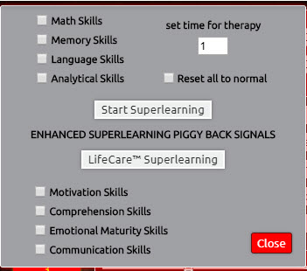
From the Main Matrix screen:
Click Program (top menu bar)
Click Timed Cybernetic Feedback Therapy, Music, Superlearning (drop-down list)
Click Quick Check Phase
Click Enhanced Learning
A grey panel appears.
Click appropriate selections
Set Time to 1 minute
(Time can be set for a maximum of 30 minutes).
Click Start Superlearning
Click Harmonic Therapy (optional)
Click Homeopathic Superimposition to add a specific learning frequency or suggestion/affirmation to be piggybacked along with the process.
Consider typing in the index number of some of the following Main Matrix items (making sure to DBL space between the numbers):
670: Memory (NV)
3325: LM 26 Memory
7011: 14 Essential Brain Nutrients
946: Remedy for Learning Disability
947: Remedy for Brain Circulation
Click Quick Check of Phase (with Harness, optional)
– Or –
Click Virtual Quick Check of Phase (without Harness using subspace, optional)
Click Harmonic Therapy (with Harness, optional)
– Or –
Click Virtual Harmonic Therapy (without Harness using subspace, optional)
Repeat this training protocol until all the bars on the graph are aligned to the left.
Click ED.X and NUCLEUS Superlearning (optional)
Note:
The Special ED.X and NUCLEUS or AFE Training Programs are found in different parts of the ED.X and NUCLEUS Software. They can be recognized by the word ED.X and NUCLEUS or AFE in the name.
These are only available when your ED.X and NUCLEUS device is connected to your computer.
They are different from other Training Protocols as they need to be activated from within the ED.X and NUCLEUS IS WORKING Box.
Click Enhanced Learning
Click ED.X and NUCLEUS Superlearning
Click and drag the ED.X and NUCLEUS IS WORKING box up, so you can see the full panel.
(To do this, you will need to click on the top border of the ED.X and NUCLEUS IS WORKING box, and, without releasing the click, drag it up so that the whole panel is fully visible).
Click Start Superlearning (in the lower right panel of the ED.X and NUCLEUS IS WORKING box)
To the bottom right you will notice 000. When it begins to rectify, these numbers will change. At first, you will see a rectification of 60 and it will then proceed to 100. This program is auto-focusing (self-selects the number of minutes needed) so you can expect it to take anywhere from a few to several minutes before rectifying.
Click End Superlearning (in the lower right panel of the ED.X and NUCLEUS IS WORKING box)
A pop-up box will appear for you to read.
Click OK.
Click Close.
Click OK on the pop-up box again.
Click Close.

Timed Therapies

From the Main Matrix screen:
Program (top menu bar)
Timed Cybernetic Feedback Therapy, Music, Superlearning (drop-down)
Timed Treatments (Training)
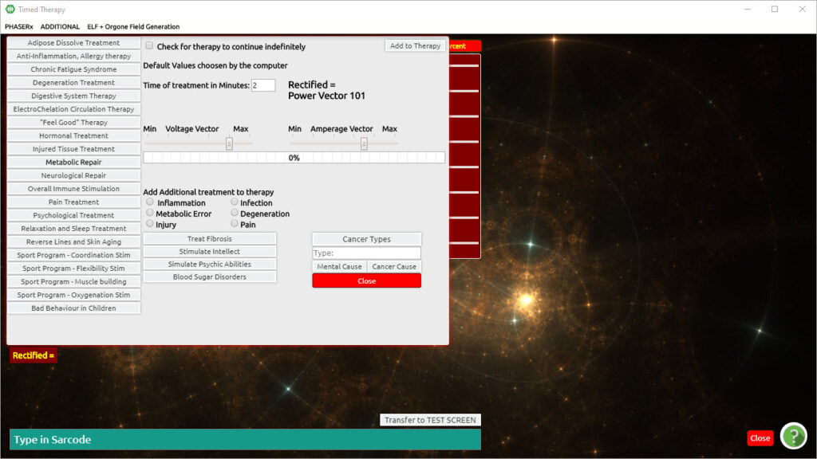

To adjust the time in minutes: click, hold and drag the slider.
-the highlighted item in bold text (Superconscious Choice)
By clicking on this any of the grey buttons, the training protocol will begin.
Repeat any choice three times, rectifying to 85 or better.

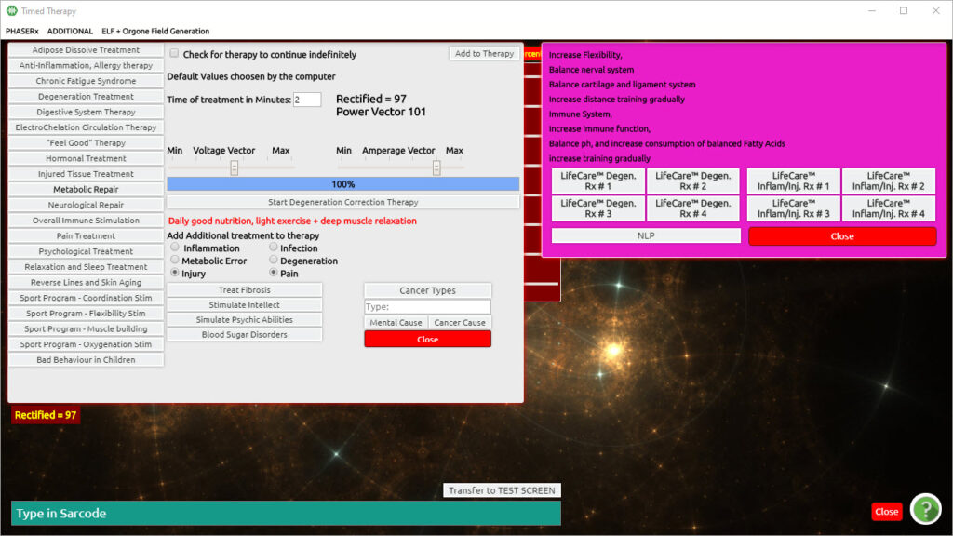

Chapter 10

ECG Fast Fourier Transform
From the Main Matrix screen:
Click Program (top menu bar)
Click Universal Biofeedback Therapy (drop-down list)
Click Electro-Physiological Oscillation
The ECG Fast Fourier Transform Panel now appears.
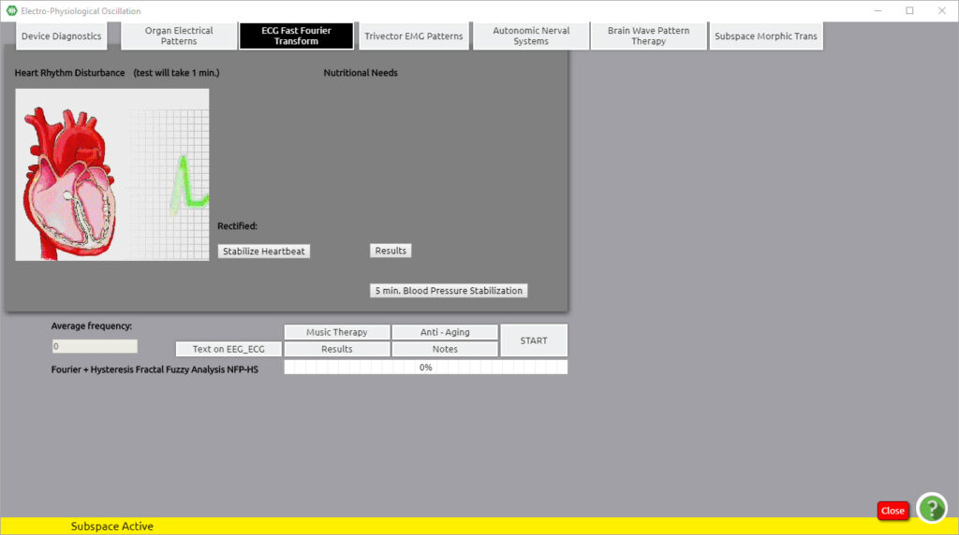
Click Start
Click OK
Click OK (finished)
Nutritional and organ-related energetic reactions are listed in a grey box.
Double Click the background of this grey box to remove it.
Click Stabilize Heart Beat – Repeat up to three times, attempting to rectify to 85 or better
Click Close

Superconscious Reduction Panel
From the Main Matrix Screen:
Click EPR Enhancements (top menu bar)
Click Client Superconscious Reduction Panel (drop-down list)
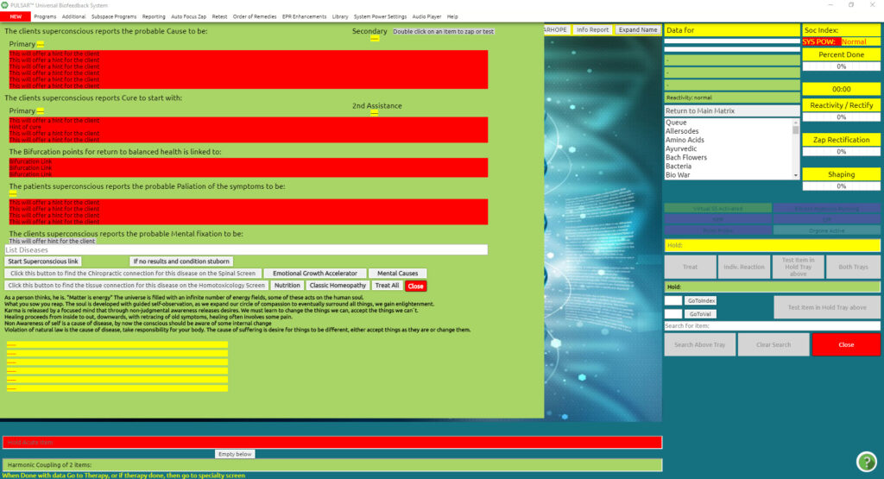

In the List Disease box, type in any concern of the client
For example, Resistance to change or Stress
Click Start Superconscious Link
Click Treat (Train) All

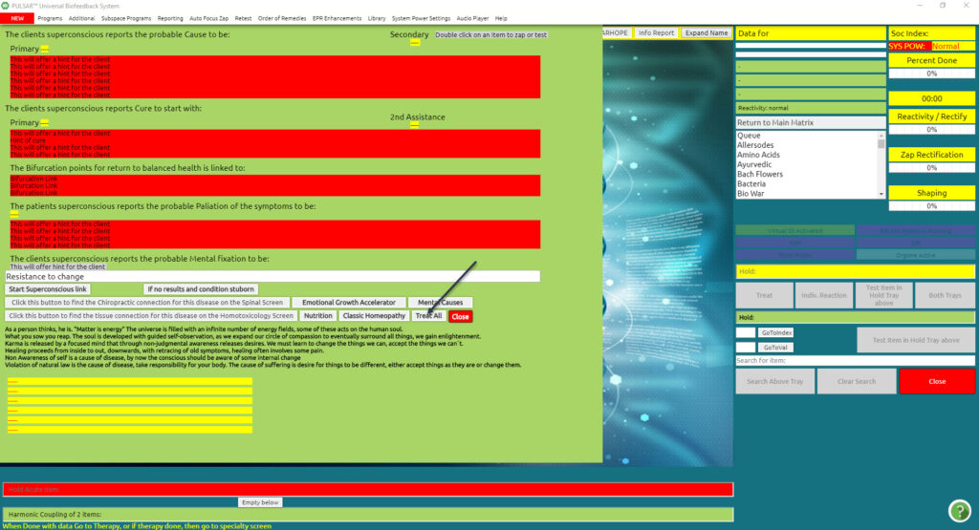

Autonomic Nerval System
From the Main Matrix screen:
Program (top menu bar)
Universal Biofeedback Therapy (drop-down list)
Electro-Physiological Oscillation
Autonomic Nerval System tab (top menu bar)
The Autonomic Nerval System screen appears.
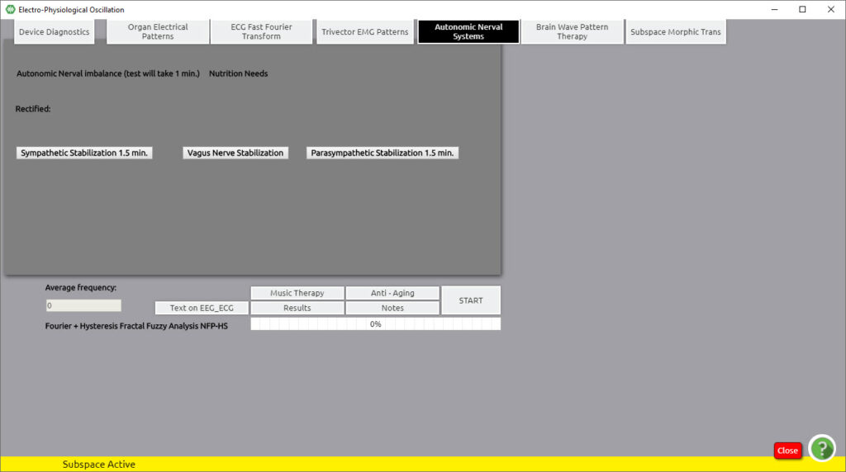

Start (will test for one minute)
Train Vagus Nerve Parasympathetic, or Sympathetic Stabilization
Depending on which is indicated in the grey report panel. Consider balancing each nervous system (for a complete relaxation experience). If the client is in good health and has no history of Vasovagal episodes
Vagus Nerve Stabilization (rectify to 85 or above)
Parasympathetic Stabilization (rectify to 85 or above)
Sympathetic Stabilization (rectify to 85 or above)
Close
***CAUTION*** Possible Undesirable Side Effects:
Before training on the Autonomic Nerval System it is advised to ask your client: Do you have a history of Vasovagal Episodes, fainting, syncope, and/or generalized heart weakness? If the answer is yes, you need to proceed with caution, and be aware of the symptom of Vasovagal Episodes:
- A slight feeling of light-headedness after a session. Please note that this may be due to the client’s own health such as low blood pressure, or suddenly standing up after being in a relaxed, reclined position during the session. If this feeling seems abnormal in any way, or of concern, then the client should see their primary healthcare practitioner.
- Through biofeedback electrical nerve stimulation; interaction with the CNS the ED.X and NUCLEUS may induce an autonomic nervous system cascade that can lead to a Vasovagal crisis. The client might sweat excessively or report nausea and dizziness. If this occurs, place a cool wet rag over their eyes gently with light pressure, tell the client to relax and breathe deeply, and wait about 5 to 10 minutes for the Vasovagal Storm to pass. In extreme cases, there might be syncope (fainting).

VASOVAGAL Reaction
Biofeedback systems using skin resistance all use the stimulation of electricity.
Some clients may have a Vasovagal reaction when their system tries to shift from sympathetic nervous dominance to a more relaxing para-sympathetic dominance. If this happens too fast there can be a Vasovagal episode.
A Vasovagal episode. A vasovagal response or Vasovagal attack (also called Neurocardiogenic Syncope) is mediated by the Vagus nerve. When it leads to syncope (fainting) it is called Vasovagal Syncope, which is the most common form of fainting.
Symptoms
In clients with Vasovagal episodes, the episodes are typically recurrent, usually happening when the client is exposed to a specific trigger. The initial episode often occurs when the person is a teenager, and then recurs in clusters throughout their life. Prior to losing consciousness, the individual frequently experiences warning symptoms such as lightheadedness, nausea, sweating, ringing in the ears (tinnitus), uncomfortable feeling in the heart, weakness, and visual disturbances such as lights seeming too bright, fuzzy, or tunnel vision. These last for at least a few seconds before consciousness is lost (if it is lost), which typically happens when the person is sitting up or standing. When sufferers pass out, they fall down (unless this is impeded); allowing the person to wake up.
The autonomic nervous system’s physiologic state leading to loss of consciousness may persist for several minutes, so:
- If sufferers try to sit or stand when they wake up, they may pass out again;
- The client may be nauseated, pale, and sweaty for several minutes.
Vasovagal syncope is rarely life-threatening in and of itself but is mostly associated with injuries from failing while having an episode.
The Autonomic Nervous System has two parts 1) the Sympathetic for stress (fight-or-flight) also known as the Thoracic Lumbar, and 2) the Parasympathetic for immunity and digestion, also known as the Cranial Sacral Nerval system. To stimulate the Parasympathetic system apply cold compresses for five minutes to the upper neck and sacrum, and then alternate with warm compresses for five minutes.

What to Do
The method of dealing with Vasovagal syncope focuses on avoidance of triggers, restoring blood flow to the brain, and measures that interrupt the process; such as cold and hot compresses. Also to avoid physical injury due to fainting.
Because Vasovagal syncope causes a decrease in blood pressure, relaxing the entire body as a mode of avoidance isn’t favorable. The client can cross their legs and tighten leg muscles to keep blood pressure from dropping.
Before known triggering events, the client may increase the consumption of salt and fluids to increase blood volume. Sports and energy drinks may be particularly helpful.
Clients should be educated on how to respond to further episodes of syncope, especially if they experience pre-warning signs: they should lie down and raise their legs, or at least lower their head to increase blood flow to the brain.
If the client has lost consciousness, they should be laid down with their head turned to the side. Tight clothing should be loosened. If the inciting factor is known, it should be removed if possible (for instance, the cause of the pain).
Wearing graded compression stockings may be helpful.
There are certain orthostatic training exercises that have been proven to improve symptoms in people with recurrent Vasovagal syncope.
How do I use my Biofeedback device with a client who has a history of Vasovagal episodes?
Do NOT use maximum settings for too long and stay at the safe calibrated levels. This will reduce the possibility of a Vasovagal episode. Always ask if there is a history of Vasovagal episodes, most often fainting or cold sweats with heart palpitations. If so always use low-calibrated settings. Do not try to push therapy after therapy on the client with a Vasovagal episode history. Please always keep a watchful eye on the client who is getting therapy on electrical stimulation. Be prepared to respond. Respond by cold water on the face gently and/or gentle pressure over the eyes with a cold rag. Push with your knuckle on the acupuncture emergency spot above their upper lip in the cleft under their nose (note, the point is on the bone so, therefore, push hard to apply pressure to the bone). Lie the client down, and be cautious that they do not stand up too fast. Reduce stress and wait for ten minutes. It will most likely pass. Do not let them leave until they are better.

Call 911 if they pass out for more than a minute, have pain or vomiting, or anytime your better judgment tells you to call 911. Report the fainting spell to the 911 crew.

Chapter 11

Bones, Nerves, Circulation, Lymph, Digestion
These training programs can all be operated in the same way as the Muscles above.
From the Main Matrix screen:
Click Program (top menu bar)
Click Spinal Muscular Re-Education, Sarcode Feedback
Click Bones, Nerves, Circulation, Lymph, Digestion, Eye, or Sinus
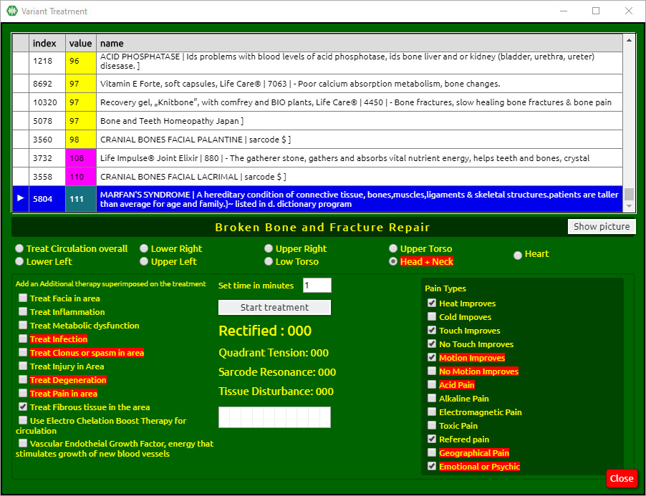
Click on an item to highlight the line
Click in the little box next to each additional item that would be appropriate to add as a piggyback signal—[These are found in the section Add an additional therapy superimposed on Treatment (Training)].
Click Start Treatment (Training)
– Or –
Choose a special focus by clicking the desired area’s radio button (Lower Right, Upper Right, Upper Torso, Heart, Low Torso, Lower Left, Or Head and Neck). Only one choice can be selected at a time.
The timer can be left on the default of 0 or set for 1 minute.
Click Start Treatment (Training)
Click OK in the Treatment (Training) Over the box
Repeat up to three times, attempting to rectify to 85 or better
Click Close
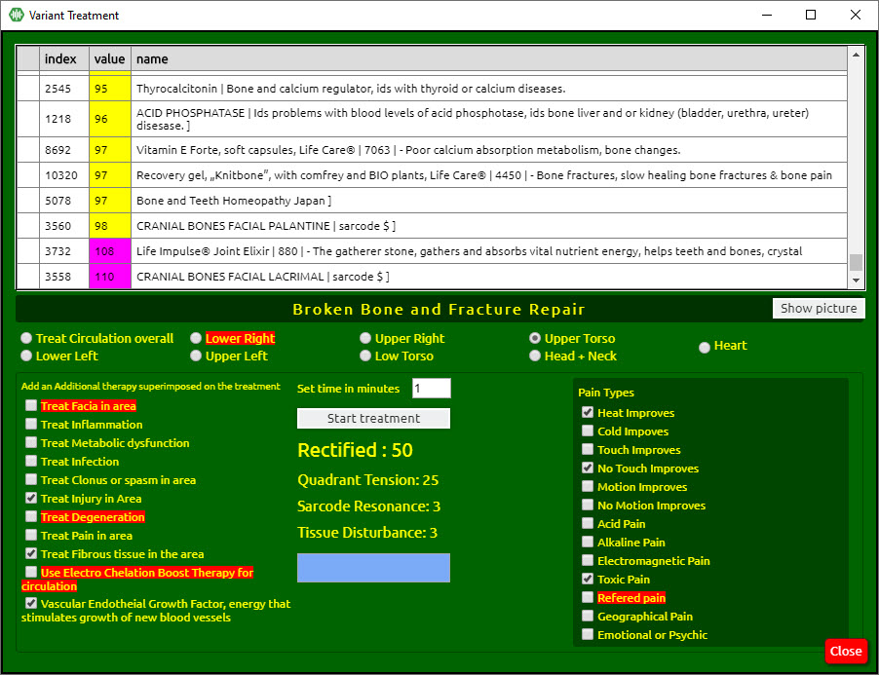

Spinal Muscular Re-Education, Sarcode Feedback
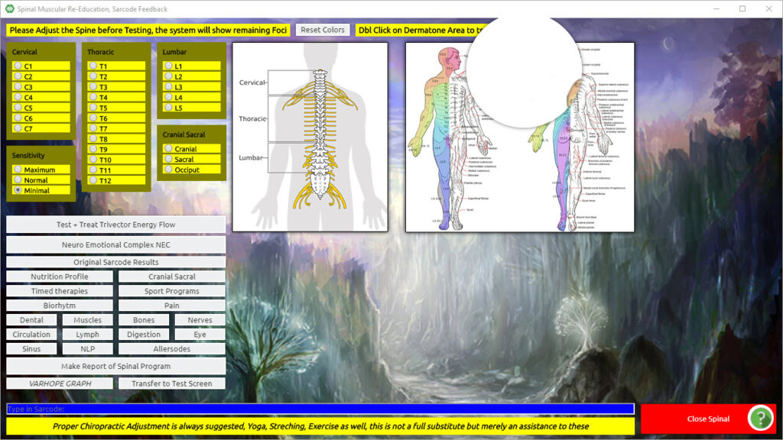
From the Main Matrix screen:
Click Program (top menu bar)
Click Spinal Muscular Re-Education, Sarcode Feedback
Click Test and Treat (Train) Trivector Energy Flow
Repeat until all vertebrae are marked as corrected.
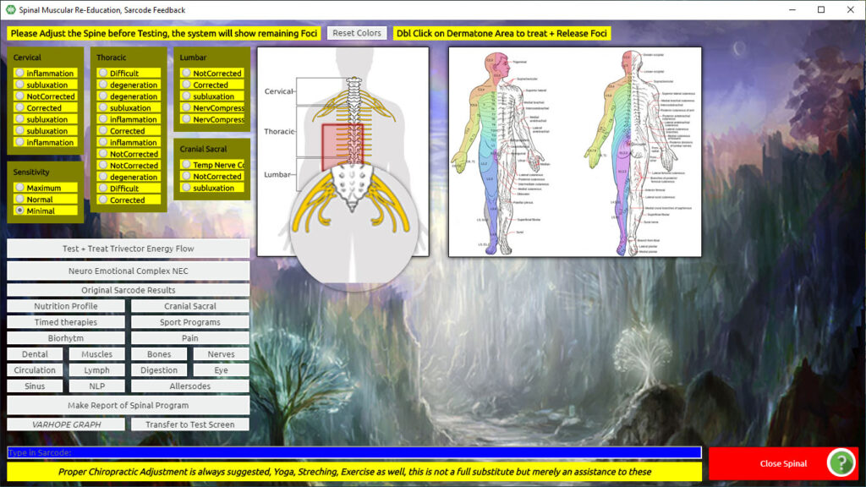
Click OK, YES or No (to any pop-up boxes that may come up during the process)
From the Main Matrix screen:
Click Program (top menu bar)
Click Spinal Muscular Re-Education, Sarcode Feedback
Click Muscles
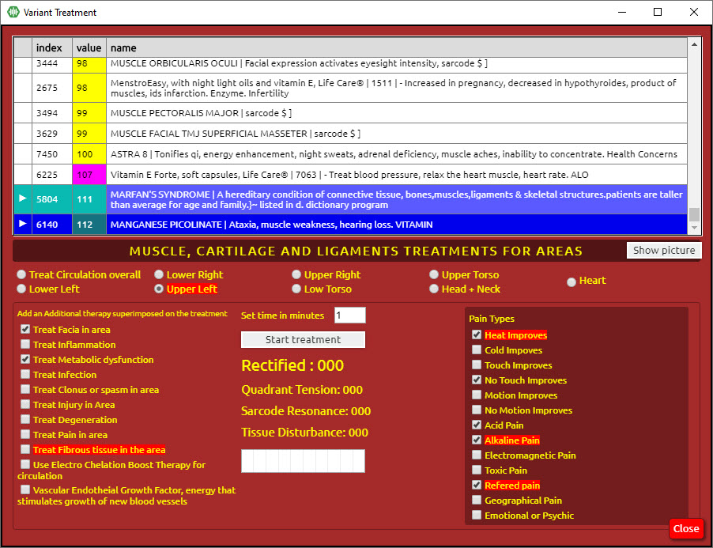
The program will isolate a particular muscle sarcode, ligament, or tendon based on reactivity; this will be indicated by a small arrow in the upper panel listing the matrix items.
Click on this item to highlight the line
Click in the little box next to each additional item that would be appropriate to add as a piggyback signal—[These are found in the section Add an additional therapy superimposed on Treatment (Training)].
Click Start Treatment (Training)
– Or –
Choose a special focus by clicking the desired area’s radio button (Lower Right, Upper Right, Upper Torso, Heart, Low Torso, Lower Left, Or Head and Neck). Only one choice can be selected at a time.
The timer can be left on the default of 0 or set for 1 minute.
Click Start Treatment (Training)
Click OK in the Treatment (Training) Over the box
Repeat up to three times, attempting to rectify to 85 or better
Click Close
– Or –
Click anywhere on the upper panel and begin to scroll up or down, using the up/down arrow keys on your computer keyboard until you find the specific muscle sarcode you are seeking.
Click each additional item that would be an appropriate piggyback signal
Click to highlight the muscle you want to train
Click Start Treatment (Training)
Click OK in the Treatment (Training) Over the box
Repeat up to three times, attempting to rectify to over 85 or better
Click Close.

Timed Biofeedback Therapies

From the Main Matrix screen:
Click Program (top menu bar)
Click Spinal Muscular Re-Education, Sarcode Feedback
Click Timed Therapies
Often there is a Superconscious choice highlighted in red on this panel. If so:
Click the red highlighted item (the timer default is set to one minute)
Click Start (in the lower right of the screen-rectify to 85 or above)
If there is not a red highlighted item, unclick any items that may have been checked in the yellow boxes as piggybacks and
Click Repeat Unconscious Search
Once the red highlight shows:
Click the red highlighted item
Click Start (rectify to 85 or above)
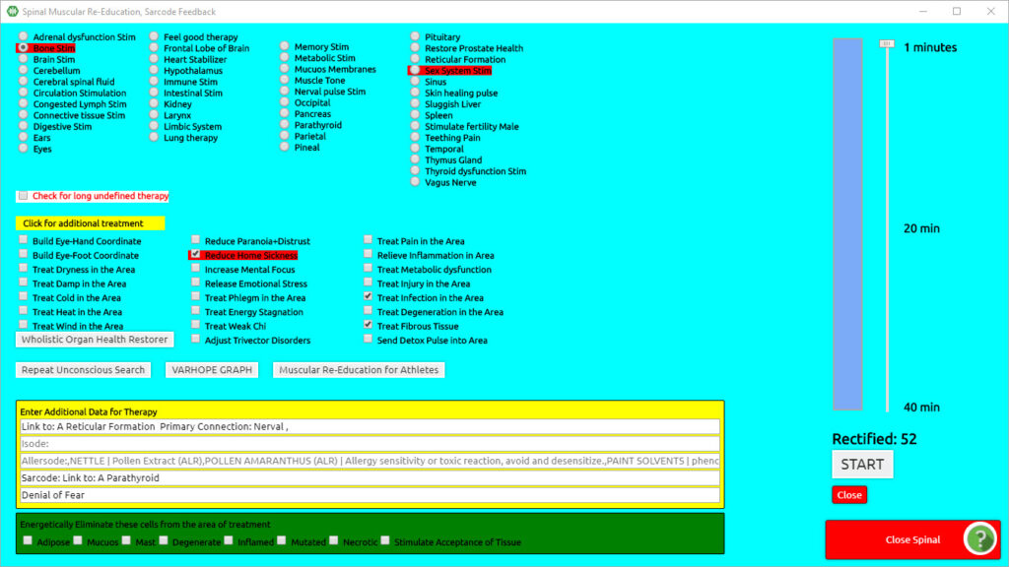

Chapter 12

Hormonal Training Program
From the Nutrition panel:
Click Male or Female Problems (depending on the client, the button will show as male or female)
Click Do you wish to use the Questions? Yes or No
Selecting Yes will provide a questionnaire that will fine-tune the training protocol.
Click Hormone Balance – rectify to 85 or above
Click Ovaries Balance or Prostate Balance – rectify to 85 or above
Click Close.
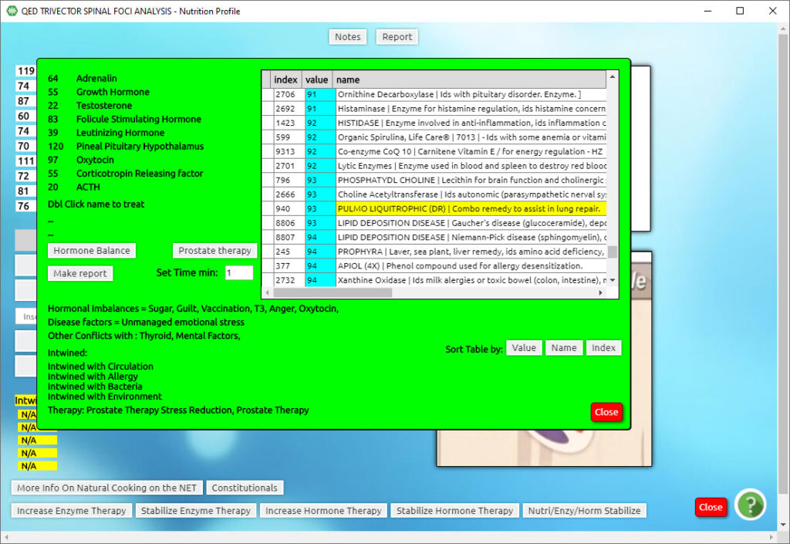

Internal Enzymes
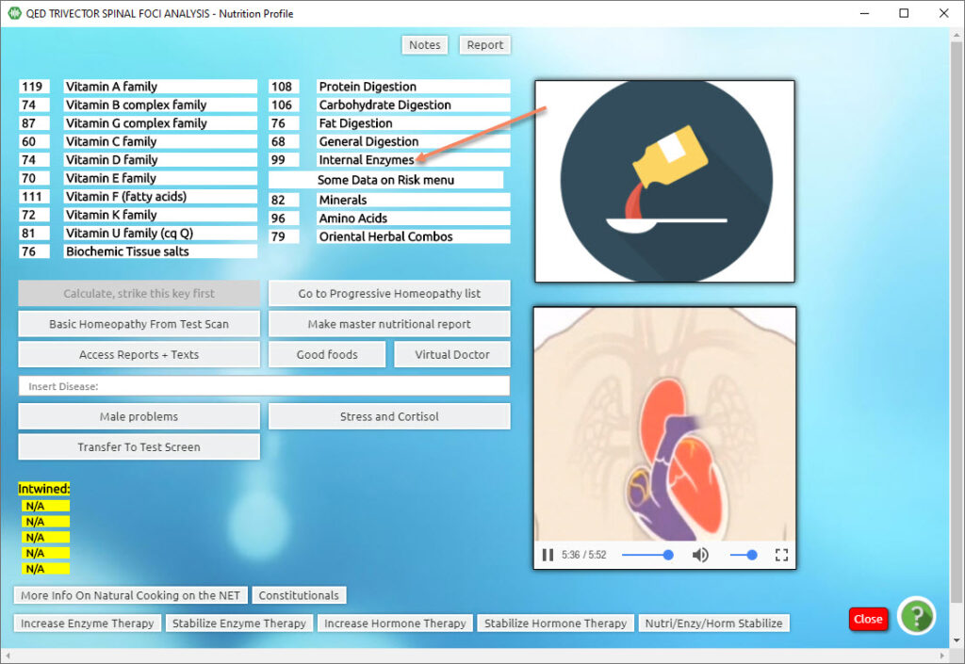
From the Nutrition panel:
Internal Enzymes
-on the highlighted item – rectify to 85 or above
Close
Nutrienergy Balance (from the panel behind – rectify to 85 or above)
Close.

Nutrition and Homeopathy Feedback

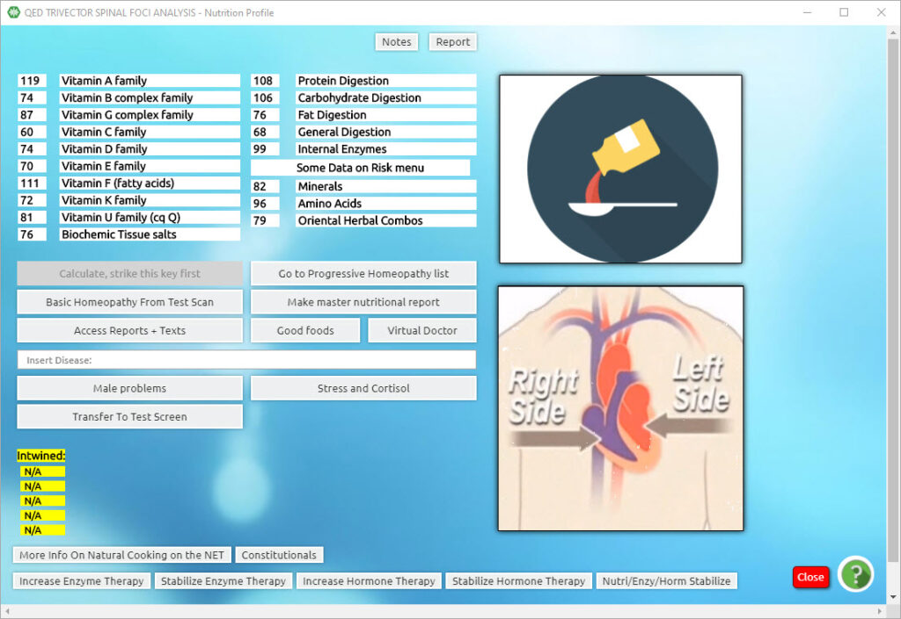

From the Main Matrix screen:
Program (top menu bar)
Nutrition and Homeopathy Feedback (drop-down list)
Calculate Strike This Key First (values for various vitamins etc. appear)
OK in the pop-up box
DBL Cis any specific Vitamin name to reveal individual items of that group in the degree of reactivity. Anything over 100 is significant.
Nutrienergy Balance
This will provide a training protocol for the whole group of items.
Rectify any choices to 85 or above

Stress and Cortisol
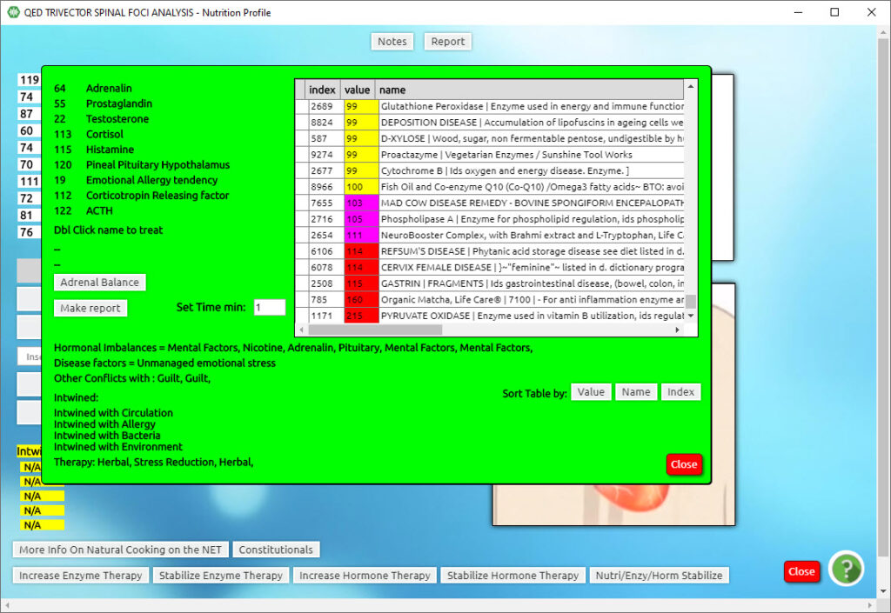

From the Nutrition panel:
1. Stress and Cortisol
2. Do you wish to use the Questions? Yes or No
Selecting Yes will provide a questionnaire that will fine-tune the training process.
3. Adrenal Balance – rectify to 85 or above
4. Close.

Chapter 13

Stimulate Emotional Growth Stress Reduction
From the Main Matrix screen:
Click Programs (top menu bar)
Click NLP Emotional Growth Stress Reduction (drop-down list)
(Rectify all chosen Training Protocols to 85 or above)
Click Stimulate Emotional Growth (stabilizes defense mechanisms)
Click Therapies (top menu bar)
Click Unconscious choice of therapy (bottom of drop-down list) – after half a minute or so, an item will appear in a blue bar at the bottom left of the screen (right below where Rectified: is).
Double Click the item posted in the blue bar.
Click Close.
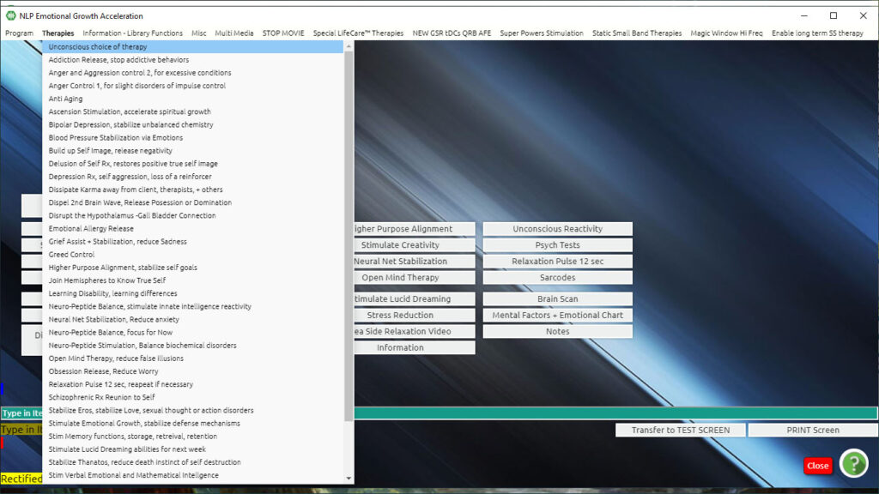
– Or –
Consider adding the following options:
Click Dissipate Karma
Caution: This is a very powerful selection and it is possible to expect that life may rapidly produce situations presenting opportunities to change old patterns of thought and behavior that are no longer conducive to well-being. A possibility would be to follow up with Ascension Stimulation and Higher Purpose Alignment.
Click Ascension Stimulation – for accelerating spiritual growth
Click Higher Purpose Alignment – for self goals
Click Stimulate Insight – for self-awareness
Click Stimulate Creativity – for inner potential
Click Neural – Net Stabilization – for anxiety reduction
Click Neuro-Peptide Stimulation – for biochemical disorders
Click Neuro-Peptide Balance – for focus and “get-up-and-go”!
Click Stim Memory – for memory functions of storage, retrieval, and retention
Click Stim Intelligence – for verbal, emotional, and mathematical intelligence
Click Open Mind Therapy – for reducing false illusions
Click Disrupt the Hypothalamus Gall Bladder Connection – for obsessive-compulsive behaviors
Click Close (when complete with choices).

Chapter 14

Other Biofeedback Choices
Any choice can be made from the drop-down list of items – watch the rectified value in the top menu bar.
Click End Therapy -This will end the program.
Close.
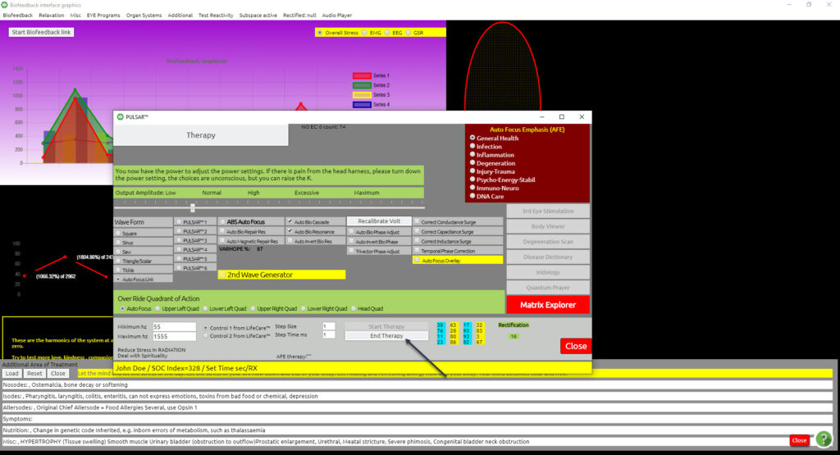

Reduce Stress in Nerves
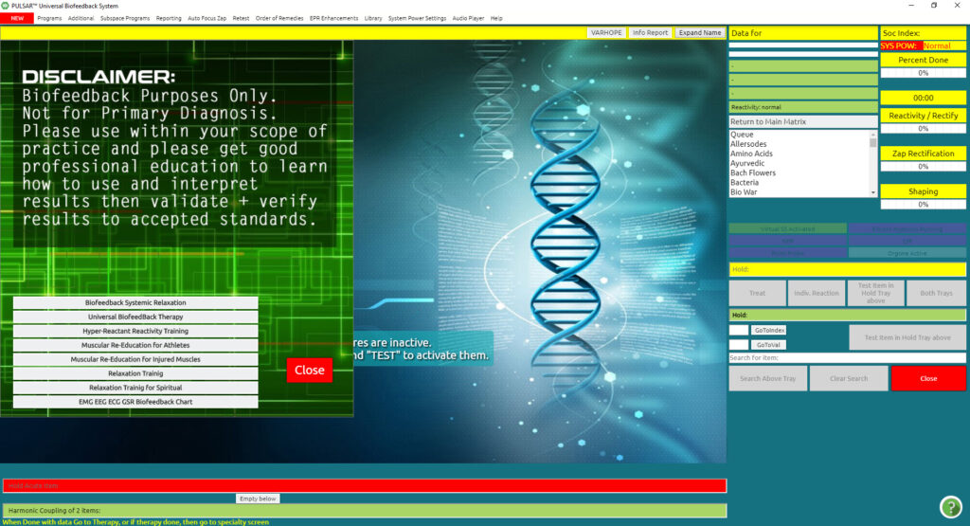

From the Main Matrix screen:
Click Programs (top menu bar)
Click Biofeedback Systemic Relaxation (drop-down list)
Click Biofeedback Systemic Relaxation (from the grey box)
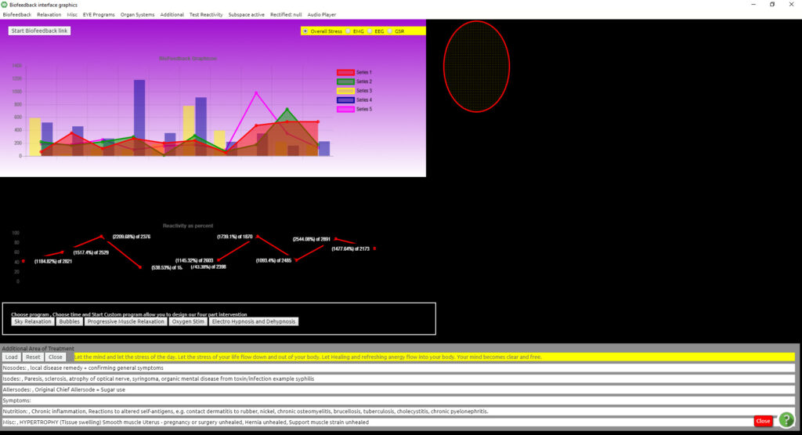

Click Biofeedback (top menu bar of the Biofeedback Panel)
Click Reduce Stress in Nerves (drop-down list)
Watch the “Rectified” value in the top menu bar on the right side. When the Training Protocol is complete, the rectification score will stop changing. For the Biofeedback program, it is important to realize that you must stop it yourself or it will continue indefinitely. The panel will continue to flash until you:
Click End Reduce Stress in Nerves Therapy – This will end the program.
Any choice can be made from the drop-down list of items – watch the rectified value in the top menu bar.
Click Close

Chapter 15

Body Scan and Face Therapy
From the Main Matrix screen:
Programs (top menu bar)
Body Scan and Face Therapy (drop-down list)
Scan All (top center of the screen) – let this complete
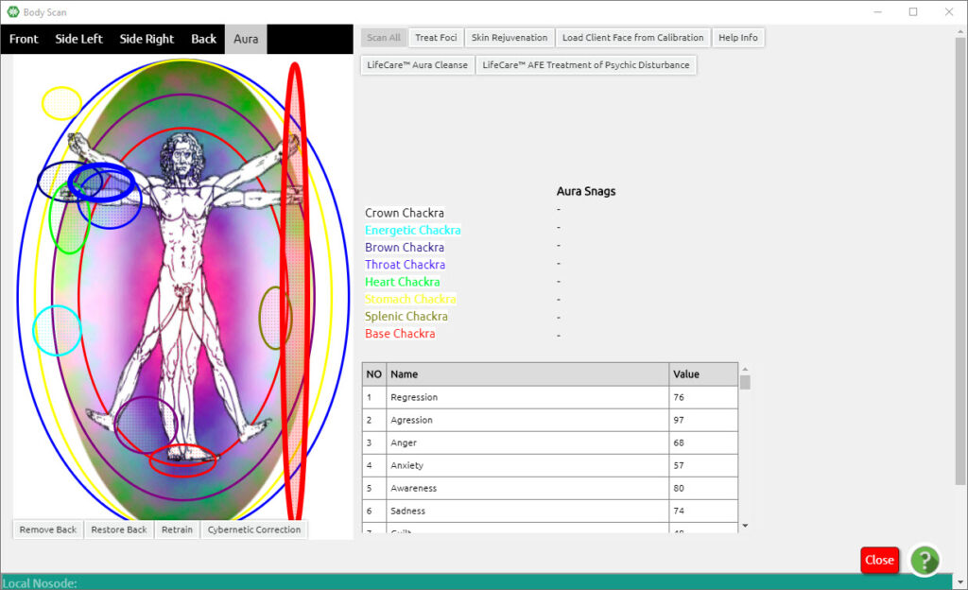

Front (upper left of the screen)
Treat Foci until there are no longer any red or purple (Foci detection) nets on the diagram (Do not mistake the Crown or Base Chakra for Foci as they are shown in the same color)
Side Left (upper left of the screen)
Treat Foci (as above)
Side Right
Treat Foci (as above)
Back

Appendix A

EDUCATIONAL LANGUAGE

Example #1:
A client reports: “I have a sore throat. What can I do about it?”
A diagnostic response would be: “Your sore throat is probably strep because that is what has been going around”. The practitioner is diagnosing what is wrong, by telling the client why she/he has a sore throat.
A prescriptive response would be: “Take vitamin C three times a day for a week, and drink slippery elm tea to soothe your throat and you will feel better”.
An educational response would be: “When I feel like that, I take extra vitamin C, and drink tea made from slippery elm bark. If you look up and read material on these two substances you can learn about their relationship to building the immune system and how the bark of the slippery elm has been used to soothe mucous membranes throughout the body and ease the soreness of my throat. I find that it also tastes good”.
Example #2:
A client reports: “My knee is really bothering me. It hurts every once in a while, ever since a high school football injury. Lately, it just hurts all the time. I’m tired of taking these painkillers constantly, I’m sure it can’t be good for me. What else can I do?”
A diagnostic response would be: “You probably have arthritis in your knee”. Or, “Arthritis usually starts several years after an injury”.
A prescriptive response would be: “Try taking Glucosamine three times a day, to decrease the swelling in your knee, and the pain will subside”.
An educational response would be: “Some of my other clients have told me that some dietary supplements are reported to reduce the swelling and decrease the pain in their joints. You might want to read up on the effects of adding Glucosamine to a daily routine”.

Using educational language verbally throughout your session, and using only educational and “client” language throughout all of your written forms, notes, and materials in your record-keeping is important both legally and ethically. It is not illegal to inform and educate about wellness and health, yet the interpretation of how the information is conveyed can make the difference between being viewed by some as “practicing medicine without a license” or not. Educating and empowering the client is the ultimate goal of the practitioner. Practicing with high professional integrity and competency is imperative.

INCORRECT TERM | CORRECT TERM | COMMENTS
Cure | Re-educate and Relax | Cure: to correct, heal, mend, regenerate, rehabilitate, relieve, remediate, repair, restore, treat or otherwise help a person recover from any medical or psychological condition. It is illegal for any unlicensed professional to cure or treat any condition, disease, or disorder. It is illegal for any unlicensed professional to cure a medical or psychological condition, disease or disorder. Re-Educate: to educate again, as for new purposes; to re-develop or re-train. Relax: to make less tense, rigid, or firm, make lax; to relax the muscles; to release or bring relief from the effects of nervousness and tension, and anxiety; to become less intense.
Diagnose | Relaxation training programs manage the stress related to the reactivity of a tri-vector signature. | Diagnose: to analyze, appraise, assay, assess, calculate, evaluate, estimate, examine, experiment, gauge, guess, investigate, judge, probe, rank, rate or reckon any medical or psychological condition, disease or disorder. It is illegal for any unlicensed professional to diagnose a medical or psychological condition, disease or disorder. Relax: to make less tense, rigid, or firm, make lax; to relax the muscles; to release or bring relief from the effects of nervousness and tension, and anxiety; to become less intense. Biofeedback is a practice that enables an individual to learn how to relax and change some physiological activities for the purpose of improving health.

INCORRECT TERM | CORRECT TERM | COMMENTS
Diseased | Stress | Disease: a disordered or incorrectly functioning organ, part, structure, or system of the body resulting from the effect of genetic or developmental errors, infection, poisons, nutritional deficiency or imbalance, toxicity, or unfavorable environmental factors; illness; sickness; ailment. Only licensed healthcare professionals can treat a disease. Stress: a biological reaction to physical, emotional, mental, psychological, or spiritual stimuli, whereby normal functioning is compromised.
Patient | Client | Patient: the term “Patient” is applied to clients under the care of a licensed healthcare professional. Certified Biofeedback Technicians and Specialists use the term “Client”. Client: a customer; a person that engages the professional services of another.
Prescribe | Educate and Coach | Prescribe: to advise, apply therapies, coerce, counsel, manipulate, promote, recommend, require, suggest, or otherwise treat a client. Educate: to train by formal instruction and supervised practice; to provide information. Coach: one who instructs trains. As Certified Biofeedback Technicians and Specialists, we educate and coach the clients to increase their awareness.

INCORRECT TERM | CORRECT TERM | COMMENTS
Test | Electro Dermal Response Stress Reaction | Test: a particular process or method for trying and assessing; to examine or evaluate. Electro Dermal Response (EDR): a technique by which sensors monitor the skin’s electrical resistance. Biofeedback devices measure the voltage, current, and resistance of the skin. Certified Biofeedback Technicians and Specialists are trained to use biofeedback equipment to measure the Electro Dermal Response stress reactions and to teach their clients how to relax and re-educate their muscles, so they can manage their stress and pain.
Therapies | Training Programs | Therapies: the treatment of disease or disorders, as by some remedial, rehabilitating, or curative process; a curative power or quality. Training Programs: for the purpose of correct verbiage, we will refer to the biofeedback programs as training programs Trained practitioners can teach clients how to relax, and re-educate their muscles in order to manage their stress and pain.
Therapist | Certified Biofeedback Technician or Specialist | Therapist: one who specializes in the provision of a particular therapy; one specializing in therapy, especially a person trained in methods of treatment. Certified Biofeedback Technician or Specialist: a person trained to use biofeedback equipment to measure the biological activities of their clients, in order to teach their clients how to relax and re-educate their muscles, so they can manage their stress and pain.

INCORRECT TERM | CORRECT TERM | COMMENTS
Therapy | Relaxation Training | Therapy: the treatment of disease or disorders, as by some remedial, rehabilitating, or curative process; a curative power of quality. Relaxation Training: to help make less tense, rigid, or firm, make lax; to help relax the muscles; to help release or bring relief from the effects of nervousness and tension, and anxiety; to help become less intense. Replace the word therapy, treat, or treatment with Train or Training Program. Biofeedback is the process of helping clients measure and changes their biological activities by relaxing and re-educating their muscles in order to help them manage their stress and pain.
Treat | Train | Treat: to deal with a disease or a patient in order to relieve or cure; to care for or deal with medically or surgically. Train: to form by instruction or discipline; to teach so as to make fit, qualified, or proficient; to make prepared (as by exercise) for a skill. Biofeedback training programs use electrical impulses to reduce Electro Dermal Response stress reactions. To treat is to attempt to cure by various means. In most jurisdictions, it is illegal for any unlicensed professionals to treat any medical or psychological condition, disease, or disorder.

TERMINOLOGY for PRACTITIONERS

The ED.X and NUCLEUS System utilizes five comfortable, conductive straps that envelop the wrists, ankles, and forehead. Once the Calibration process is complete, a three-minute Electro Dermal Response stress reaction test is performed with results displayed on the ED.X and NUCLEUS computer software interface.
Through the use of biofeedback training programs, Certified Biofeedback Technicians and Specialists can train their clients with stress reduction training programs for muscle re-education, relaxation training, pain management, and brainwave training to improve the quality of their lives.
The programs are “relaxation training for tri vector signature”. Trivector signatures appearing on the program should not be discussed with clients.
Certified Biofeedback Technicians and Certified Biofeedback Specialists and Unlicensed Practitioners are trained to be professional providers but are not qualified to diagnose, treat, cure or prevent any medical or psychological condition, disease, or disorder. By law, it is illegal in the US, Canada, and most other jurisdictions, it is legal for qualified professionals to practice Biofeedback as long as they do not claim to diagnose, treat, cure or prevent any medical or psychological disorder, disease, or condition. In addition, they may not use any terms that imply any of the aforementioned.
The following are guidelines for practicing with safe terminology:
DO NOT Assess DO NOT Make Claims or Promises
DO NOT Counsel DO NOT Prescribe
DO NOT Cure DO NOT Recommend
DO NOT Detect DO NOT Repair
DO NOT Diagnose DO NOT Scan
DO NOT Evaluate DO NOT Test
DO NOT Heal DO NOT Treat
DO NOT Identify DO NOT Use the word “Disease”
- The items mentioned above are not within the scope of biofeedback.
- We use biofeedback stress reduction training programs for muscle re-education, relaxation training, pain management, and brainwave training.
- We explain that health is an individual matter with many approaches to healing and no guarantees.
- Biofeedback is a practice that enables an individual to learn how to change some physiological activities for the purpose of improving health.
- Biofeedback instrumentation uses mild electrical impulses that measure skin temperature known as (EDR) Electro Dermal Response. Electro Dermal response has replaced the term (GSR) Galvanic Skin Response

Appendix B

Electrode Data Check Box Does Not Appear
The Electrode Data Screen box should appear at the 25% indicator when the program is loading. (This only takes place if you have the ED.X and NUCLEUS device connected to your computer). Make sure the device is turned on and connected before you open the ED.X and NUCLEUS program from your desktop. You will see the circle around the power button light up, and then hear a musical tone as it initializes.
If you have a preloaded laptop that came with your purchase it is usually just a matter of having it connected to the designated USB port. A document will come with your computer explaining which port has been designated. The port is usually on the left side bottom or back. It may also be one on the back of your computer, generally the left side, depending on the Computer Model. The right side port is usually reserved for an external mouse.

BASIC TROUBLESHOOTING
MOST FREQUENT CAUSES OF FREEZE-UP:
Freezes occur much more frequently with a new practitioner than with a seasoned one. Why might that be? It’s because may tend to click indiscriminately at buttons, faster than the computer can handle. It boils down to a lack of knowledge about when to click, which buttons to click, how many clicks (single or double click), at what interval of clicking as well as what should happen after a button is clicked! Each click is essentially an instruction to the computer, and too many instructions coming at once can put the computer on “brain overload”. If you double-click when all that is needed is a single click, that ends up being a double command and the computer tries to process both commands. If you add to that, another hasty click because it is not responding, what could result is a white screen and freeze-up.
The computer needs to take its time to process those instructions in the background, one by one until it is ready to proceedagain.
If one waits P-A-T-I-E-N-T-L-Y and gives the computer time to catch up, it is then able to process further commands. Unfortunately, the freeze-up is often not just temporary and other measures must be taken.
Another common problem is that the touchpad on your computer can be very sensitive and can mistake a brush of the finger for a click. A highly advisable solution would be to get an external USB or wireless mouse. This can save you a lot of frustration and make it easier for you to navigate the software.
The experienced ED.X and NUCLEUS user has learned what can be called the Art or Zen of Clicking! Through hard-won experience, the seasoned practitioner knows all that is needed is a single click or a double click. The practitioner, in essence, learns to dance with the system. Getting to know the timing and sequencing of when and where to click becomes as important as learning the steps of the tango with a partner. As a newcomer, you will need to give yourself time to experiment – to discover – which buttons require a waiting time before the next button is clicked, which program needs to be clicked on before the other, etc.
TRAINING PROGRAMS PRONE TO LOCK UP
- Disease Probability and Dictionary
- Biofeedback Systemic Relaxation Training Programs
- Auto Trivector
- Auto Scalar
- Spinal Muscular Re-Education, Sarcode Feedback
- ED.X and NUCLEUS or AFE Training Programs
- And Other ED.X and NUCLEUS Training Programs

Sometimes a WHITE SCREEN appears in place of the panel image you were previously working on. Do not click anything! The program is attempting to process the information and is overloaded. Just be patient and wait a few minutes. The panel image will return once the process that was engaged has been completed. If you are waiting and this is taking much longer than is necessary (a few minutes or the amount of time the program was set for).
This can often be avoided if you are careful not to click a second time, too hurriedly, on a process that is already running or one that is not immediately responding.
Please see What to do if the Screen is Frozen

DISEASE PROBABILITY AND DICTIONARY TRAINING
It is best to activate the Disease Probability and Dictionary training program before activating the Bodyviewer and Irid. Avoid using the Long Term Therapy choice if you want to be free to change to other training choices during your session.
Do not use the Minimize button at the top right of the panel. This goes for all panels including Iridology, Bodyviewer, Consciousness, Disease Dictionary, Irid, Bodyviewer, etc. (to toggle between all programs). Or you can press the Alt + Tab keys on your keyboard to easily rotate between programs.
When you have started the Disease Probability and Dictionary it is best to wait a few moments for it to begin the process before clicking on Consciousness (bottom task bar) to return to the ED.X and NUCLEUS Program. If you try to return to ED.X and NUCLEUS too soon, it can lock up. Just wait a few moments and try to click on Consciousness again. This should minimize the Disease Dictionary training program to the background while you continue to work in another panel.
BIOFEEDBACK SYSTEMIC RELAXATION TRAINING PROGRAM

Problems With Graphics or Multimedia
If the Bodyviewer is open and activated properly, video graphics will display in the middle of the Bodyviewer panel. Not all items have a video graphic, so in some cases, you may get an Unspecified Error message. In this situation, click Stop Animation in the top menu bar to remove the error message. To hack to see if the graphics are playing properly you can select any picture choice to the left of the panel, once you click on it, the video graphic should start to play.
Make sure DivX is installed on your computer
- Download the DIVX codec by clicking HERE
- Install the downloaded codec and you are good to go.
If the codec pack is set properly there should be no problems with any graphic or multi-media options. That means in Manfly.avi, Bodyviewer, Iridology, Body Scan and Face Therapy, or other ED.X and NUCLEUS Training Programs.
This codec is already included in your windows 10 installation, so there is no need to download it, the videos should run fine.

Biofeedback Systemic Relaxation
Sometimes it seems like the Biofeedback Systemic Relaxation training program gets frozen. The following processes may help alleviate problems with potential lock-ups in the Biofeedback Training Program:
- Activate the Reduce Stress in Nerves (drop-down menu) under the top menu bar of Biofeedback Systemic Relaxation (top menu bar). Do this before activating other training choices. This particular process seems to tune to the client quickly and you will see rectified numbers flickering and changing almost immediately after activating (in the top menu bar). This seems to lessen the chances of freezing in the rest of the Biofeedback Systemic Relaxation training programs. Rectification occurs when you have a value above 85 that stops changing. Then you can click the Click Here to Stop button (in the top menu bar) to stop the process.
- When you activate the next training protocol watch to see that rectified values are appearing and changing. If you see nothing within the first few seconds Click Here to Stop and try to re-activate the process. Sometimes the freeze-up occurs if it does not tune to the client quickly enough.
- If you are having trouble closing a Training Program and there is a smaller three-dimensional graphic box in the upper left-hand corner of your screen, you can try to close it first. Use the red X in the upper right-hand corner of this smaller graphic box and then attempt to Click Here to Stop and terminate the process.
- If the ED.X and NUCLEUS Working box is pulsing on and off during a particular Biofeedback Systemic Relaxation training program; there is a special technique to stop it. Click on the Click Here to Stop. If that doesn’t work, you can click on the Click Here to Stop in the menu bar very quickly 20-30 times. An easy way to do this is to hold the mouse with one hand and click with the index finger of the other hand. One of these clicks will produce just the right timing to catch it on the color change (when the Click here to Stop button pulses darker).
- Another button to try: Stop Therapy Loop might also work. However, when you click it tells you to Please Wait, you still might have to click the Close button on the ED.X and NUCLEUS is Working panel. You might have to do this a few times. If the Close button gets a line around it, it means it is frozen.
- You can press the enter key (sometimes there is an open box in the background that you can’t see, and it is waiting for a response).

Disease Probability And Dictionary
It is best to activate the Disease Probability and Dictionary training program before activating the Bodyviewer and Irid. Avoid using the Long Term Therapy choice if you want to be free to change to other training choices during your session.
Do not use the Minimize button at the top right of the panel. This goes for all panels including Iridology, Bodyviewer, Consciousness, Disease Dictionary, Irid, Bodyviewer, etc. (to toggle between all programs). Or you can press the Alt + Tab keys on your keyboard to easily rotate between programs.
When you have started the Disease Probability and Dictionary it is best to wait a few moments for it to begin the process before clicking on Consciousness (bottom task bar) to return to the ED.X and NUCLEUS Program. If you try to return to ED.X and NUCLEUS too soon, it can lock up. Just wait a few moments and try to click on Consciousness again. This should minimize the Disease Dictionary training program to the background while you continue to work in another panel.

Hints And Warnings
If you had to close ED.X and NUCLEUS using the Ctrl+Alt+Delete method when you restart a warning message will appear ED.X and NUCLEUS were shut down improperly do you want to restore the last client, Yes or No
Hint:
- If you are returning to the ED.X and NUCLEUS program after a lock up and you used Ctrl Alt Delete or another method to shut down, you will usually get a message ED.X and NUCLEUS were shut down improperly do you want to restore the last client?
- If you reload immediately with the same client and are trying to return to ED.X and NUCLEUS after a lock-up; click Yes to the Question.
- After Password, go directly to ‘‘Test’’, from the Main Menu and resume. You would skip the Demographic and Calibration steps. This way the last client you were working with will be restored and appear as the Client on the Main Matrix screen.
Warning:
- If you clicked Yes but intend to load a different client you will end up with overlapping information. The last client’s info gets restored to the blue info box, but the new client is loaded as the Testee.
- Always click No to this message when your intention is to load a new or different client since the last session.
- If you intend to reload the same client and are trying to return to ED.X and NUCLEUS after a lock-up; click Yes to the Question.
- If, when you open the Password screen, there is a message asking you to enter your name or Country, DO NOT DO IT, as this could result in a loss or corrupt your client files. (The only time you should need to re-enter the data is after loading a new version or re-installing the software).
- If you are asked to insert your name or Country, just get out of the program using the Ctrl Alt Delete method to close the program.
- Shut down the Computer and turn off the ED.X and NUCLEUS devices.
- Wait two minutes and restart the computer.
- Restart. Reload the client as usual but do not retest. The test results will be restored. However, you will notice that the color values change and there will be restoration. However, you will notice that the color values change and there will appear to be more reds, purples, and yellows. This happens when it reverts to a default setting. Instead, you will have to pay more attention to the number value and placement of the items.

Setting The Com Port
If it is still not detected you may need to check and set the Com Port:
ATTENTION: ED.X and NUCLEUS ONLY work ON COM4!
Take note some of these steps require a right mouse click vs. the usual left mouse click. Keep the device turned off during this process.
- Right Click My Computer
- Click Properties
- Click Hardware Tab
- Click Device Manager
- Find Ports and Double Click to Open it may say Ports (Com & LPT)
- Click Find Prolific USB to Serial Com Port#
- (if it is Com4 this is correct, if not continue)
- Right Click on Prolific USB to Serial Port Com#
- Click Properties
- Click Advanced
- Click on the Com # to highlight it
- Use the up arrow on your keyboard and click up until you get Com4
- Click OK, and close
- Click OK again as you close out
- Close all windows and go back to the Desktop
- Turn the device on again and reopen the ED.X and NUCLEUS Program

Special ED.X and NUCLEUS Programs Or AFE
Several panels in the program have additional ED.X and NUCLEUS Programs (any button that has ED.X and NUCLEUS or AFE in the name). These are found on:
- NLP screen (Special ED.X and NUCLEUS Therapies)
- Body and Face Scan, [ED.X and NUCLEUS Aura Cleanse, ED.X and NUCLEUS AFE Treatment (Training) or Psychic Disturbances]
- Anti Aging (ED.X and NUCLEUS Interactive Anti-Aging pulse)
- Check Current Rectifications (Super ED.X and NUCLEUS Electrical Rectification)
- Dark Field Analysis (ED.X and NUCLEUS Pulse for Immune Stim), and Blood Cleanse (ED.X and NUCLEUS Pulse for Stem Cell Stimulation)
If you click on any of these ED.X and NUCLEUS training protocols, the ED.X and NUCLEUS are Working box comes up and does not go away. You are not frozen!
Using the AFE or Special ED.X and NUCLEUS Training Programs
- Once you have selected one of these Training Programs, you must pull the ED.X and NUCLEUS is Working box up by clicking and dragging on the top border of this panel. When the whole box is visible on your screen you will see a white area on the right bottom inside of the ED.X and NUCLEUS is a Working box. (The Aura Cleanse is an exception, this one only has a button to “Stop Aura Cleanse”, do not use the Stop Therapy loop button)
- Click the Start (name of the program) in the white area. The rectification will show to the right of these keys. This can take several minutes.
- Click on the Stop/End button (for the name of the program) in the white area.
- Click OK (on the pop-up message box)
- Click Close on the ED.X and NUCLEUS is Working box to remove it from the screen.
- Click OK (if you get another pop-up message)
HINT:
If you get into a situation where you are caught in a loop and the pop-up keeps repeating after clicking close, the following is a little trick you can try:
- Drag the pop-up message so that the OK is aligned with the Close button.
- Now place the cursor on the OK use one hand to do the mouse click and the other to quickly click Enter on your keyboard immediately after. This may take several attempts.

Training Programs Prone To Lock Up
- Disease Probability and Dictionary
- Biofeedback Systemic Relaxation Training Programs
- Auto Trivector
- Auto Scalar
- Spinal Muscular Re-Education, Sarcode Feedback
- ED.X and NUCLEUS or AFE Training Programs
- And Other ED.X and NUCLEUS Training Programs
Sometimes a WHITE SCREEN appears in place of the panel image you were previously working on. Do not click anything! The program is attempting to process the information and is overloaded. Just be patient and wait a few minutes. The panel image will return once the process that was engaged has been completed. If you are waiting and this is taking much longer than is necessary (a few minutes or the amount of time the program was set for).
This can often be avoided if you are careful not to click a second time, too hurriedly, on a process that is already running or one that is not immediately responding.
Please see What to do if the Screen is Frozen.

Tricks To Prevent And Deal With Freeze-Up
Be patient and give yourself (and the computer) TIME. The TIMING of your clicking is important.
- Completely shutting down both the ED.X and NUCLEUS programs and the computer between clients for at least two minutes clears the RAM.
- Consider running your computer maintenance functions.
- Use each screen’s Close button as opposed to the red X at the top right of the window.
- When you are running the ED.X and NUCLEUS programs. Avoid stacking panels as much as possible. It is better to return to the Main Menu or Main Matrix screen before venturing off in a new direction. Bill Nelson has provided various links from panel to panel within the program, but using these links can add unnecessary complexity to the issue and will sometimes increase lockups. (Example: If you are in the Risk Profile training program and link to Spinal, yes you can check for vertebrae relationships and train them, but it may not be advisable to start going into other spinal training programs, or linking from there, to additional training program panels.)

Using Ctrl+Alt+Delete Tricks
- You must press the Ctrl Alt and Delete keys on your keyboard all at once and release.
- The Windows Task Manager box appears.
- Make sure you are in the Applications tab.
- The programs that you have opened will be listed: Consciousness, Disease, Bodyviewer, Manfly.avi, and/or Irid.
- In the Status column, check to see whether the programs are running or not responding. If the program is listed as running, that is good – you are more likely to be successful in getting out of the freeze-up.
- At the bottom of the box, click on New Task.
- The Create New Task box now appears. Close by clicking the red X on the top right-hand corner of this panel.
- Close by clicking the red X on the top right-hand corner of the Task Manager box.
- All the above steps may seem complicated at first but once you get the hang of it, there’s really nothing to it. Doing this seems to trick the computer into coaxing a process to complete or for the OK message to appear on top, rather than behind the panel.
- Another variation of the above trick is to use the Switch To button (instead of New Task). If Consciousness is highlighted, change the selection by clicking on the Bodyviewer, now click Switch To. Attempt this a few times back and forth and it may unfreeze the computer.

What to do when computer screen is frozen
- Hold the Alt and click the Tab button on your keyboard. View the panels available by keeping one finger on Alt and then clicking and releasing the Tab you can move between the different panels that are open on your computer. Going through one or two rotations like this could un-stick you, but it only works for simple lock-ups.
- In some cases, a panel will freeze because a pop-up message box is waiting for an OK click, but it is stuck behind the panel. The most often occurs in The Spinal and Sarcode, and Risks Profile training programs and other programs linked to it (Ex: pain, nerves, muscles, sports, etc.) To resolve this simply put your cursor towards the bottom of your computer screen to bring up the taskbar so you can click on Consciousness. Clicking on this will often bring the message box into the foreground, so you can click OK and continue.
- Another option is to press the Alt and the F4 keys together simultaneously. Only hold them down briefly, as a long hold can close you right out of the whole program. Attempt this a few times to see if it works.
- If you’re running a training program with the ED.X and NUCLEUS is Working box on your screen you can try this option as a last resort:
Click and drag on the top border of the ED.X and NUCLEUS is Working box to see if you have the option to Stop Therapy Loop. When you click on it, you will get a message Please Wait. Be patient – it may take several minutes, or it may not work at all. It is worth trying if all other options fall.

Updates and chnages

Brain wave pattern therapy
Basic values ​​are obtained by pressing the “TREAT” button

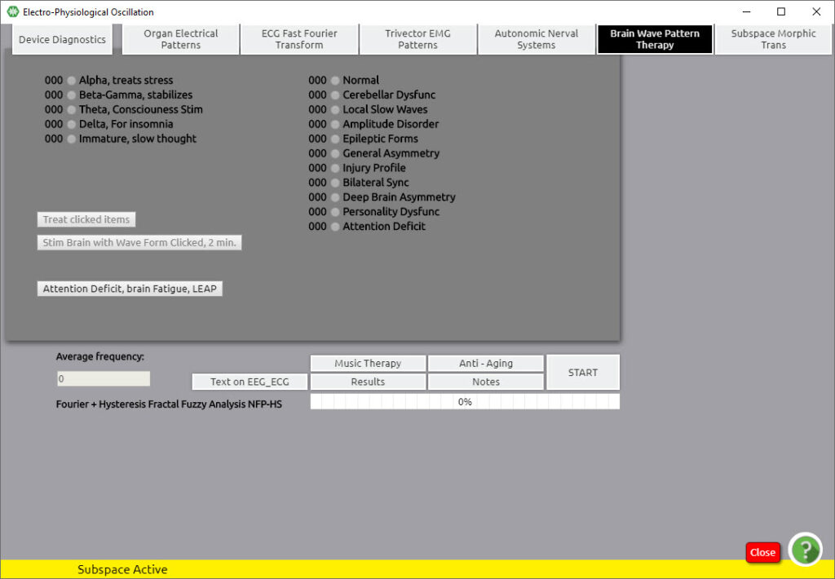

Balancing begins with “Delta Waves” from the left column. The highest value in the right column will be automatically selected
Click on “Treat clicked items”

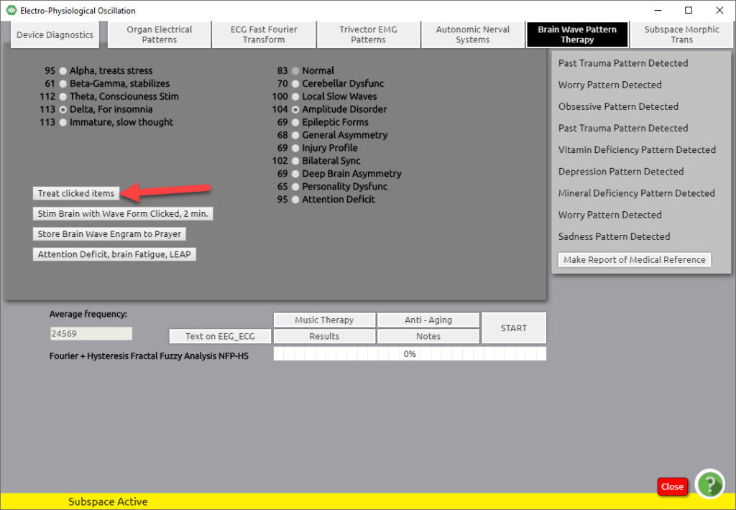

After the value selected in the right column drops by 10 or more below the level of the “NORMAL” value, we move to “Theta waves”
The procedure is the same, the next highest value in the right column is selected and treatment is performed until the selected value drops by 10 or more below the “NORMAL” value, by clicking on “Treat clicked items”
Also balance the cell waves (“Beta Gamma”, “Alpha”)
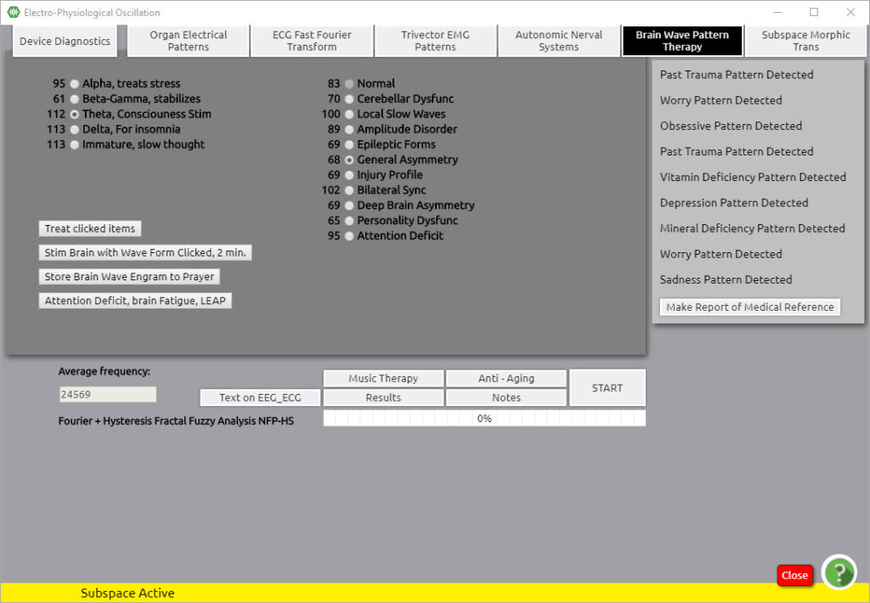
Careful! The “NORMAL” value in the right column cannot be selected because it is the reference value for the other values.

Changes made with Update no.43 & 44

From the latest update made this last week, Update no. 43&44, some basic changes have been made.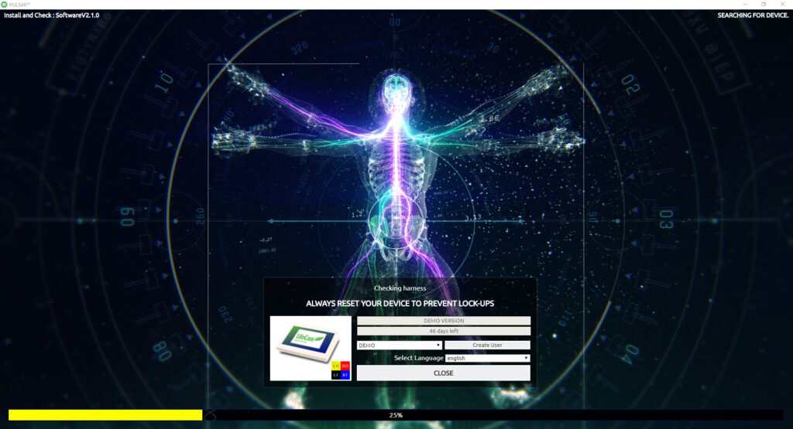
As soon as you click the close button on this panel where the device is found, you shall enter the password panel directly, without having to choose the password option on the main panel.
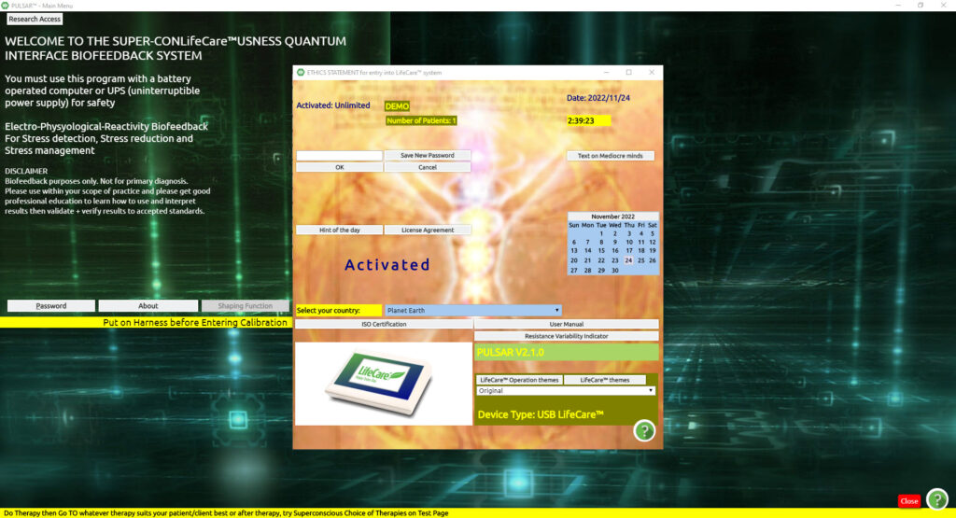
As soon as you put in your password and close, the Demographics panel opens directly.
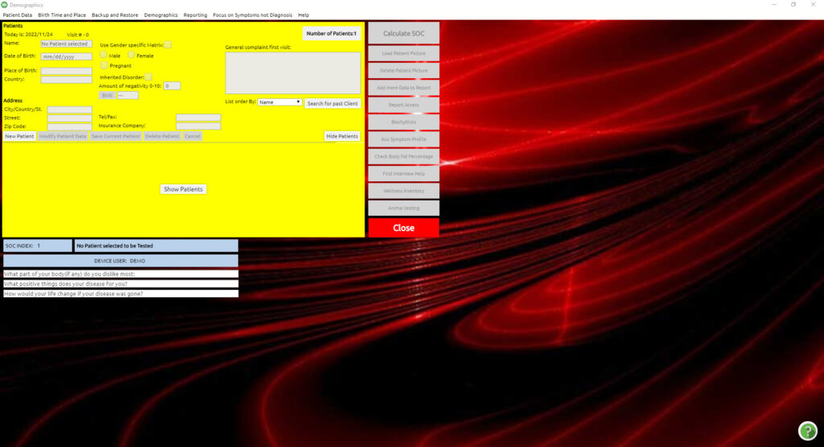

This new process enables us to enter the program quicker with fewer clicks.
After choosing your previous client or entering a new client (as you already know from our previous sections), and pressing the large close button on the right, you will be taken to the Main Panel to proceed as normal.
Let us proceed into “calibration” and thereafter “testing” so that we go through the changes together.
After calibration and before testing, you shall notice on the top line a difference in the drop-down menus. We will go over them one by one, but at this point, we would like to point out that you are now able to run certain programs before testing. Anything which is not greyed out, you can run.
Common programs that you may wish to run before testing are the items under the option Additional as also the items under the option Subspace Programs.

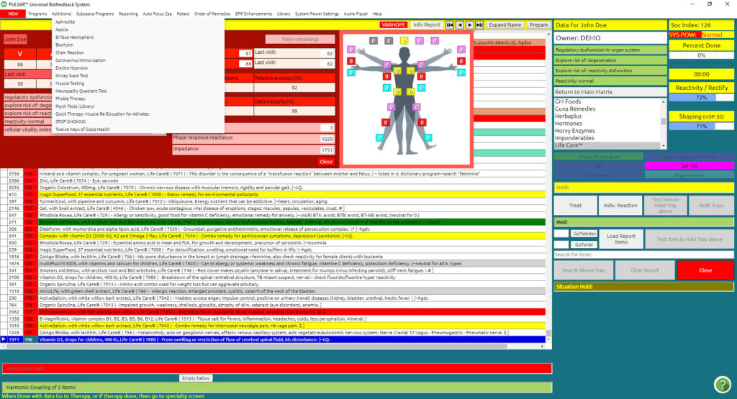

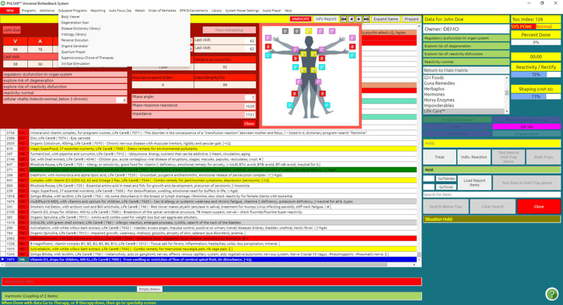
For now, let us proceed to test and we shall go through each change thereafter.
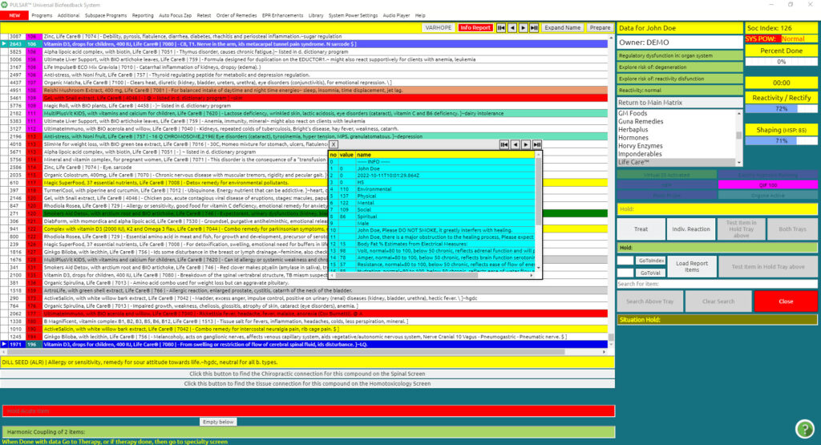

After Testing, you shall notice now a new order of the drop-down menus.
Firstly, in red, you shall see the drop-down menu NEW.
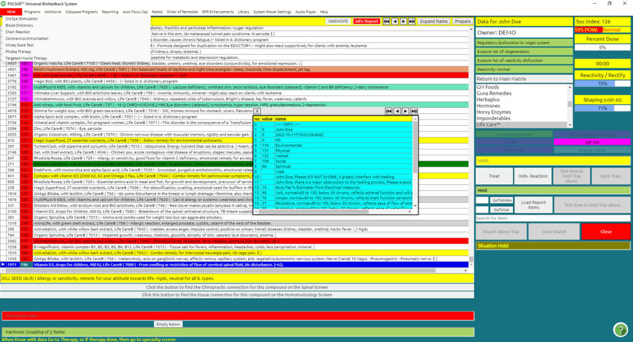

These are the new programs that have been added so that you can find them and refer to them faster with one glance. Of course, this is their temporary place just in order to inform you of a new program added.
If you select one of the programs in this NEW drop-down menu, let’s say the first one for example you will notice a message in red coming up below.

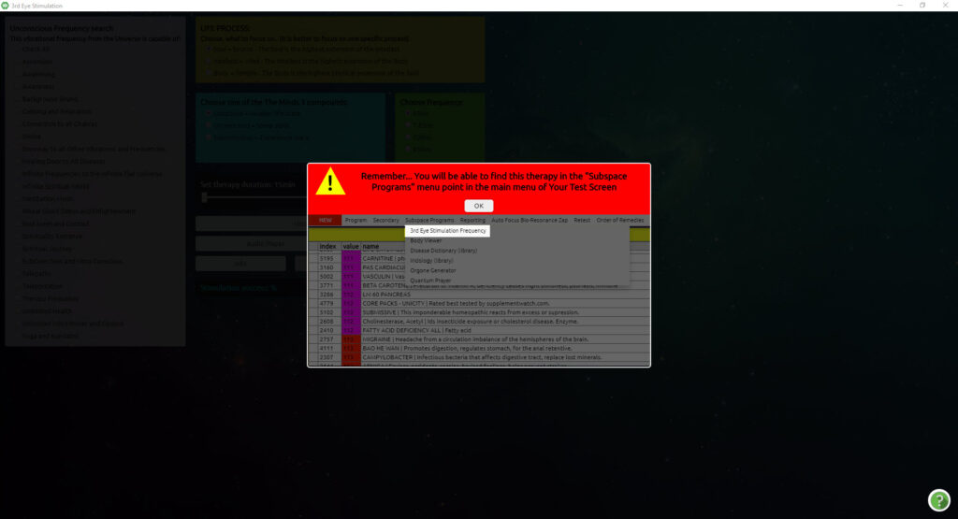

This informs us of where we will be able to locate it within the program. For instance, in this example, the 3rd Eye Stimulation Frequency, tells us that we will be able to find it under the dropdown menu Subspace programs.
By clicking OK, we proceed in running this program.
The same process is for each of the items under the NEW drop-down button.
Remember: the NEW drop-down menu is only a temporary list of new applications added to our software. So please take note of the messages which appear, as, at some point later on in updates, you will find these items only in the specified areas.
Please refer to our following videos for each New feature or relative chapter in your basic navigation manual provided.
The items under the drop-down menus, Programs, Additional, Subspace Programs, and Reports have been placed specifically and relatively so that you can find each program with ease.
The items under Programs, are the main programs with which you work with a client. The items under Additional, are mainly the automated programs.
The items under Subspace Programs are all those items that work in subspace.
The items under Reports are all those features used for reporting and adding info to reports.
The next drop-down menu which has changed is Library.

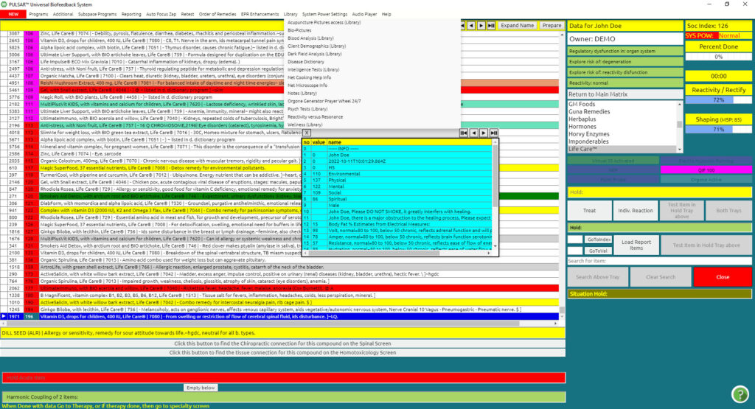

Here you can find library information, literature, things to read or information you may want to refer to, etc.

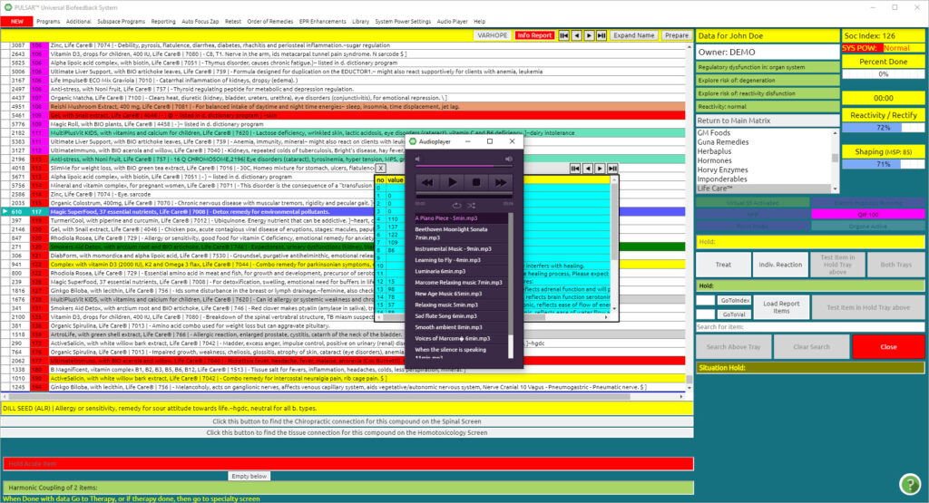

The drop-down menu Audio Player opens up a panel in which you can select music to play during your session. This panel can be minimized and can be referred to anytime during your session by toggling on the PULSAR icon at the bottom of your screen.
Enjoy your new update. This year so many new add-ons will appear.

Changes made with Update no.45 & 46
With this update, several changes have been made.
First off, you will notice a change in the VARHOPE panel. The same readings are still there, the only difference is the appearance, neater and more concise. If you wish to see the meanings of each reading, just hover your cursor over the number and the meaning shall appear.

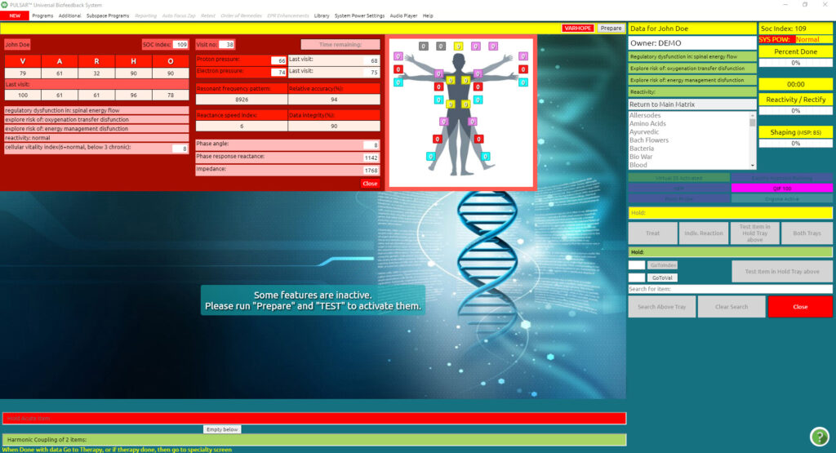
As below, I hovered my cursor over O (oxygenation) and you can see the meanings of the readings.
For more in-depth explanations of the readings please refer to our video VARHOPE Score Interpretation on our support site https://support.quantum-medical.eu/ or Chapter 2 in our user manual.
After testing, when the matrix appears, you will notice that the VARHOPE panel remains in view for your review and analysis. If you wish to close the panel, simply press the button close on the right bottom of the red panel.
If you wish to refer to the red VARHOPE panel at some other point during your therapy, simply refer to the drop-down menu Retest, and click on Activate red panel with vital organs.
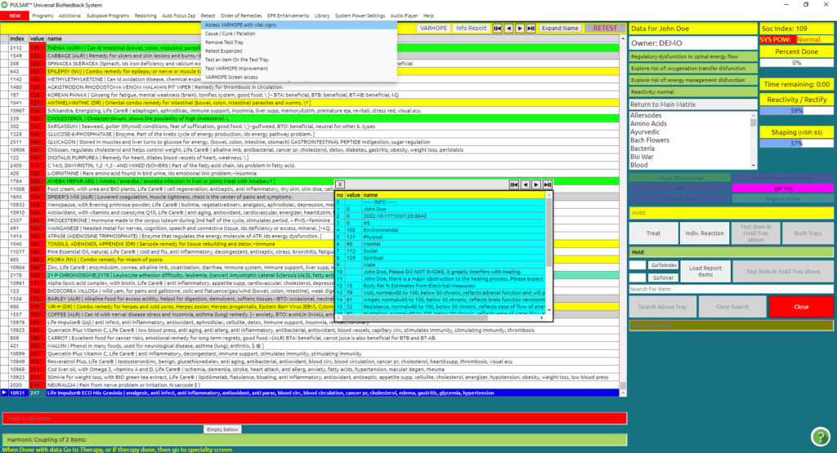
The next new and exciting feature of our software is the Coronavirus Immunization panel. As you already know from our previous updates, all new programs added to our software are initially and temporarily found under the NEW red drop-down menu, for quick reference.

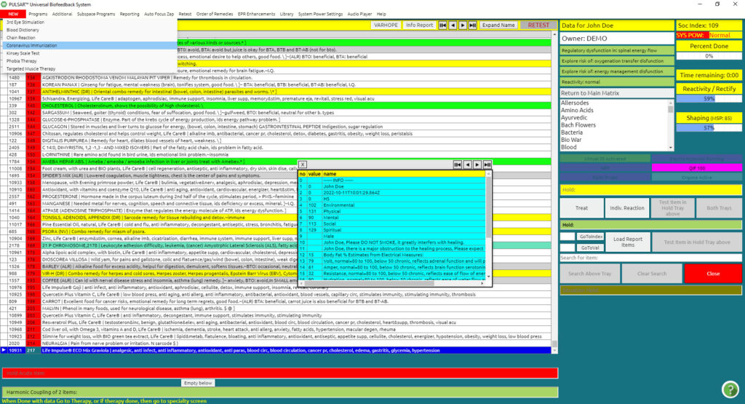

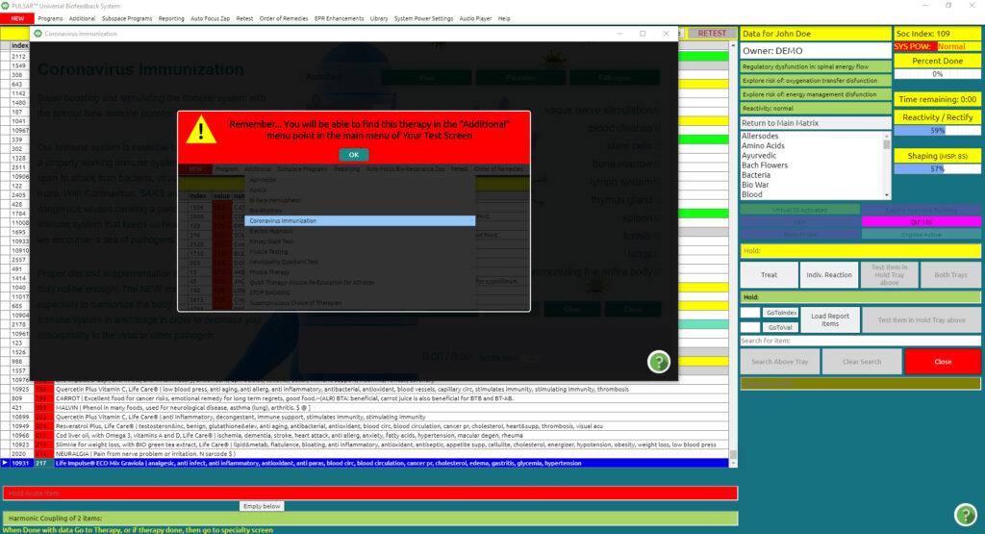
Its permanent place, however, is located under the Additional drop-down menu.
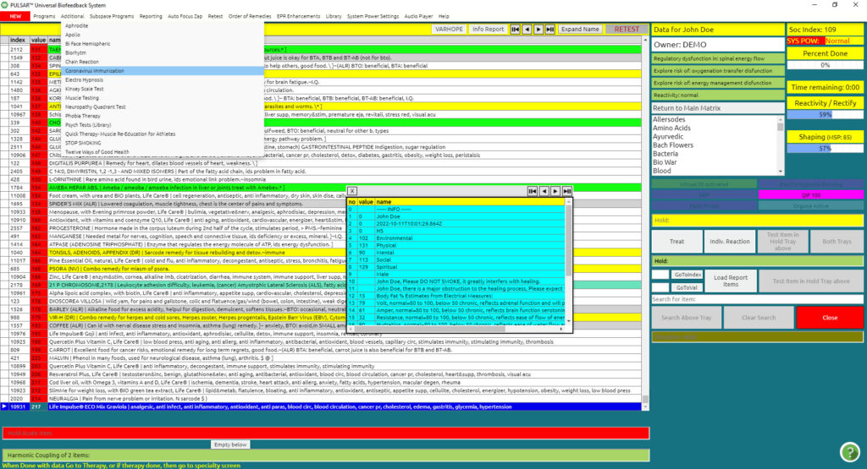
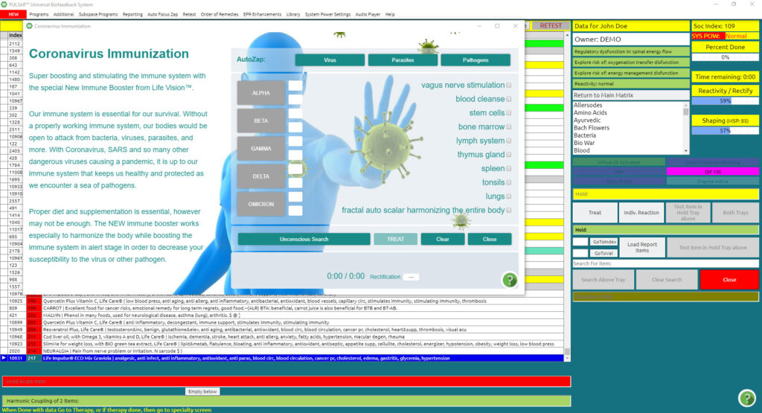
For more on how to use the Coronavirus Immunization panel, please refer to our video on our support site https://support.quantum-medical.eu on the Coronavirus Immunization or Chapter 17 in our user manual.
The next feature that changed with this update is the Feedback Homeopathic Activation Panel. This can be located under the Program dropdown menu.
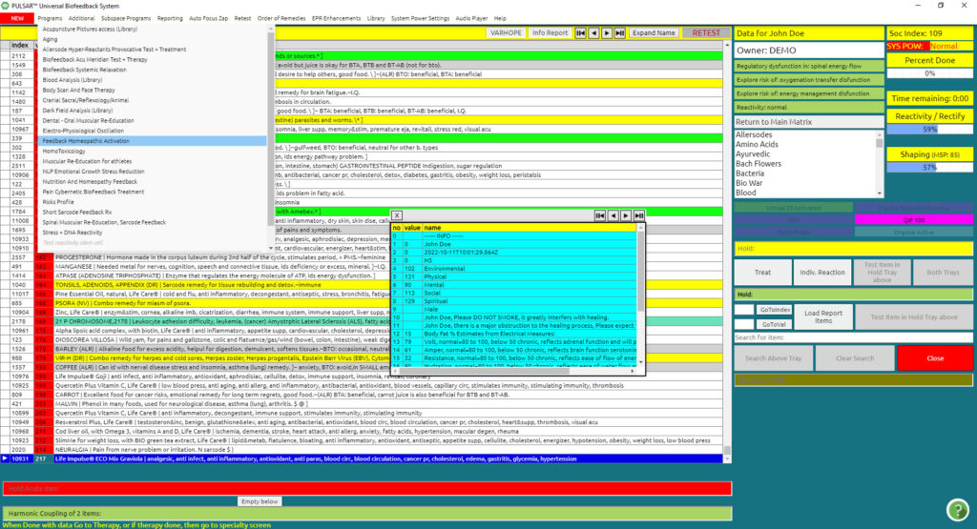
All therapies and usage remain the same as previously, only the appearance of the panel has changed, being more user-friendly.

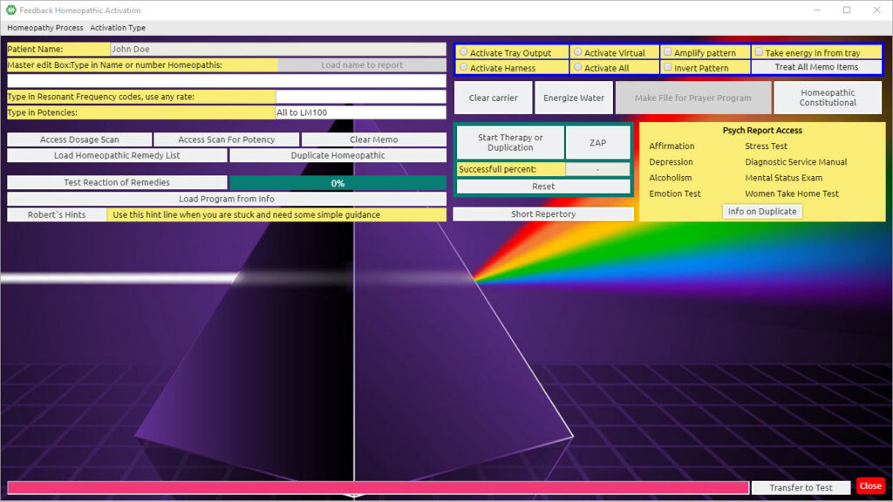
For more on how to use the Homeopathic Feedback Activation Panel, please refer to our video on our support site https://support.quantum-medical.eu/ or Chapter 16 in our user manual.
The next item changed with this update is the Biofeedback Systemic Relaxation program under the drop-down menu Program.
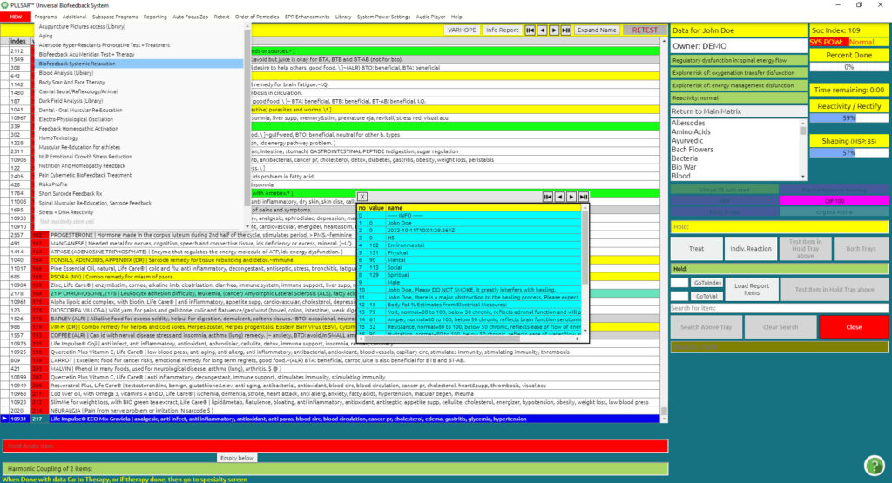
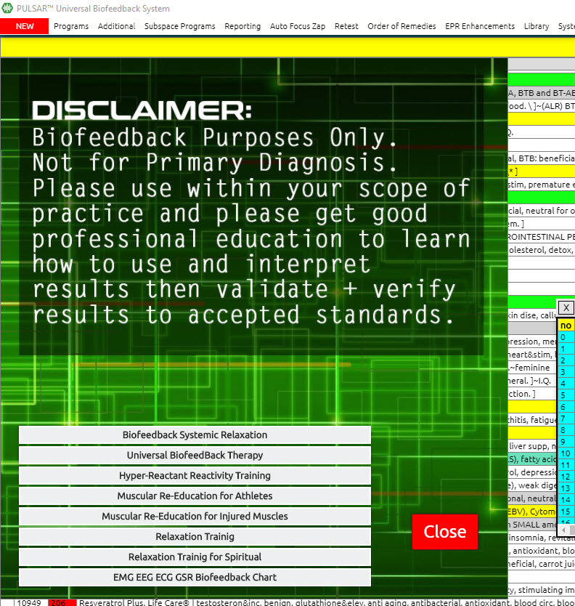
Click Biofeedback Systemic Relaxation to enter the program.
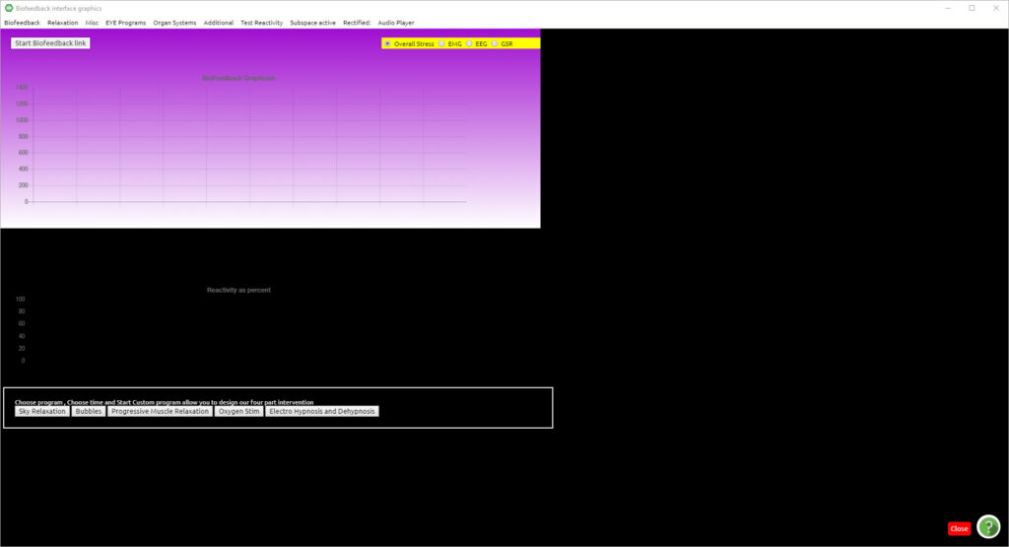
The feature which has changed from previously is the selection of unconscious choice under EACH drop-down menu. The feature now allows you to click the unconscious choice up to three times so that the client’s unconscious chooses which therapy it needs.

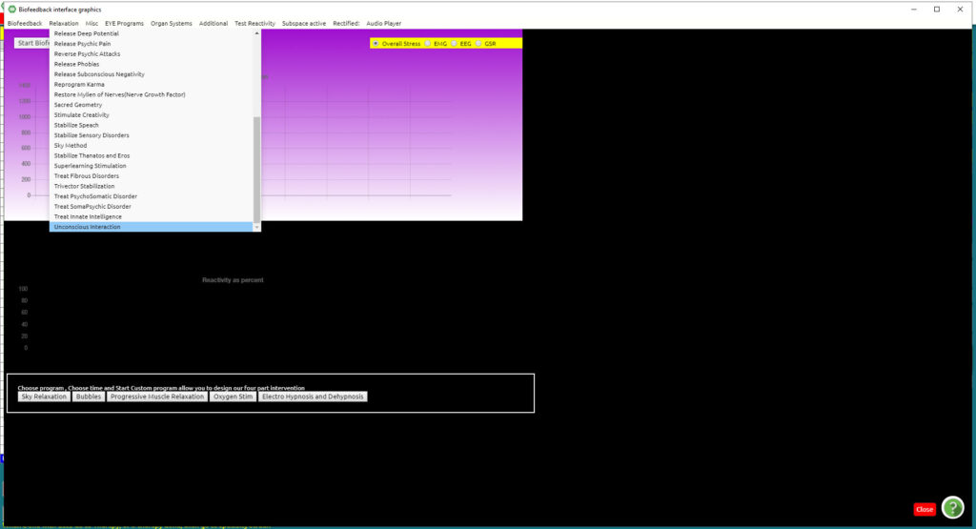
You shall notice a check beside each chosen therapy, while after three selections the “unconscious” is greyed out. The purpose is so that you can choose, as a therapist, what the client needs most. You can repeat this for each drop-down menu, choosing and getting an idea and information about what the client needs most.
For more on how to use the Biofeedback Systemic Relaxation Panel, please refer to our video on our support site https://support.quantum-medical.eu/ or Chapter 14 in our user manual.

Changes made with Update no. 46
With this update, several changes have been made.
First off, you will notice a change in the VARHOPE panel. The same readings are still there, the only difference is the appearance, neater and more concise. If you wish to see the meanings of each reading, just hover your cursor over the number and the meaning shall appear.
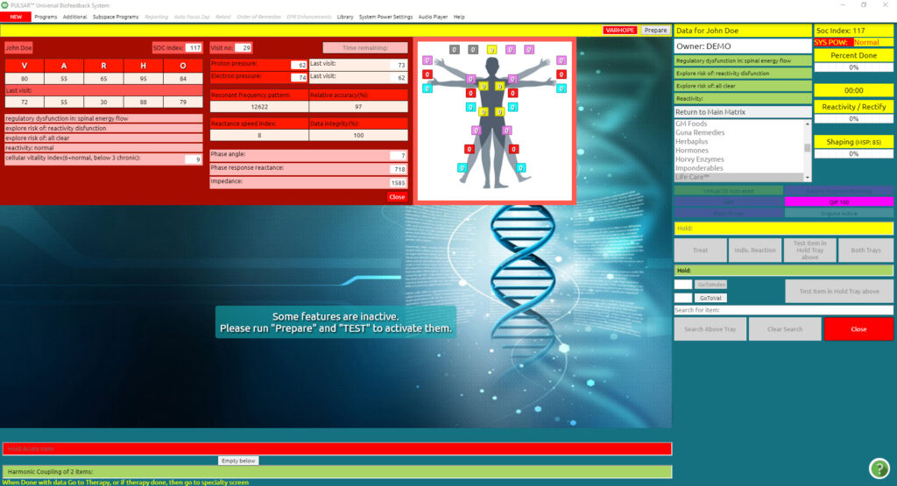
As below, I hovered my cursor over O (oxygenation) and you can see the meanings of the readings.
For more in-depth explanations of the readings please refer to our video VARHOPE Score Interpretation on our support site https://support.quantum-medical.eu/
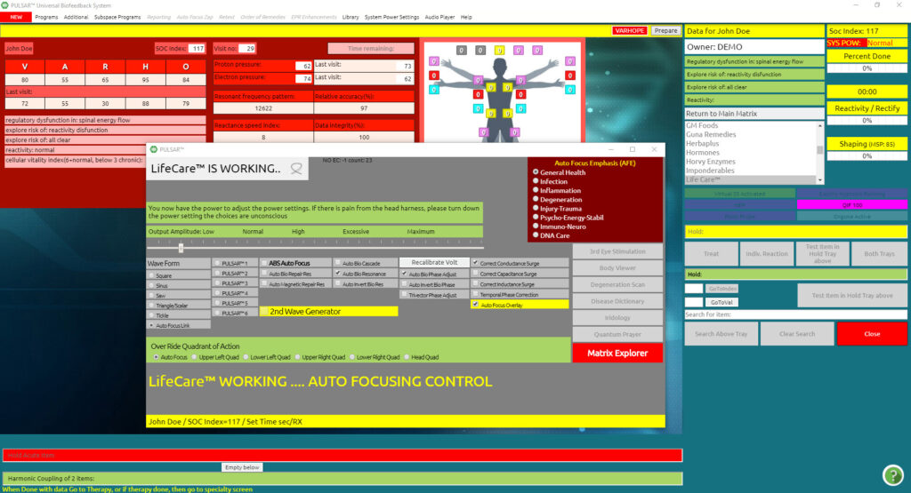
After testing, when the matrix appears, you will notice that the VARHOPE panel remains in view for your review and analysis. If you wish to close the panel, simply press the button close on the right bottom of the red panel.
If you wish to refer to the red VARHOPE panel at some other point during your therapy, simply press the VARHOPE button.
The next new and exciting feature of our software is the Coronavirus Immunization panel. As you already know from our previous updates, all new programs added to our software are initially and temporarily found under the NEW red drop-down menu, for quick reference.

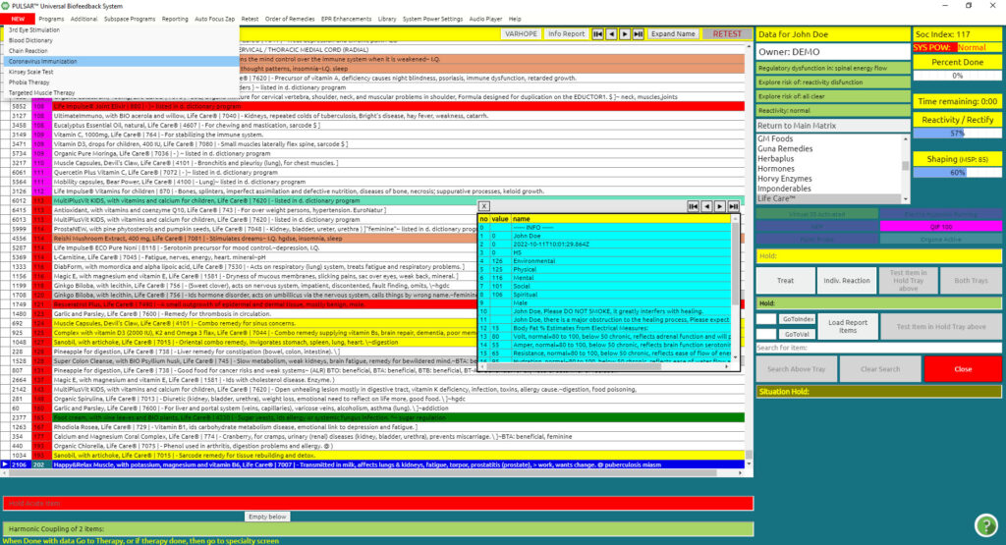

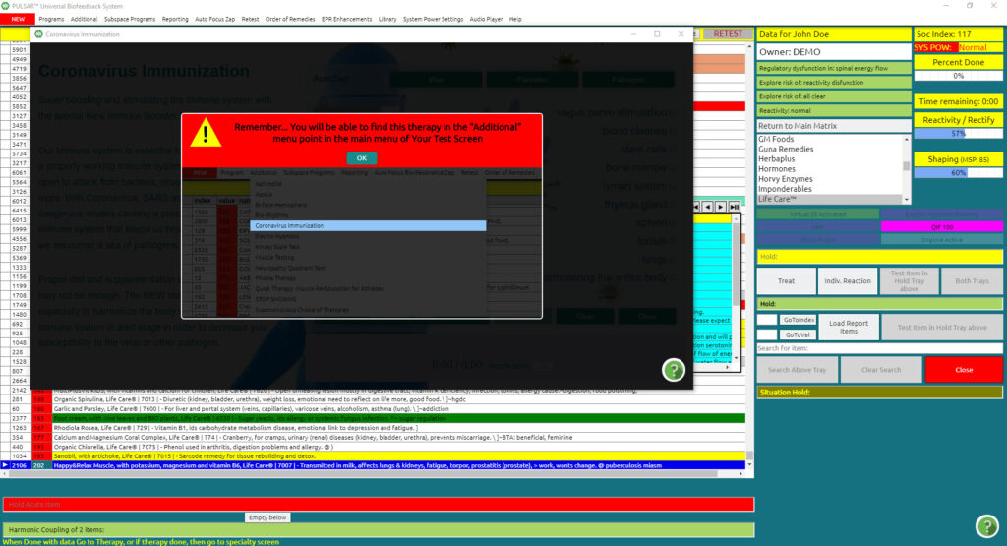
Its permanent place, however, is located under the Additional drop-down menu.
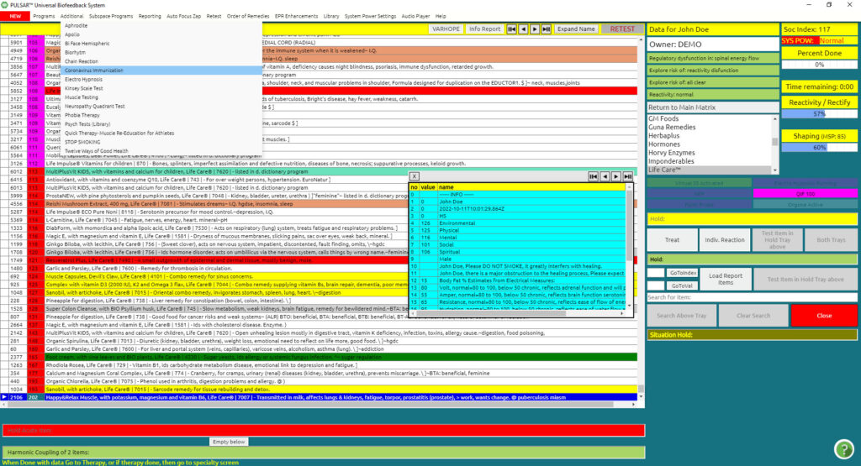

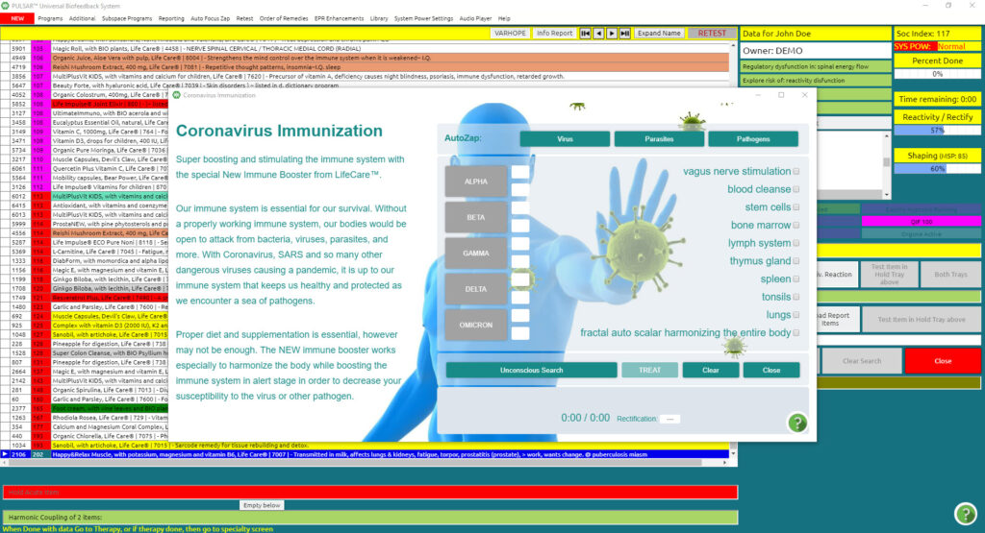
For more on how to use the Coronavirus Immunization panel, please refer to our video on our support site https://support.quantum-medical.eu/ on the Coronavirus Immunization or Chapter 17 in our user manual.
The next feature that changed with this update is the Feedback Homeopathic Activation Panel. This can be located under the Program dropdown menu.
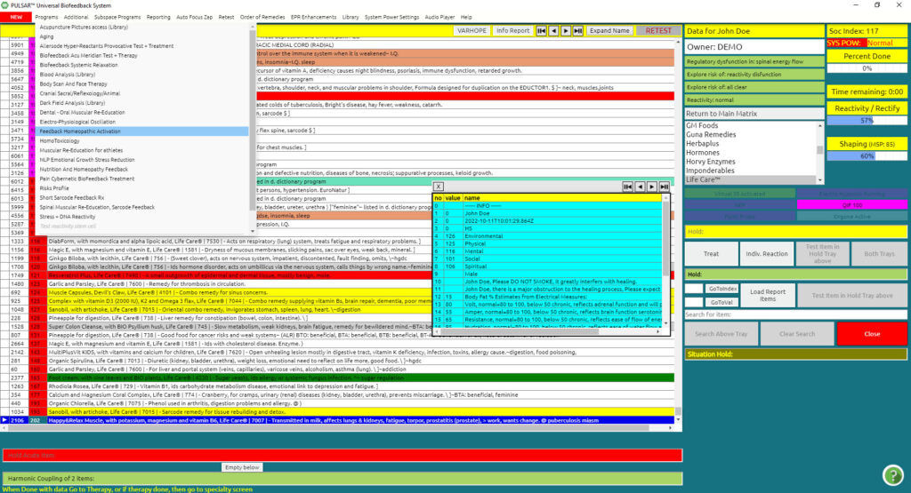
All therapies and usage remain the same as previously, only the appearance of the panel has changed, being more user-friendly.
For more on how to use the Homeopathic Feedback Activation Panel, please refer to our video on our support site https://support.quantum-medical.eu/

The next item changed with this update is the Biofeedback Systemic Relaxation program under the drop-down menu Program.
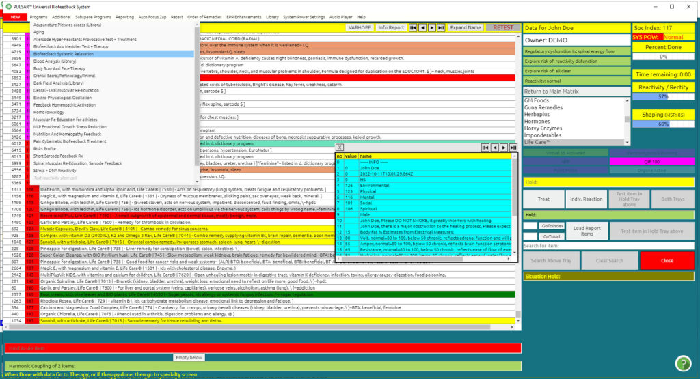
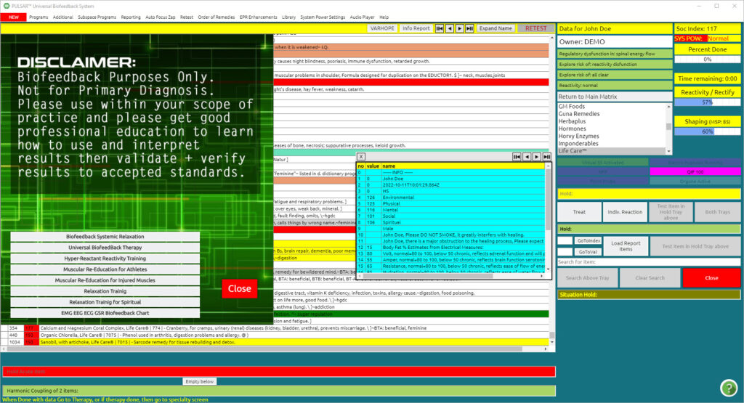
Click Biofeedback Systemic Relaxation to enter the program.
The feature which has changed from previously is the selection of unconscious choice under EACH drop-down menu. The feature now allows you to click the unconscious choice up to three times so that the client’s unconscious chooses which therapy it needs.

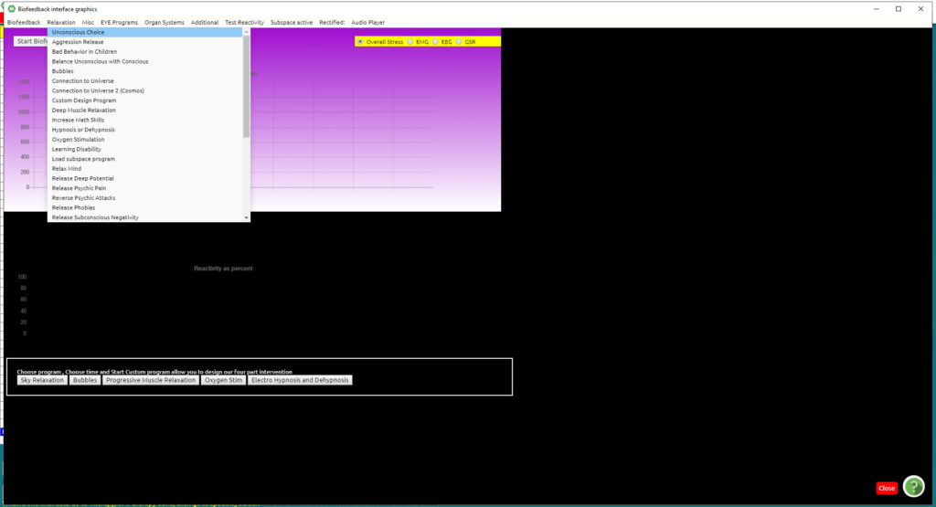
You shall notice a check beside each chosen therapy, while after three selections the “unconscious” is greyed out. The purpose is so that you can choose, as a therapist, what the client needs most. You can repeat this for each drop-down menu, choosing and getting an idea and information about what the client needs most.
For more on how to use the Biofeedback Systemic Relaxation Panel, please refer to our video on our support site https://support.quantum-medical.eu/

